Forecasting Ammonia Concentrations and Color Levels using Machine Learning for Reclaimed Water Treatment Operation and Management

Ting Hsi LEE

Water scarcity is a global challenge. One of the promising ways to mitigate the water resource crisis is via wastewater reclamation. Chlorine is commonly used for reclaimed water disinfection and requires precise dosing to satisfy endorsed quality standards. Ammoniacal nitrogen (NH $​_{3}$ N) and colour exist in the reclaimed water at concentrations between 0.23 – 5.44 mg N/L and 80 – 150 Hazen units, respectively, and can affect the chlorine demand. Forecasting the reclaimed water quality enables a feedback control system over the disinfection process by predicting the exact chlorine dose required which secures sufficient time to respond to sudden surges in color and ammonia levels. This study developed time-variant models based on machine learning to predict the NH $​_{3}$ N concentration and colour three hours into the future in the reclaimed water. The NH $​_{3}$ N data was collected by an online analyzer, and colour data was collected by a customized auto-sampling spectrophotometer, both are installed in the reclaimed water treatment plant in Hong Kong. Long Short-Term Memory (LSTM) was found to be the most effective architecture for training NH $​_{3}$ N and colour forecasting models. In the training processes, we applied data pre-processing methods and feature engineering, a technique to select or create relevant variables in raw data to enhance predictive model performance. From feature engineering, we discovered that the daily fluctuation in NH $​_{3}$ N and colour has correlations with the urban water consumption patterns. This finding further enhanced the NH $​_{3}$ N and colour forecasting model performance by 4.9% and 5.4% compared to baseline models. This research work offers novel methods and feature engineering processes for NH $​_{3}$ N concentration and colour forecasting in reclaimed water for treatment optimization.

# 1 Introduction

## 1.1 Background

Urban water challenge increases as the cities grow larger. The World Bank estimates that the urban population in worldwide will double by 2050—with serious implications of escalating water demands in cities by 50–70 precent (TheWorldBank, 2021). The amount, distribution, and quality of the available fresh water in urban water cycle has largely been affected by the global climate change. The report from (UNICEF, 2021) points out that one in four cities are facing challegnes to supply adequate water to inhabitants, the situation is even worse in cities from developing wrold. The rise of urban water usage will generate more wastewater, thus, the conversion of municipal/industrial wastewater into reusable water is drawing much attentions over the years. Reuse water increases the water availability by substituting the use of freshwater on non-potable (drinkable) uses for agricultural irrigation, industrial, and urban water reuses, etc. The alternative reuse water can supply many activities and save drinking water for other purposes elsewhere (Adewumi et al., 2010).

The construction of reclaimed water facilites often require a huge amount of capital investment. Upgrading available wastewater treatment plants with the reuse water treatment facilities is an economic solution which accompanied with the benefits of the potential of realizing resource recovery (e.g., nitrogen and phosphorus recovery) (Kehrein et al., 2020; Maryam and Büyükgüngör, 2019). The primary concern of reusing treated wastewater is the the potential risks caused to the public health. Under unexpected circumstances, it is possible for the reclaimed water facilites to produce unqualified reclaimed water, which is harmful to the living beings (i.e., as reuse water is ingested directly or through irrigated crops) and irrigated soil (Adewumi et al., 2010). In Hong Kong, reclaimed water quality is regulated with up to 10 or more water quality parameters, and any parameters fail to meet the standard will lead to disqualification. The common practice for controlling the treated water quality is achieved through water quality control strategy. The market controllers have evoled from a simple on-off logic controller called Programmable Logic Controller (PLC), to a more advanced multi-step response controller called proportional-integral-derivative (PID), and finally to the controller consists of machine learning models.

The deployment of machine learning models in the water quality controllers for assisting water quality control strategy is a ground-breaking application. Many research papers have proposed various machine learning models for replacing the PLC and PID controllers, and demonstrated the benefits machine learning have brought. From the study of (Librantz et al., 2018), the disinfection process in a drinking water treatment plant, a PID and machine learning based controller were depolyed to compare the operational costs of meeting the chlorine concentration set-point (i.e., the controller is set to increase or decrease the chlorine dosage until a specific concentration is reached). The results showed that Artificial Nerual Network based model has a more satisfied cost reduction in a chlorination dosing control system comapred to PID controller. Another reseach finding suggests using a Support Vector Regression (SVR) model as the controller required less time in reaching the set-point concentration of free chlorine residual compared to PID controller in both simulation and experimental conditions Wang et al. (2020).

The superior performance of machine learning models comes from the tranining of high-quality datasets with good amount of data and data which can fairly represents the dynamic of the system. Previous work has only focused on how the models were trained by the dataset and the performance comparisons between models and PID controllers in water quality control. This raises many questions such as in the senarios when the amount of data is insufficient in length or types (i.e., only a few variables such as pH values or chlorine concentration are available), or the collected data is in poor quality (i.e., missing values or exists extreme values). Although a few papers have discussion the use of data pre-processing methods for removing the noise in raw dataset using data smoothing filters (Cheng et al., 2020), or creating new features in addition to the raw dataset (Mamandipoor et al., 2020), the influence of data pre-processing methods on the model outputs were not revealed.

Machine learning models for water quality control have two main types of algorithms, regression and classification. The former provides forecasting results of specific values, while the latter provides a decision of yes or no (i.e., 1 or 0). Regression model is also called forecasting models, which play an important roles in water quality control in drinking water treatment plants (DTPs) and wastewater treatment plants (WWTPs). The need of using forecasting models are becuase the unpredictable nature of water quality, and the treatment operations are subjected to the change of water quality to produce effluent complied the government regulation (Chen et al., 2003). In the reclaimed water system in Shek Wu Hui Effluent Polish Plant (SWHEPP), forecasting models are needed for the effluent treatment management and operation. However, only limited online sensors are availabe onsite. Despite the access to limisted data for model training, it’s still possible to train a forecasting model with one input, which is also called a self-prediction model. In this study, we will attempt to build machine learing models for forecasting water quality patameter in reclaimed water. Meanwhile, the issue of insufficienct data in quantity will be addressed with data pre-processing methods.

## 1.2 Objectives

The specific objectives of this thesis work are:  
(1) To build baseline univariate forecasting models using machine learning and deep learning models.  
(2) To develop data preprocessing methods for enhancing model forecasting performance.  
(3) To extract features and hidden relations of water parameters in MBR effluent by analyzing the wastewater collected upstream of the WWTPs.  
(4) To develop methods for improving performance of forecasting models using the hidden features and relations of the water parameters.

## 1.3 Organization of the thesis

In Chapter 1, “Introduction,” the background information, objectives and organization of the thesis were presented.

Chapter 2, “Literature Review,” provides the overview of water quality process controls, the reviews cover the water treatment plant, wastewater treatment plant, and in reclaimed water system.

In Chapter 3, “Materials and Methods,” the instruments for ammonia and colour data collection, programming environment, and data preparation methods were summarized. The processes of the formulation of extra features for training forecasting models were illustrated.

In Chapter 4, “Results and discussion,” the performance of machine learning and deep learning models were compared. Forecasting models trained by different data pre-processing methods and the effect of feature engineering were both compared with the baseline model performance.

In Chapter 5, “Conclusions and Recommendations,” the findings obtained from this thesis work were summarized and the possible future studies were recommended.

# 2 Literature Review

## 2.1 Introduction to water quality control

### 2.1.1 Automated system for water quality control

Programmable logic controller (PLC) is an industrial computer system designed for any process requiring a series of devices and equipment operates cohesively to achieve multiple purposes in manufacturing or treatment processes. The main components of PLC include a center process unit (CPU), input modules and output modules (I/O). CPU is responsible to process digital signals from input modules and send commands through output modules based on the control logics programmed on the PLC. For chemical dosing control in water treatment plants (WTPs), PLC system receives readings from turbidity and pH sensors and uses pumps to dose aluminum solution automatically (Andhare and Palkar, 2014). The PLC system with the capability of producing real-time output commands in response to the input sigals also makes it widely used in the wastewater treatment plants (WWTPs). For oxygen concentration control in the aeration tank, PLC system receives signals of dissovled oxygen (DO) detectors and transmits signals to open or close the electric butterfly valves to further alter the DO concentration (Zhu and Qiu, 2017). Although PLC systems are the most used system across industries for its easy programming and reliable control, PLC system is merely a device that can be programmed to control operative devices with on-off logic (i.e., a logic control with two states) and the capability of complex control is compromised. Many WTPs or WWTPs have the need of precise control of the treatment processes. Being awared of the limitations of the PLC systems, a more advanced controller called proportional–integral–derivative (PID) controller for receiving analog signals was developed to obtain more sophisticated controls over the operative devices.

To react to rapidly changing process conditions, a PID controller generates an output value based on continuous calculation of an error value e(t) as the difference between a desired setpoint (SP) and a measured process variable and applies a correction based on proportional, integral, and derivative terms. The use of the "P", "I", and "D" allows the system to quickly reach steady state with a feedback control system (i.e., the system output is returned to the system input which is included in the decision-making process in PID controller). A PID controller is a technology (i.e., a specialist algorithm) for contorlling a single device with more complex logics, while a PLC system is a physical system consists of different modules and capable of controlling dozens of devices only with two-state logic. In addition, A PID controller can be designed to operate on PLC device and provide a more precise control strategy to a designated device. In WWTPs, a single-variable feedback analog control loop in PID can be used to control the temperature in the activated sludge treatment by stablizing the system temperature in a shorter time (Bados and Morejon, 2020). The feedback control scheme is also applied in WTPs to adjust the addition of chlorine dosage (i.e., also known as the disinfection process, chlorination, or postchlorination) to reach the target concentration of free chlorine residual (FRC) (Wang and Xiang, 2019). Disinfection process is carried out in a chlorine contact tank which provides sufficient time for chlorine to disinfect pollutants. Since the chlorine added by the dosing device requires time to travel from the entry to the exit, the system output can only reflect the changes of water quality in a delayed time of 30 minutes (i.e., the designed time for water to travel in chlorine contact tank is usually 30 minutes or longer). In the case of chlorination, the lag of time makes feedback control difficult (Kobylinski et al., 2006) as the system is delayed in responding to any sudden surge of the pollutants when it can only receive output at the end of the disinfection process. PID controllers in WWTPs also encounter similar challenges as the increasing complexity of water quality and stricter regulations on the discharged water quality.

To tackle the difficulties encountered in process control system, many control strategies are proposed, such as feed forward-feedback control, linearized and optimal control, model-predictive control, and fuzzy control, etc (Demir and Woo, 2014). Among the algorithms used in control strategies, Artificial Intelligence (AI) modeling has gained the most attentions in recent years compared to modeling based on mathematical models or empirical formulas. In WTPs or WWTPs, to fully understand the physical, biological, and chemical interactions in the treatment plants is very difficult. The unpredictable behaviors during the water treatment can be the significant changes of influent flow rate, flucutations of water quality, the complexity of biological treatment process, and the large time delay exists between this control variable and the process input, etc. Therefore, AI modeling shows a great potential in dealing with the highly complex conditions in the treatment process (Li et al., 2021). In the next sections, the applications of different AI modeling methods will be discussed.

### 2.1.2 Artificial Intelligence

Artificial intelligence (AI) can perform cognitive tasks with the development of computational solutions. The concepts of AI are usually confused, in fact, AI is a very broad term and any kind of algorithms or models which involved in decision-making with computation fall in the domain of AI. For example, fuzzy logic and optimization algorithm are formulated with human design and computer decision making process. There are another subset of AI called machine learning (ML), but the process of generating a ML model is different to generating a fuzzy logic model. ML uses learning algorithms to generate a model via learning from historical or large amount of data without being explicitly programmed. ML algorithms can be classified into three categories, which are Supervised, Unsupervised, and Reinforcement learning. In the training process of supervised learning, input variable (x) and output variable (Y) we will provided, and model will learn from the provided dataset to map the x to the Y. A trained supervised model can generate a prediction for the response to the new data (i.e., also called the unseen data). Unsupervised learning is when the dataset is not labelled, the model can learn to infer patterns in the dataset without reference to the known outputs. This type of algorithm can find similarities and differences in the data. In reinforcement learning, models are designed to constantly interact with the environment in a try-and-error way and recieved rewards and punishments based on the purpose of the tasks. Generating a optimal action to achieve lowest penalties is the main function of a reinforcement learning model. In process control, supervised learning are frequently used in many senarios.

Regression is a supervised machine learning technique used to predict continuous values. A regression model can estimate the relationship between the input variables in the system and the output target from a given dataset, and then use the nonlinear relationship to map the unseen input data to a predicted output data. This type of application is sutiable for water quality prediction (Librantz et al., 2018), and sensor fault detection (Cecconi and Rosso, 2021), etc.

Fuzzy logic (FL) control is still an effective strategy for process control, and this type of AI modeling is called reasoning. Fuzzy logic is described as an interpretative system in which objects or elements are related with borders not clearly defined, granting them a relative membership degree and not strict, as is customary in traditional logic. The typical architecture of a fuzzy controller, shown in Figure 3, consists of a fuzzifier, a fuzzy rule base, an inference engine, and a defuzzifier Santín et al. (2015) proposed a hybrid control system comprised of FL controller and model predictive control using optimizaion model to control the chlorine dosing in a WTP. FL controller and optimzation model fall in the domain of AI, which is excluded from the subset of ML.

Fuzzy logic (FL), a method based on multi-valued logic, uses fuzzy sets to study fuzzy judgement, which allows FL-based fuzzy inference systems to simulate the human brain to implement natural inference [40].The adaptive fuzzy neural inference system (ANFIS) composed of FL and ANN with an inference mechanism has high interpretability compared to common ANN. The combined model has been used to control coagulant dosing systems [41,42].

### 2.1.3 Machine learning and deep learning

In machine learning, popular models which are frequently used by the researchers for training predictive models are Supporting Vector Machine (SVM), Random Forest (RF), and Artificial Neural Networks (ANN). Librantz et al. (2018) trained a RF model to predict the free residual chlorine concentration (FRC) in a WTP, and Xu et al. (2021) built a RF-based model to predict total nitrogen concentration in water bodies. Guo et al. (2015) compared the reliability and accuracy of an ANN model and a SVM model in predicting 1-day interval T-N concentration in a WWTP, and the results showed that RF model has higher accuracy while ANN model is more reliable for assisting decision-making process.

As the the computing power doubled every 18 months according to Moore’s law. A subset of ML, Deep Learning (DL) becomes more accessible for sovling everyday issues. In simplicity, DL models can be defined as neural networks with more than two hidden layers (i.e., the model complexity increased and required more computing power to calculate). In DL, there are various types of architectures designed based on the type of problems. For image processing, Convolutional Neural Network (CNN) is designed to extract important features from the image vectors. Another popular DL architecture is Recurrent Neural Network (RNN), which is powerful in solving time series-related applications and Natural Language Processing (NLP) tasks (Li et al., 2018). Although each architecture has their strengh in tackling different types of problems, both architectures can be used for a single task Li et al. (2022) built a regression CNN-RNN model for rainfall-runoff prediction. DL can be extremely powerful when multiple architectures ared fused into a single model to perform a specific task, which cannot be realized by machine leraning models. That being said, DL can achieve higher model performance in terms of the prediction accuracy compared to ML.

## 2.2 Water quality control with machine learning

### 2.2.1 Drinking water treatment plants

A drinking water treatment plant (DWTPs) produces potable (i.e., drinking water) water for human consumptions by removing contaminants from the source water, such as lake or stream, or from an underground aquifer. The raw water enters DWTPs and goes through treatmet units of coagulation, flocculation, sedimentation, filtration, and disinfection in sequence as the primary treatment scheme in the conventional DWTPs (Li et al., 2021). During the treatment processed, colloids, suspended matter, pathogenic microorganisms and organic matter are removed to meet the regulated standard. However, the quality of raw water isn’t always stable, and corresponding actions are required to be promptly adopted when events like the surge of pollutants or the large variability of the influent flow. In any event, the treated water from DWTPs should generate drinking water which complies the World Health Organization’s Guidelines (WHO’s guideline) for drinking water quality. Otherwise, the treated drinking water should either be discharged and result in the short term outage of water supply to the downstream cities or the users will receive contaminated drinking water which can potentially transmit diseases and cause illness.

Turbidity is one of the critical water quality indicators, which can be defined as the "optical quality" of water, and the unit to decribe the turbidity is called Nephelometric Turbidity Unit (NTU). High levels of turbidity in raw water can impede the effectiveness of filtration and chlorination processes, and potentially cause short-term outages of water supply. Heavy rainfall and fissures within the aquifer can also lead to turbidity events are mostly likely to cause high turbidity (World Health Organization, 2017). The challenge in event of high turbidity in raw water is it occurs rapidly and mitigating activities must be actionable immediately. To address sudden event of such, Stevenson and Bravo (2019) trained forecasting models based on general linear model (GLM) and RF to predict the time when the turbidiy reaches higher than 7 NTU. The results indicate both model can successfully predict the events (i.e., with accuracy between 0.81 and 0.86), and RF model is found to have higher precision due to it’s ability to capture the nonlinear relationship between rainfall (mm) and turbidity (NTU).

To maintain operational costs and water quality in the coagulation process, the amount of coagulant, which is mainly subject to the turbidity and alkalinity in the raw water, is traditionally determined thourgh manually sampling and analysis. Jar test is designed to find out the optimal chemical dosage for coagulation to remove the turbidity in raw water, and the entire process includes on-site sampling and up to more than 40 minutes of laboratory works (Gani et al., 2017). To replace the laborious procedure of jar tests, Wang et al. (2022) proposed using principal component regression (PCR), support vector regression (SVR), and long short-term memory (LSTM) neural network to build predictive models for outputing daily estimated chemical dosage. Compared with linear PCR model, nonlinear SVR and LSTM models captures more relationship between the chemical dose (e.g., ferric sulfate) and the raw water quality based on a higher R-squared value of 0.70.

Disinfection is the last step of water treatment processes in drinking water treatment plants to generate safe potable water. In this step, one or more chemical disinfectants like chlorine, chloramine, or chlorine dioxide are added into the water to inactivate any remaining pathogenic microorganisms. However, the chlorination process requires precise dosing of disinfectant—too high will lead to the formation of disinfection byproducts (DBPs), and too low will result in insufficient levels of the residaul disinfectant concentration. In both senarios, the treated drinking water can pose health threats to the end users. The aforementioned PID controller can achieve automatic dosing of disinfection, however, Wang et al. (2020) found out that the accuracy of the predicted disinfectant dosage using (i.e., chlorine is used in this paper) a Support Vector Regression (SVR) model outperformed a PID controller in both simulation and experimental conditions. An Artificial Nerual Network based model also shows a more satisfied cost reduction in a chlorination dosing control system comapred to PID controller (Librantz et al., 2018).

The invariability of the raw water quality is always a big issue for disinfection. For instance, chlorine dose can be excessive dosed when the treated water contains less pollutants (e.g., non-organic matters and ammonia nitrogen). Exessive addition of chlorine results in the problem of wasting chemicals which is reflected on the increase operational cost and potentially generate undesired disinfection by-products (e.g., trihalomethanes (THMs), which are carcinogenic to human) due to the chemcial reaction between pollutants and overly dosed chlorine. Xu et al. (2022) trained an ANN model for predcting the occurrence of THMs in tap water using simple and easy water quality parameters (e.g., pH, temperature, $UVA_{254}$ and residual chlorine ($Cl_{2}$)). Despite the results showed a good model accuracy in predicting for THMs (i.e., T-THMs, TCM and BDCM), the applications of the model is largely limited in reality due to the lack of dataset regarding the quantity and quality . In fact, lack of high quality dataset for trianing ML models is a common issue, which explains up until recently, mathametical or empirical based AI models like fuzzy logic (Gamiz et al., 2020; Godo-Pla et al., 2021) is still widely used for process control in WTPs.

### 2.2.2 Wastewater treatment plants

Human activies produce wastewater and discharge from homes, businesses, factories and commercial activities to the sewage systems which connect to wastewater treatment plants (WWTPs). The function of a WWTP is to remove contaminants from sewage and water so that the treated water can be returned to the natural water body without dangering any living beings reside in the ecosystem. Undertreated wastewater can lead to harmful algal blooms or cause oxygen deficit in the water (i.e., low oxygen content can kill the fishes). The steps for treating municipal wastewater involve three major categories—primary treatment, secondary treatment and tertiary treatment. The pollutants which will either float or settle will be removed in primary treatment; next, secondary treatment is mainly responsible for removing BOD $​_{5}$ in the biological processes; in the final tertiary treatment, membrane filtration, adsorption by activated carbon and addition of disinfectant can be applied optionally to futher eliminate the undesired pollutants in the water.

Wastewater can be defined as the flow of used water discharged from homes, businesses, industries, commercial activities and institutions which is transported to treatment plants via pulbich sewer system or engineered network of pipes. This wastewater is further categorized and defined according to its sources of origin. Domestic wastewater refers to water discharged from residential sources generated by kitchen wastewater, cleaning and personal hygiene. Industrial/commercial wastewater is generated and discharged from manufacturing and commercial activities, such as textile industry and food and beverage processing wastewater. Institutional wastewater characterizes wastewater generated by large institutions such as hospitals and educational facilities. Regardless of the source of the wastewater, WWTPs have to achieve at least three sustainability targets: environmental protection (i.e., low pollutants discharge), social acceptance (i.e., human sanitary protection) and economic development (i.e., feasible operational and management costs) (Mannina et al., 2019). To effectively achieve these goals, process control is requried to reduce energy consumption, improve on effluent quality, and save costs in plant operation and management. The focus of this study is on discussing the development of using process control for treatment operation and management.

Under known operational conditions of a WWTP, machine learning models can be trained to assist the plant operators optimize treatment processes to improve effluent quality . Wang et al. (2021) proposed a machine learning framework, utilizing a model based on Random Forest to predict the effluent Total Suspended Solid (TSS) and phosphate (PO $​_{4}$). This study features using collected data from six on-line sensors (i.e., flow rate, TSS, pH, PO $​_{4}$, temperature, and total solids (TS) meters) across the treatment line to train the RF model. The results indicated that the influent temperature is the most influential variable for both TSS and PO $​_{4}$ in the effluent, and PO $​_{4}$ depends strongly on the TSS in aeration basins, etc. It has been suggested that the combined use of RF model and analytical tools allows the author to pinpoint the critical factors influencing on the effluent quality, and this seems to be a innovative approach. However, there are severl major drawbacks hindering such model developments using on-line sensors to collect training data. Many of the existing WWTPs and DWTPs are not equipped with on-line sensors, and lack of automation and instrumentation is common. One of the examples that lack of data from on-line sensor is an emerging techology called aerobic granular sludge (AGS) in secondary treatment (i.e., biological treatment). In addition, Wilén et al. (2018) claimed that the complex nonlinear relationships between the sludge, wastewater quality and operational conditions makes the operation and management of AGS difficult. Awaring the high complexity of the AGS and the unavailabilities of on-line sensors, Zaghloul et al. (2021) attempted to address the issues by collecting data from lab-based reactors and training machine learning models. Considering the intricacy of operation coditions and the AGS system, the author claimed that with the use of feature selection and ensemble model, which is train with three different ML models, overfitting can be prevented. Given that the findings in this study provided good model performance in predicting Chemical Oxygen Demand (COD) and other sludge-related parameters, the results stating the fact of reducing overfitting using ensemble learnings should be treated with caution. Similar to the AGS system, electrocoagulation reactor is also an complex system that the operation and management are based on pH value, the current density, flow rate and the initial concentration of heavy metal ions, etc. Interestingly, instead of using an ensemble model to prevent the overfitting issue claied by Zaghloul et al. (2021), Zhu et al. (2021) used a deep learning Long and Short-term model (LSTM) and a error compensate Autoregressive Integrated Moving Average model (ARIMA) to predict the removal rate of heavy metal ion concentration in wastewater. A LSTM-ARIMA model has strengthed the model performance compared to solely used LSTM or ARIMA model in predicting removal rate shown by the Results. A possible rationalization of using as LSTM model without worrying model overfitting is that deep learning is sophsiticated enough for learning the nonlinear patterns in complex system while machine learning model like RF might fail to capture the intricate relationships, resulting in overfitting.

The advancement in technology allows the easy access to real-time water quality data via on-line sensors. The collected real-time data can be used to train predictive models and assist the plant operation and management. Depite the advantages of what on-line sensors are capable of, the pitfalls can jeopardize the quality of predictives models or even induce wrong decisions for plant operation, ultimately deteriorate treatment efficiency in WWTPs. Haimi et al. (2015) suggested that reliable and moderately-priced real-time sensors are not always available, in addition, sensor malfunctions (i.e., fouling or erroneous measurement) can cause the down-time of the sensors. For the unavaible sensors (i.e., "hard-to-measure" or expensive sensors), many research works have proposed building "soft sensors". Instead of using hardware sensors to measure the water paratmers, soft sensor generates real-time values through a machine learning model, which is trained by other easy-to-measure water quality data. In the works of Wang et al. (2019), easy-to-measure variables such as, pH, flow rate, TSS, and ammonium nitrate (NH $​_{4}$-N) are input to machine learning models to predict hard-to-measure water quality paratmers of COD and total phosphate (TP). Pattnaik et al. (2021) also used DO, pH, conductivity, turbidity, and temperature to train a model to predict BOD. It’s beleived that both research works can solve the issues of the uavailability of certain water quality sensors.

The automated treatment operation and management heavily relies on the reliability of the on-line sensors, thus, preventing and the early detection of when the sensors are malfunctioned is the upmost concern to the plant operators. Sensor fault detections can be catogorized into three groups, which are (1) individual faults—an outlier data which can be distinguished with the respect to others data points; (2) contextual faults—an anomalous instance in a specific context and normal in another; (3) collective faults—a cluster of irregular intances with respect to other data trends (Chandola, n.d.). Many research papers have proposed using machine learning models to help identify the sensor fouling.

Two main types algorithms, which is regression and classification can be used for finding fouling signals. A regression algorithm can identify fouling signals by comparing model predicted outputs (e.g., ammonium or COD concentration) to the actual signals; a classification algorithm can distinguish fouling signals through the direct outputs of the model (i.e., the model outputs 2 class labels, one can be assigned as normal and the other is abnormal signal). Cecconi and Rosso (2021) proposed a ammonium fault detection mechanism, utilizing a regression ANN model, along with principal component analysis (PCA) and Shewhart monitoring charts (i.e., statistical control chart). The remarkable idea from this study is to analyze the residaul between the predicted ammonium and the real ammonium snesor signal and identify the individual and contextual faults with the help of statistical tools. Despite the accuracy of fault detection mechanism can reach R $​^{2}$ value of 0.87, the method comes with great limitations. The author points out to maintain the high accuracy of the predictive model, the quality of the input data needs to be carefully attended by performing manual cleaning procedures on a weekly basis.

Research has tended to focus on solving collective faults in sensor fault detection (ref of soft sensor solving individual faults) rather than collective faults. The major reason is collectives faults are hidden in regular signals, and only by identifing a combination of signals by experts can spot the irregularity. Thus classification technique using deep learnig is proposed to address collective faults in the works of Mamandipoor et al. (2020). It is believed that this is the first research paper using a LSTM network to achieve a fully automatic fault detection method in WWTPs. Contrast to others works, input variables for model training heavily relies on the manual selection of the experts before inputing into models like PCA and fuzzy nerual networks. The significance of using a deep learning network is it’s capability of capturing long-term temperol dependencies from a large dataset compared to machine learning models (i.e., PCA-SVM model). The results showed that the accuracy (i.e., F1-score) from LSTM model is 92%, outperformed the PCA-SVM model of 87%. This finding suggests using DL models in classification problems is promising for solving collective faults.

### 2.2.3 Water reclamation system

The increasing demands of water in cities is mainly attributed to the rapid urbanization and the population moving from rural to urban centers. In many major cities, the evergrowing water usage and wastewater discharge drive the development of water reclamation (Lyu et al., 2016). In WWTPs, the technologies applied in water resue include disinfecting with chlorine addition, ultra-violet (UV) irradiation, biological treatment, and membrane filtration, etc (Norton-Brandão et al., 2013). However, even with the most advanced water treatment technology, the treated reclaimed water quality is still subject to the variability and varations of pollutant contents in wastewater effluent (Chen et al., 2003), and can potentially fail to meet the reclaimed water standard. The research studies propose to apply machine learning techniques to assist the disinfection process in water reclamation can be catogorized into three groups (1) optimize the treatment management in WWTPs to alleviate the loadings of water reclamation process (Al-Ghazawi and Alawneh, 2021; Viet et al., 2021); (2) actively branch out the desired and undesired wastewater effluent for subsequnt disinfection process of water resue or direct disposal into water body (Chen et al., 2003); (3) adapt process control methods to stablize the disinfection performance in the reclaimed water system (Demir and Woo, 2014).

The technology advancement and research studies of water reuse have been discussed for more than two decades. However, the reseach publications aim at improving the reclaimed water system as a whole in recent years are not too many. The economic reasons behind constructing water reuse facilities universally could be the major obsticle for the government sectors. The economic burden of both building new reclaimed water institution on new locations or retrofit existed WWTPs is deterrent (Adewumi et al., 2010). To discover more values and resuable resources from water reuse, Chojnacka et al. (2020) takes the circular economy perpective into accelearting the process of adopting water reuse system for agriculture production. The author introduces the potential of gradually replacing chemical fertilizers with partially treated wastewater for sustainable crops production despite there are many limitations to be overcome. In Italy, the circular concept is also studied by Colella et al. (2021). Four different resource recovery senarios were brought up and two of the senarios include the nutrients recovery turned into nitrogen and phosphorus fertilizers. Several researchers in recent years have provided the overall potential and challenges of treated wastewater reuses in the world, it is believed the day of using reuse water universally will soon advant with the collaboration across different disciplines.

Reclaimed water for non-potable reuses can serve for irrigation for agricultures, toilet flushing and irrigation for landscaping, etc. Water Supply Department (WSD) will soon implement a reclaimed water supply system in SWHEPP by disinfecting the teriary treated sewage (i.e., MBR permeate). The produced reclaimed water will be served for non-potable reuses and is required to satisfy the water quality standards, shown in Table. [tab:reclaimed-standard].

lcl Parameter & Unit & Requirement  
*E. coli* & cfu/100 mL & Not detectable  
Colour & Hazen Unit & $≤$ 20  
Ammoniacal Nitrogen (NH $​_{3}$-N) & mg/L as N & $≤$ 1  
Total Residual Chlorine & mg/L & $≥$ 0.2  
Dissolved Oxygen & mg/L & $≥$ 0.2  
Turbidity & NTU & $≤$ 5  
5-day Biochemical Oxygen Demand & mg/L & $≤$ 1  
pH & - & 6-9  
Threshold Odour Number & - & $≤$ 100  
Synthetic detergents & mg/L & $≤$ 5

## 2.3 Tools and techniques for enchancing the performance of machine learning modeling

### 2.3.1 Programming languages

Matrix Laboratory (Matlab) is a propreitary programming and numeric computing platform used across industries and academia for data analysis, algorithm developments and model buildings. In wastewater treatment industry, Matlab is known for using with an add-on software called Simulink for modeling, simulating, and analyzing the dynamic system (i.e., chemically enhanced primary clarifier (Bachis et al., 2015). The use of Matlab-Simulink in wastewater treatment industry is known for the development control strategries of WWTP automations. In 1987, International Water Association (IWA) developed the first mathematical model for simulation-based evaluation, which is Activated Sludge Model 1 (ASM 1), and the modified activated sludge models and Benchmark Simulation Models (BSM) were further developed in the following years (Talib, 2011). The difference between the two is, ASM is designed for developing control strategies exclusively in activated suldge treatment process, and BSM 1 is to develop the automation in the entire WWTP (Ballhysa et al., 2020).

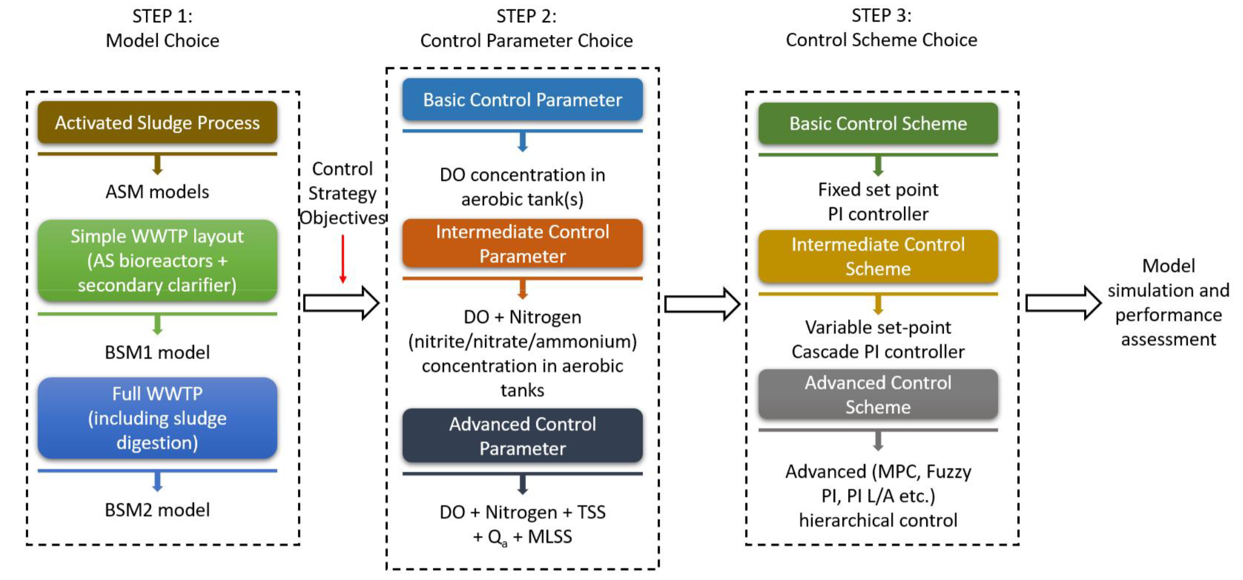

Proposed framework for control strategy design by Ballhysa et al. (2020).

In recent year, many publications present an interesting way to demonstrate how machine learning based model predicitve control (MPC) can outperfrom the conventional PID controller in WWTPs using BSM. The researchers use Matlab-Simulink to simulate the treatment processes in WWTPs while the block of PID controllers are swapped to machine learning models, and the effluent quality or treatment system performance can be differentiated via BSM simulated results. Wang et al. (2020) compared the stability of chlorinated water quality in the effluent of a DWTP with two control strategies, which are PID feedback controls and a predictive model based support vector machine (SVM). The BSM simulated results showed the SVM model required 21 minutes less to reach the residaul chlorine setpoint compared to PID feedback controls. A proposed neuro-fuzzy PID controller (i.e., a hybrid machine learning model consisted of nerual networks and fuzzy logic) also showed a superior performance in optimizing the chlorine dosing rate and to minimize the chance of errors (Hong et al., 2012) The significance of using BSM in Matlab-Simulink enables the performance of traditional and machine learning based control strategies can be compared in objective and fair senarios, also providing the practicability of machine learning to the experts in the field. Matlab is a powerful and resourceful platform providing various machine learning functions, including point-and-click apps for training and evaluation, available algorithms of classification and regression algorithms, and Automatic machine learning (AutoML), etc (MathWorks, 2022a). The direct access to the abundant features along with the integration of Simulink makes Matlab an appealing option for many researchers in wastewater treatment industry, especially in the research domain in machine learning and control strategy simulation. Despite the countless benefits of using Matlab, Python programming language stands out in different ways.

Python is a high-level, interpreted, and object-oriented programming language, and features with simple and easy to learn syntax providing good readability (“What is Python? Executive Summary,” n.d.). The large developer community (e.g., GitHub and Stackoverflow) and open-source access (i.e., free of charge) have made Python an ideal tool for machine learning starters. The most cutting-edge research in the field of Artificial Intelligence is often led by the Tech Giants like Google and Amazon, which conduct research on Python (e.g., machine learning frameworks of TensorFlow (Google)in Python), as well as the big research community using Python. All the lasted updates and developments relating to machine learning architectures and techniques are usually accessible in open-source Python community, including the example codes. Contrary to Python, users on commercial software Matlab need to wait for the software engineers working in Matlab to update the lastest machine learning applications onto Matlab plaform, which is a time consuming process and create a delay of time and accessibilities to many resources (Castro, 2018). Machine learning developers in wastewater treament industry can freely choose between the programming methods based on the research need. For those looking for mature machine learning algorithms can simple use Matlab and be satisfied with the functionalities, on the other hand, for those intend to incoporate more new techniques and architecutures in machine learning model can consider using Python as the programming language. Interestingly, MathWorks recently announced using Python functions in Simulink Model (MathWorks, 2022b), despite the update from Matlab, to the best of my knowledge, there is no research papers develop machine learning on Python and run on Matlab-Simulink.

### 2.3.2 Data pre-processing

The ubiquitous sensors installed in WWTPs for treatment automation generate a massive amount of data on daily basis. Before being used for any purposes, the data must be understandable for explanation and relevant enough for water experts to extract valuable information (Kehrein et al., 2020). Without the help of Artificial Intelligence, data manipulation before training machine learning models can be time-consuming and challenging. The specific designed algorithms can perform data evaluation and augmentation; thus the quality of data can be improved. Any statistical or machine leranign algorithms which can complete these tasks are known as the data pre-processing methods. The causes of sensors rendering undesired data with low quality are from the limitations of the hardware sensors and the dynamics of the sampling locations. In general, the fouing data generated by sensors can be described in eight distinct states (Newhart et al., 2019; Rosen et al., 2008):

Operational: Sensor is working properly with normal measurement noise.

Excessive drift: When a sensor outputs a value progressively further from the truevalue.

Shift: When the output of the sensor is a constant amount away from its true value.

Fixed value: When the sensor is stuck and keeps repeating the same value.

Complete failure: Similar to a fixed value fault, but the sensors either give offthemaximum or minimum, value, zero or no value at all.

Wrong gain: When signals away from the calibration point are under- orover-amplified bythe sensor.

Calibration: The sharp change in sensor output directly following a calibration.

Isolated fault: When a single point in a series shows an incorrect value.

The researchers and experts have been proposing solutions for filling the data gaps created from sensor faults and maintenance operations, but number and length of missing values are largely subject to the dynamics of the system being monitored and other factors. In their open-source wastewater data treatment toolkit,De Mulder et al. (2018) has recommended five data inputation strategies aimed at data generated from water resource recovery facilities:

Interpolate.

Use a correlation with other available measurement signals.

Replace with a corresponding value in an average daily profile.

Repeat the values obtained on the preceding day.

Replace with the output of a model.

The efficient monitoring of sensors and proper use of the data for developing control strategies in wastewater treatment industry rely on careful data quality control. In recent years, the automated data evaluation has drawn attentions of experts and reseraches in this field while manually detection of sesor fouling is unrealistic due to the tasks are labor-intensive and laborious. Alferes et al. (2013) presented three practical approaches for data quality validation, which are capable of automated calculate single abnormal vaules and collective faults over a long period of time. The author claimed that the significance of the research work is performing data quality validation scheme on multivariate dataset. The pitfalls of the study is despite the promising approaches proposed in the study, the validity still depend on the thresholds or acceptability limits in the actaull WWTPs. Similar to the data inputation strategies, the real situation differs tremendously across different WWTPs. That being said, instead of providing general guidance of how to munipulate data, the focus should be emphasized on how to use algorithms to help users understand, analyze, and process the fouling data.

### 2.3.3 Feature engineering

The purpose of feature engineering aims at enriching the raw dataset through selecting, manipulating, and transforming data, which forms better dataset relating to the underlying targets to be learning by the machine learning model. Feature engineering and data pre-processing are easily confused with each other, the fundamental difference between the two is the former creates actual features which are not included in the raw data, while the latter is a data noise removing and cleaning process. In the study of Mamandipoor et al. (2020), feature engineering was performed to generate five extra features, which are the statistical metrics of mean, maximum, minimum, variance and standard deviation of a specific input feature. However, in the comparisons of the final results, the author only emphasized on evaluating model accuracies across varied machine learning models (i.e, PCA-SVM and LSTM models). Another interesting technique used by Zaghloul et al. (2021) is to create the gradient values of an input variable to assist the model to better learn the trend of the historical removal rate of water parameters in aerobic granular sludge reactors. Similar to the results showed in the work of Mamandipoor et al. (2020), the influence of how engineered features affects the ultimate model accuracy is excluded in the results and discussion part. This raises many questions like how significant the feature engineered inputs are to the model accuray, and which techniques can be used upon which senarios.

There is still a considerable ambiguity with regard to the neccessity of using feature engineered inputs in traning predictive model in WWTPs. In the prediction of total nitrogen (TN) in the effluent, the author input nine features and performed feature sensitivity analysis, which can capture the change of the output values attributed to the change input. The result showed that the top three most significant inputs, which are temperature, TN flow and pH share significant effectiveness to the prediction of TN. The author claimed physical related cause-and-effect relationships bewteen the effluent TN and those top three effecitve features can be elucidated by machine learning model (Guo et al., 2015). In another work of predicting influent BOD concentration, the study clearly stated using five inputs instead of three inputs will cause model overfitting, and three inputs for model training was considered sufficient citepAlsulaili. Varaibles that are created from feature engineering have no physical properties, leading to extra unexplainable essence in addition to the black box nature of machine learning models. Besides, extra model inputs from feature engineering can also cause overfitting if the data quality is not carefully evaluated. Said by Andrew Ng, "Coming up with features is difficult, time-consuming, requires expert knowledge. Applied machine learning is basically feature engineering". From the quote and the recent studies we are uncertain to how feature engineering techniques can practically help the development of machine learning models in wastewater treatment industry, more research is required to futher elucidate the effectiveness of performing feature engineering.

# 3 Methods and Materials

## 3.1 Wastewater treatment plant description

### 3.1.1 Process and data sources in SWHEPP

Shek Wu Hui Effluent Polish Plant (SWHEPP) is a secondary sewage treatment plant, which treats the municipal wastewater of the Sheung Shui, Fanling Districts and adjacent areas, and treated leachate effluent from North East New Territories (NENT) leachate treatment plant. The plant is designed for 300,000 population equivalents (PE) in 2001, and in 2009, the daily treatment capacity has been expanded from 80,000 m $​^{3}$/day to 93,000 m $​^{3}$/day. SHWEPP is operated and maintained by Drainage Services Department (DSD), and the plant will be upgraded to teritary treatment level to increase the treatment capacity of 190,000 m $​^{3}$/day by the end of 2025. As shown in Fig. 3.1, the treatment plant is mainly comprised of primary sedimentation, secondary biological treatment, and final sedimentation followed by a membrane bioreactor (MBR), which provides an advanced level of organic and suspended solids removal. To monitor the effluent quality in real-time, low volume of the MBR effluent is pumped to an effluent container near by the MBR location. Two on-line meters, ammoniacal nitrogen on-line sensor and colour level on-line analyzer are installed in the effluent container, which are indicated as (a) and (b) in Fig. 3.1.

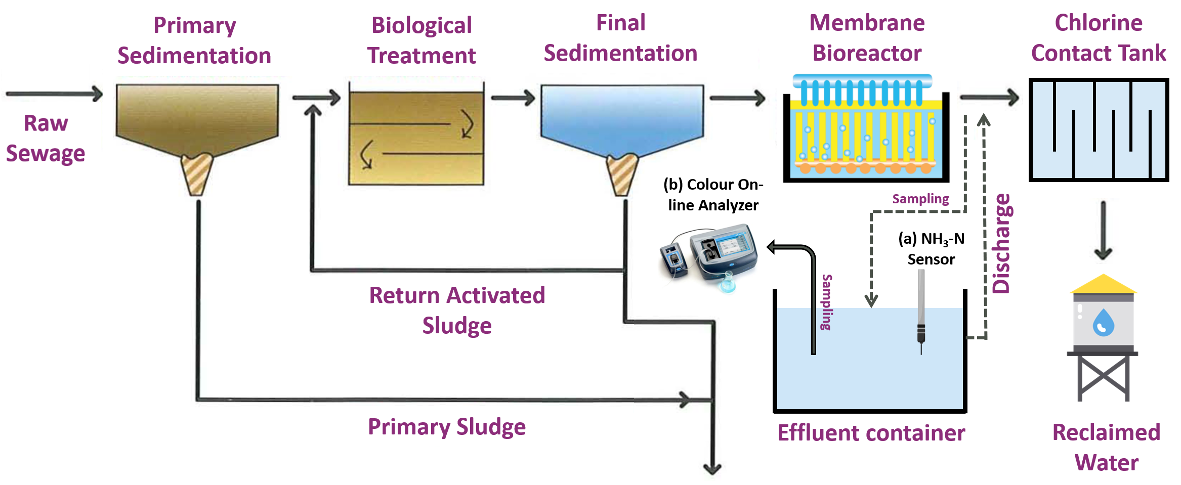

Sewage treatment process flowchart at SWHEPP (adapted from Drainage Services Department 2020)

## 3.2 Data collection and preparation

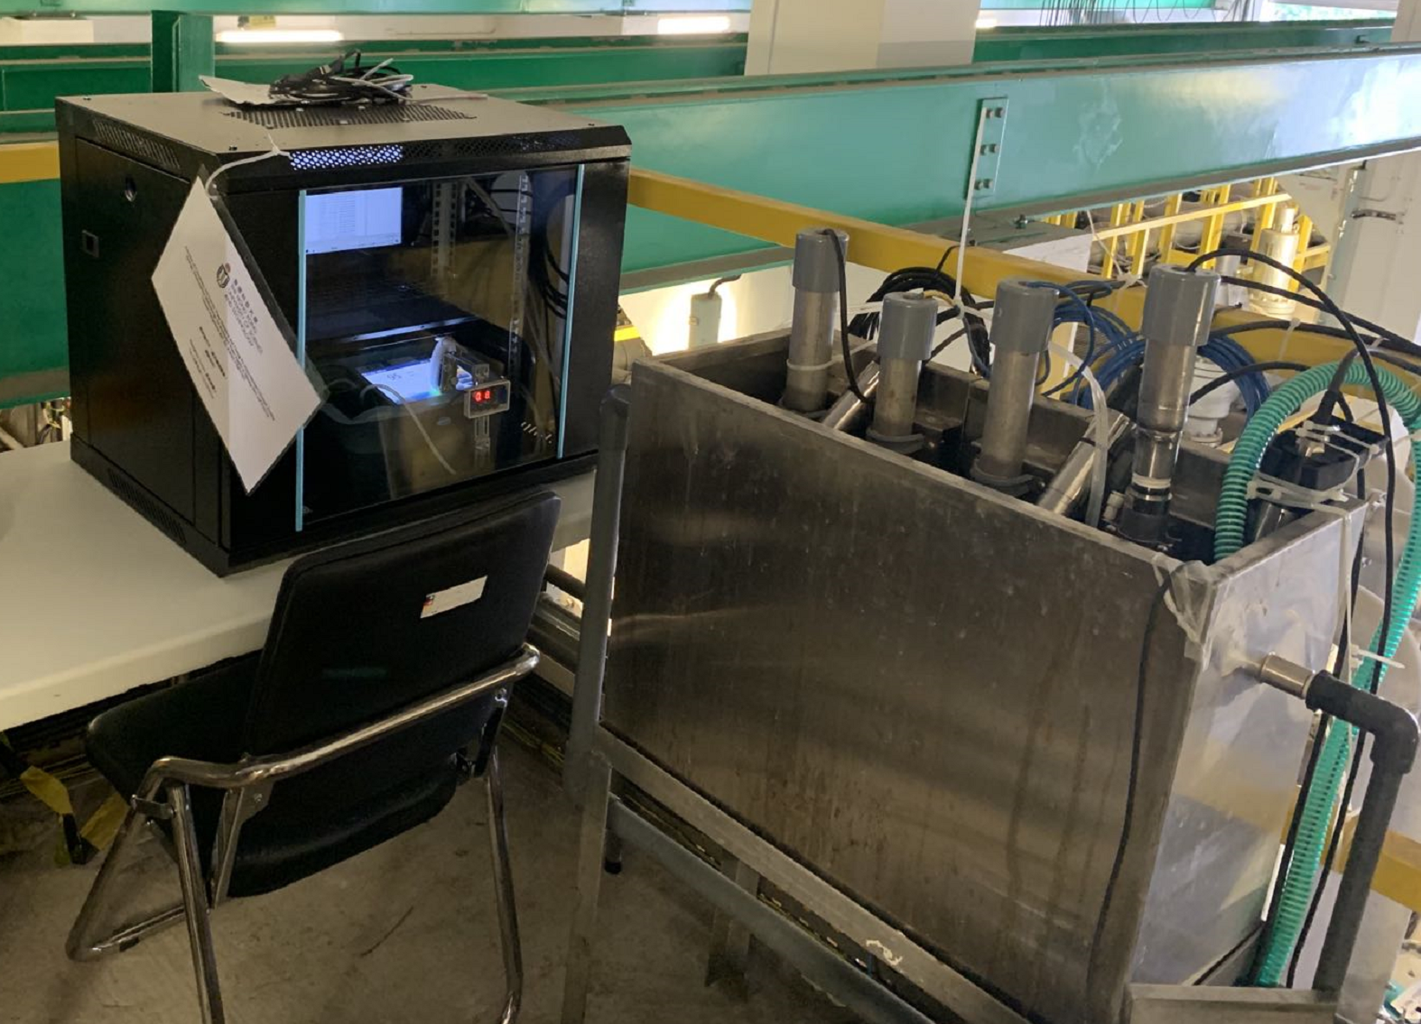

Colour levels and ammonia concentration are measure in the effluent container (i.e., on the right of the image.) A water pump transports MBR effluent to the effluent container continuously at real-time. The black vault on the left of the image contains a laptop and a colour spectrophotometer.

### 3.2.1 On-line data monitoring and collection

To enable us to perform on-line monitoring of ammonium concentration (NH $​_{3}$-N) in the MBR effluent, a Ammonium and Potassium Probe, AmmoLyt $​^{®}$ Plus 700 IQ (Xylem Company) is installed as in Fig. 3.3 in the effluent container, as shown in Fig. 3.2. The operation was commenced on 27 April 2021 and completed on 27 March 2022. The ion-selective electrode (ISE) probe provides continuous and reagentless monitoring of ammonium and potassium at the configured interval of one measurement per minute. Due to the ISE probe cannot differentiate the potentials difference cause by ammonium and potassium ions in the electrodes, the on-line monitoring of ammonium concentration requires the continuous calibration using potassium concentration.

The instrument records ammonium concentration as NH $​_{4}$-N mg/L, a form to express the sum of nitrogen found in reduced nitrogen (III) form. Ammonia has a reported pKa of 9.25 (National Center for Biotechnology Information, 2022), meaning ammonium is a primary species under the pH of 9.25 in water. In WWTPs, the pH in water normally ranges from pH of 7–8, making the NH $​_{4}$-N concentration the dominant species. Both ammonia and ammonium contain one nitrogen atom, 1 mg/L NH $​_{3}$-N is the same as 1 mg/L NH $​_{4}$-N. Thus, to prevent confusion, in the following paragraph the unit of NH $​_{4}$-N will be expressed by NH $​_{3}$-N, which is the unit used in the water quality standard. The collection of on-line ammonia data is achieved through downloading csv files from the website connected to the IQ Sensor Controller (Xylem Comapny), as shown in Fig. 3.4.

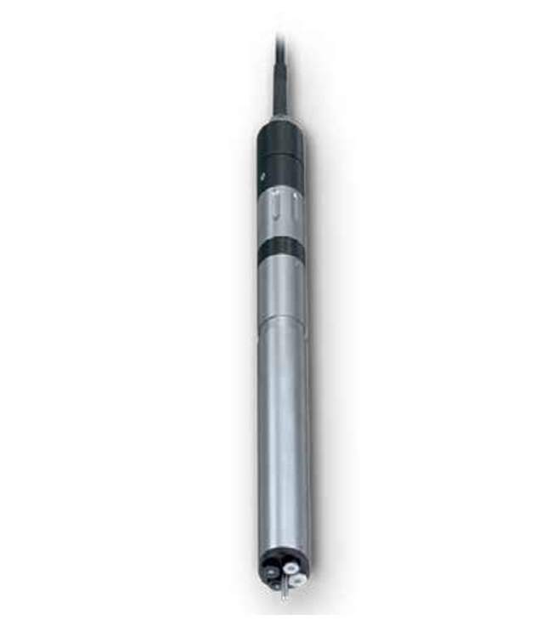

AmmoLyt $​^{®}$ Plus 700 IQ, Xylem.

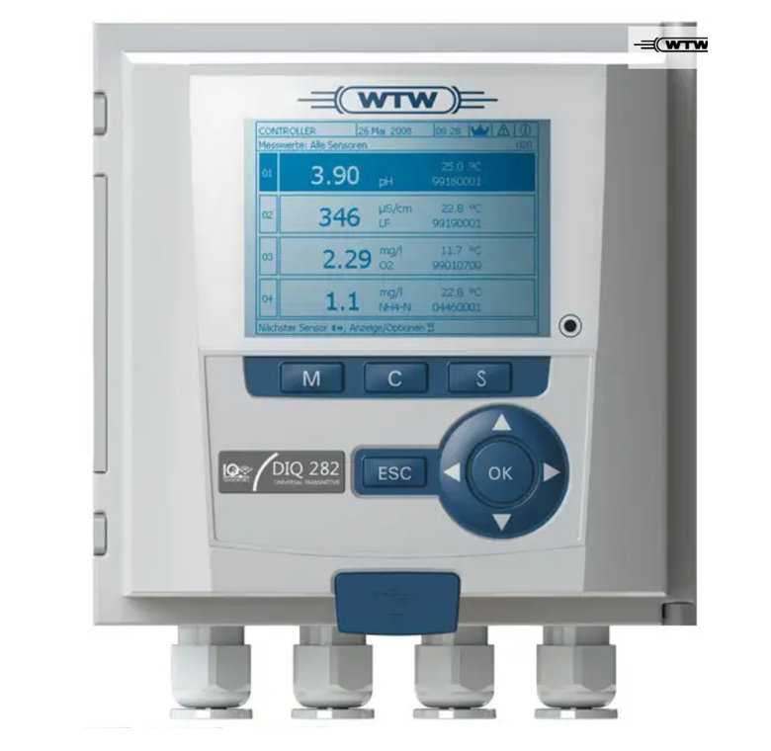

DIQ/S 284-EF controller, Xylem.

An hourly monitoring of the colour levels of MBR effluent was conducted from 5 October 2021 to 26 February 2022 by using a custom-made on-line colour analysis system. Originally, the spectrophotometer as Fig. 3.5 and a peristaltic pump as Fig. 3.6 can only initiate a single measurement of colour level by pressing the "READ" buttom on the DR3900 panel. To realize continuously sampling and analyzing colour level without human intervention, an actuator with programmable time function was mounted on the panel of DR3900, as shown in Fig. 3.7.

The automatic sampling and analzying of the colour level begins with the action of the actuator, by clicking on the "READ" button to initiate the colour analysis at a fixed interval of 30 minutes. 3 mL of sample was collected from the effluent container and delivered to the spectrophotometer cell. Then, the sample was subsequentially analysed by the spectrophotometer with the data transmitted to an automatic data acquisition and storage software pre-installed in the laptop. The DR3900 device is connected to a laptop, which receives the real-time data and stores on a data management software from Hach company. To access the real-time data from the laptop, Google Remote Desktop is used to operate the laptop via Internet cloud services using any devices having access to the Internet. The entire process is illustrated in Fig. 3.8. After the measurement, the sample will be discharged to the effluent container and the online colour monitoring system is left idle until the next measurement.

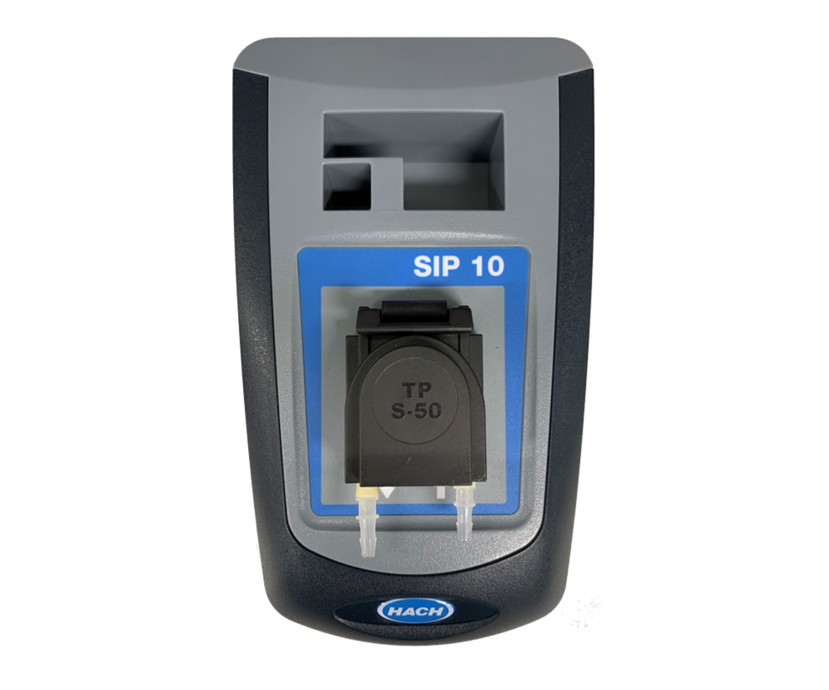

SIP10 peristaltic pump, Hach

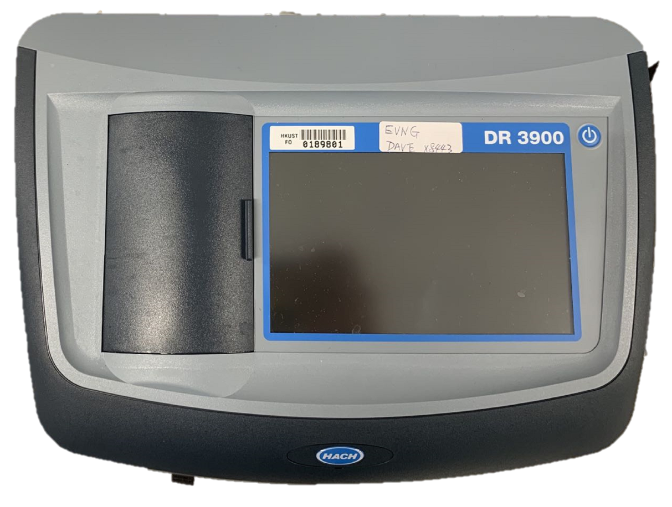

DR3900 spectrophotometer, Hach

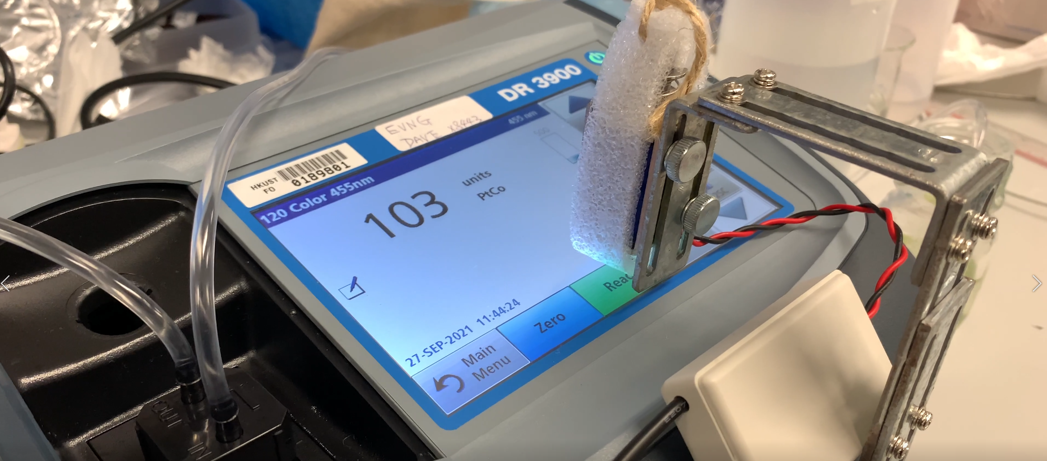

Customized clicker/actuator

The maintenance and calibration of the DR3900 spectrophotometer is performed on a weekly basis. During the maintenance, the DR3900 device was shut off, and chlorine solution at the concentration of 100 mg/L was pumped into the sampling tubes and the plastic cuvette for disinfection and cleansing. The cleanse of the tubes and cuvette were manually inspected with eyes to make sure no foreign objects were stuck inside. De-ionized water was brought to the site to perform the spectrophotometer calibration after the reboot of DR3900.

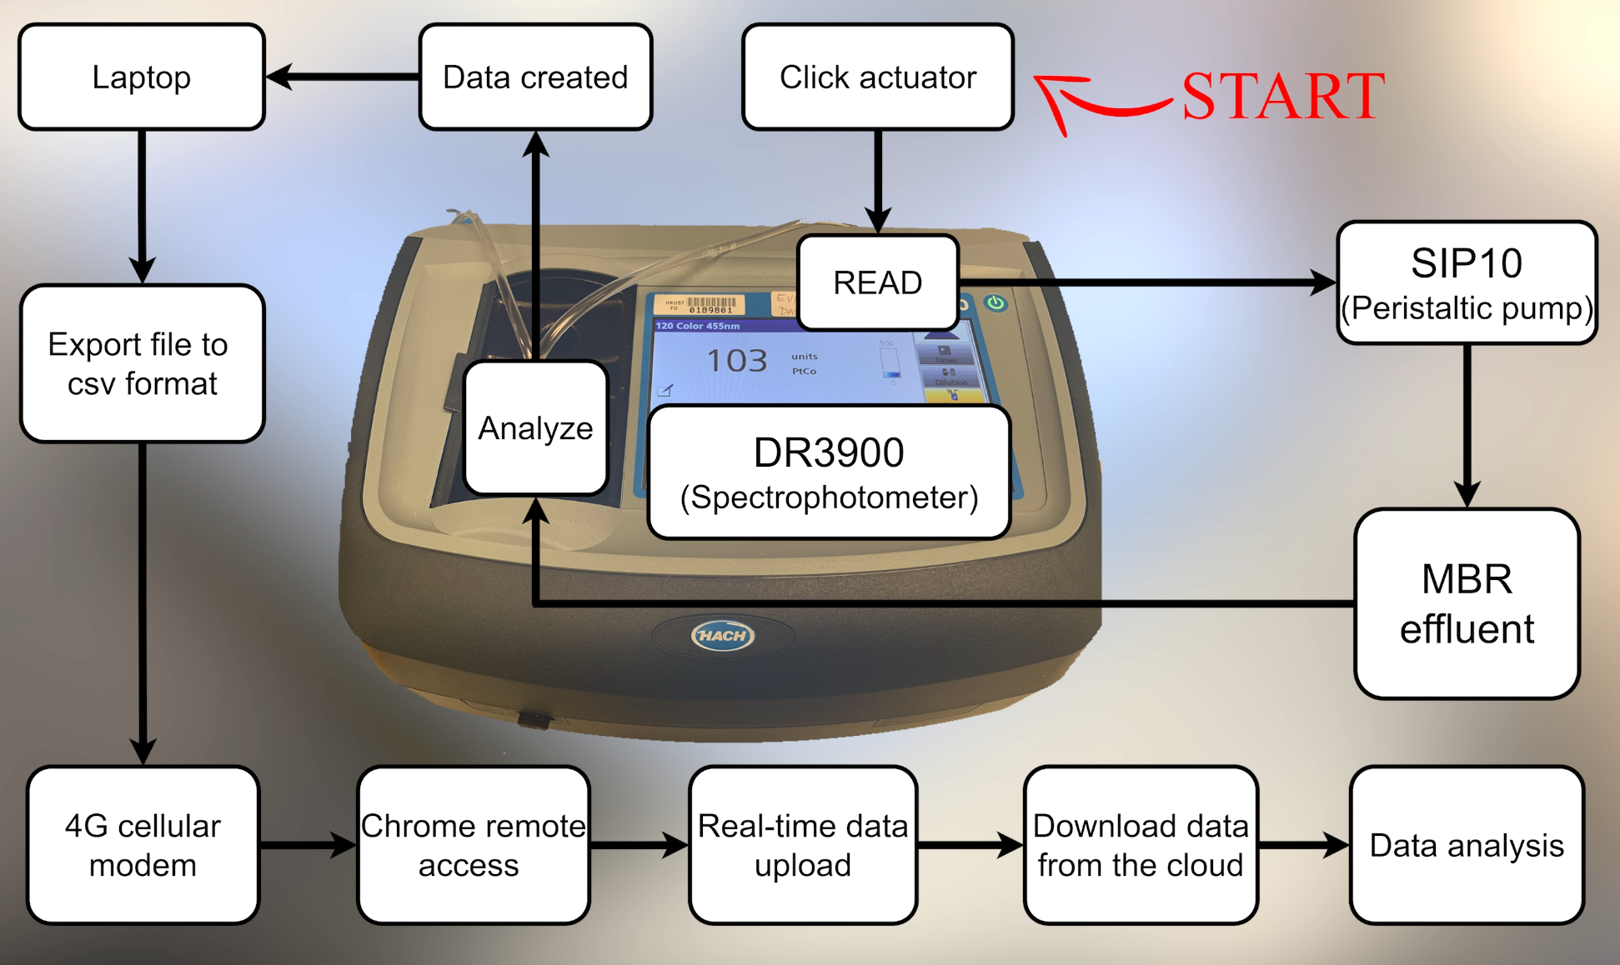

Schematic diagram of the custom-made on-line colour anlaysis system.

Based on the proposed model training methods, which ammonia and colour data are used as the second features of training colour and ammonia forecasting models, the size and time of the ammonia and colour datasets should be the same. In addition, abnormal data caused by sensor downtime should also be excluded. Thus, we chose the ammonia and colour data from 23 December 2021 to 22 January, as shown in Fig. 3.9.

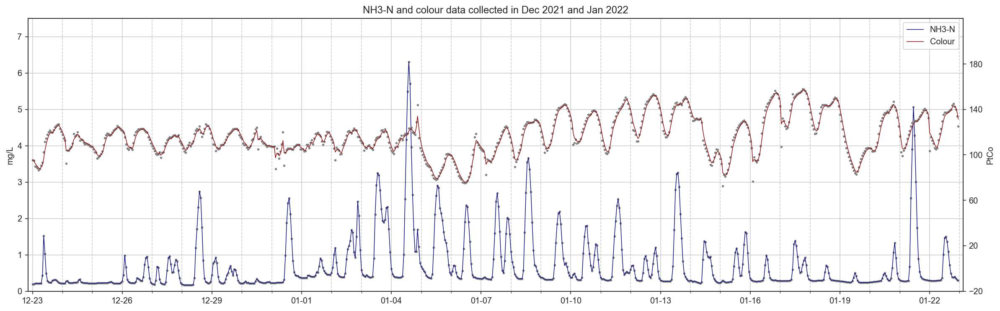

Ammonia and colour data collected from 23 December 2021 to 22 January 2022.

### 3.2.2 Loss function for model evaluation

Loss functions are used to determine the error between the model outputs (i.e., prediction or forecasting values) and the given target value (DeepAI, 2022). The bigger the difference between the ground truth $y$ and the model outputs $\hat{y}$, the higher the value of the loss function is, meaning the model perfomred poorer. A low value for the loss means the modle perfomred well. The selection of the types of the loss function is essential for training the model to perform specific tasks. In this study, Mean Squared Error (MSE) is used for evaluating the regression models. The values of MSE will never be negative, and is formally defined by the following equation:

$$MSE=\frac{∑(y_{i}-\hat{y_{i}})^{2}}{n}$$

### 3.2.3 Data cleaning and pre-processing

In this study, ammonia concentration and colour level forecasting models will be trained, and the model training steps are shown in Fig. 3.10. The training processes are split into two sections, one is the baseline model training steps, the other is proposed model training steps. The training steps of the first section used cleaned data to train forecasting models and generated baseline model performance, which will be further compared with the model perfromance generated from the second section. The second section includes using pre-processed datasets (i.e., data smoothing) and feature engineering enhanced datasets to train the forecasting model. In machine learning, the data used for training models is refered to model inputs, features and variables.

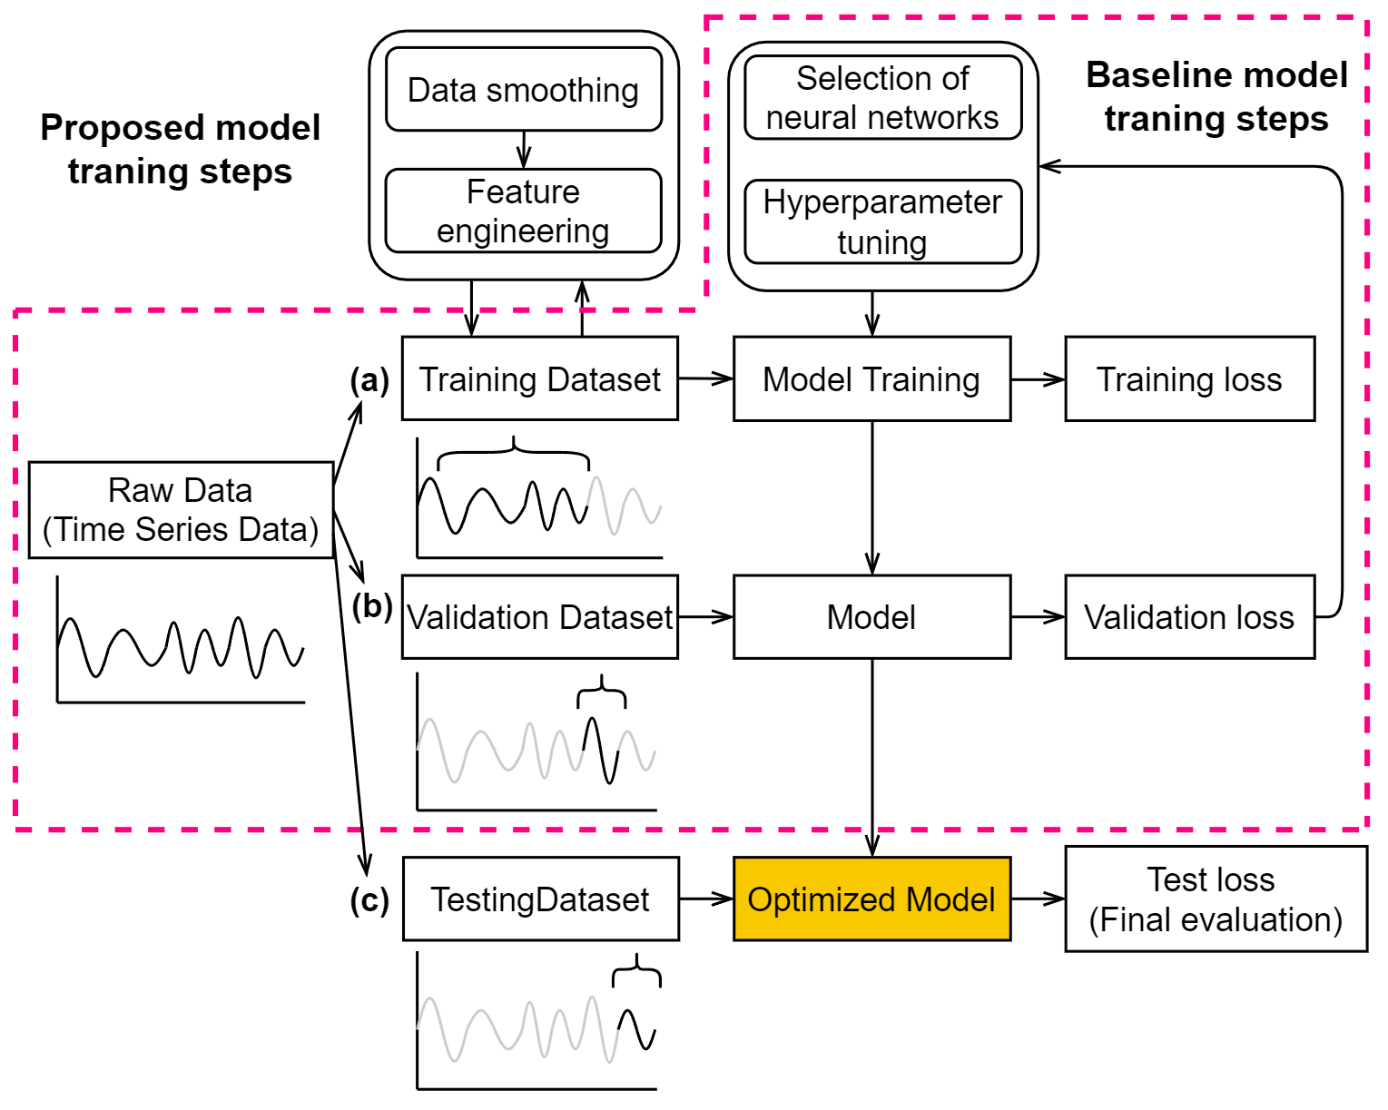

Machine learning model training steps.

The raw data embedded in the original csv files exists many issues, such as missing values, having extreme low or high values, and unreadable texts, etc. Thus, the data cleaning and pre-processing are necessary for more effective process of model training. Python programming language and related modules of Numpy and Pandas were used to clean and pre-process the raw dataset for further usage. The ammonia raw dataset contained 44,640 samples (data points) with 8 variables, giving a matrix size of 44,640 x 8, and the samples were collected in time series at 1 minute interval. The colour level raw dataset contained 1488 samples with 34 variables, giving a matrix size of 1488 x 34, and the samples were collected in time series at 30 minute interval.

Before the high-resolution data from colour and ammonia datasets were compressed into time series data at 1 hour interval via averaging, extreme values were manually removed. For ammonia dataset, we replaced the values higher than 7.0 mg/L with NaN (i.e., Not a number), and futher use interpolation to fill up the NaN along with the missing values in the dataset. For colour dataset, we manually took out the relatively low data points on the days when the maintenance and calibration tasks were performed; extremely values higher than 300 Hazen Unit were also replaced by NaN. Same as the data cleaning method used for ammonia dataset, the missing values and NaN were filled up via interpolation.

#### 3.2.3.1 Data smoothing with Savitzky-Golay and EWMA filter

Data smoothing was performed on both ammonia and colour datasets using the same method. One of the effective ways to remove the noise from the dataset is to apply data smoothing filters. Two filteres were applied in this study, Savitzky-Golay (SG) and Exponentially Weighted Moving Average (EWMA) filters.

A SG filter is a digital filter that can be applied to a set of digital data points for the purpose of smoothing the data without distorting the data tendency. This is achieved via convolution, by fitting successive sub-sets of adjacent data points with a low-degree polynomial by the method of linear least squares (Wikipedia, 2022a). The illustration is shown in Fig. 3.11 and the procedures of how data points are smoothed is presented in the following steps:

Extract short-time window (i.e., blue dots in Fig.3.11)

Determine polynomial degree (e.g., different polynomial degree is compared in Fig. 3.11).

Find the smoothed data point (i.e., at center of the window).

Repeat for shifted window (e.g., similar to moving average).

The equation to decribed the smoothed value of $Y_{j}$ can be expressed in Eq. [sg-eq]:

$$Y_{j}=(C⊗y)_{j}=\sum_{i=\frac{1-m}{2}}^{\frac{m-1}{2}}{C_{i}}y_{j+i}, \frac{m+1}{2}≤j≤n-\frac{m-1}{2}$$

where $Y_{j}$ corresponds to the $j^{th}$ smoothed data point, $m$ to the window size (i.e., numer of data points intended to smooth out) and $C_{i}$ to the convolution coefficients (i.e., determined by Savitzky and Golay (1964)).

Exponentially weighted moving average (EWMA), also known as auto-regressive (AR) filtering, is a technique that filters measurements. An EWMA filter smoothes a measured data point by exponentially averaging that particular point with all previous measurements. The EWMA equation can be expressed in Eq. [ewma-eq]:

$$\begin{matrix} & α=\frac{2}{span+1} \\ & y_{0}=x_{0} \\ & y_{t}=(1-α)y_{t-1}+αx_{t}\end{matrix}$$

where $α$ corresponds to the decay paratmeter, $x_{t}$ to the value at a time period, $y_{t}$ to the value of the EWMA at any time period t, span to the window size.

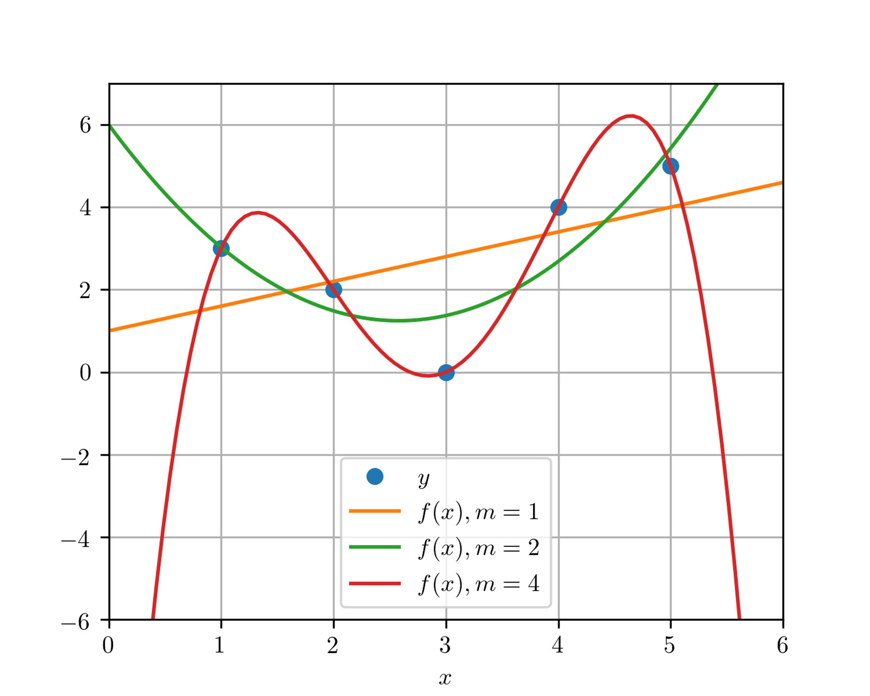

SG filter with different polynomial degree (Taal, 2017).

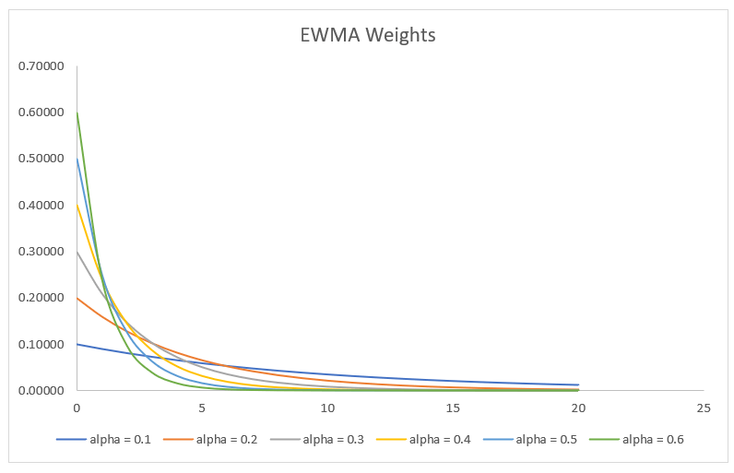

Examples of weights with exponential decay at varied alpha values (CFI, 2022).

Both SG and EWMA filters are required to select the hyperparamters, the selected values are presented in Table. [tab:filter-hyperparameters].

lcc Group Name & Window size & Polynomial degree  
SG-5 & 5 & 2  
SG-7 & 7 & 2  
SG-9 & 9 & 2  
EWMA-2 & 2 & -  
EWMA-3 & 3 & -  
EWMA-4 & 4 & -

Fig. [fig:smoothed] shows the influences of different windows sizes on SG filters as in Fig. 3.13 and on EWMA filters as in Fig. [smoothed-ew].

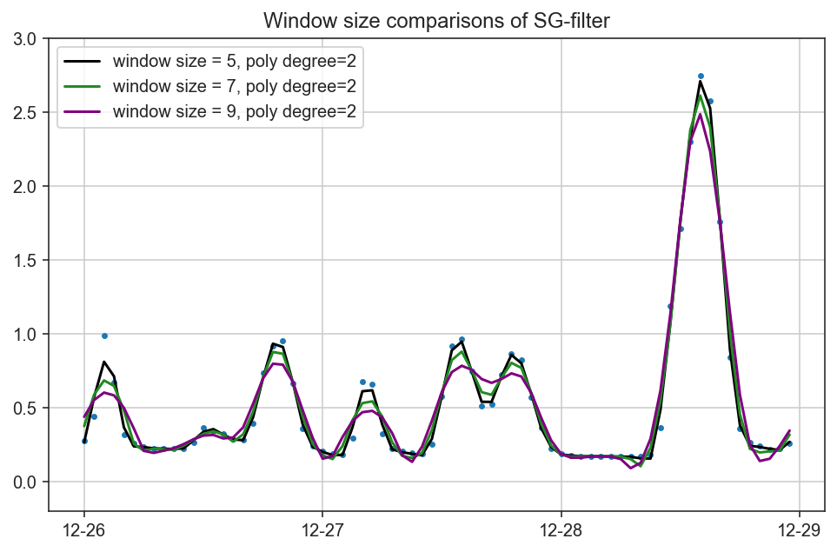

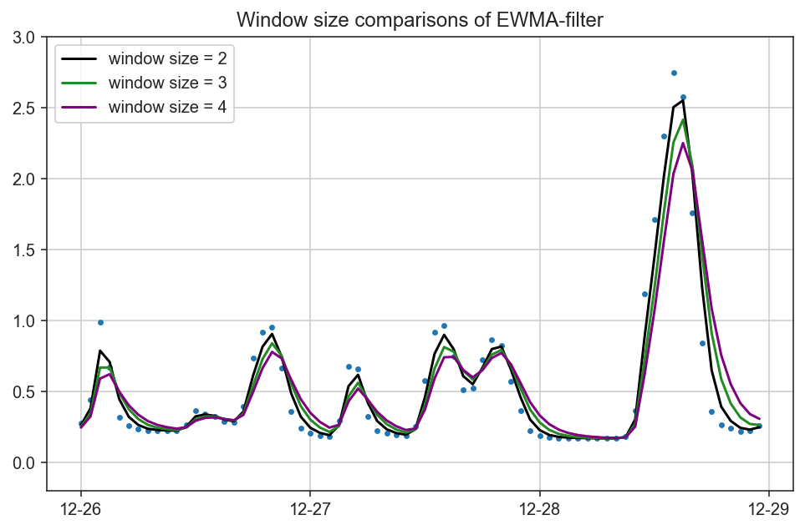

#### 3.2.3.2 Outlier Removal

Despite the extreme values in the ammonia raw dataset were removed based on simple conditions (i.e., concentration higher than 7.0 mg/L), the ammonia sensor can still capture unideal data points collectively. In the outlier removal process, we intended to identify the collective faults of ammonia data in the unit of an entire day. To determine whether the ammonia data on a specific day shows collective fault, two abnormal conditions are defined:

NH $​_{3}$-N fluctuation $≤$ 0.1 (i.e., lower than the sensor resolution).

No diurnal fluctuation (i.e., Fluctuation = peak value – bottom line value).

To automiatically realize the identification of noraml or abnormal signals, peak analysis was performed on the daily ammonia data. The analysis takes a one-dimension array (i.e., the data form of ammonia in a day) and finds all local maximum values by simple comparison of neighboring values. This function will also provide information such as width and prominence, as in Fig. 3.15 to help us identify whether the diurnal fluctuation is existed.

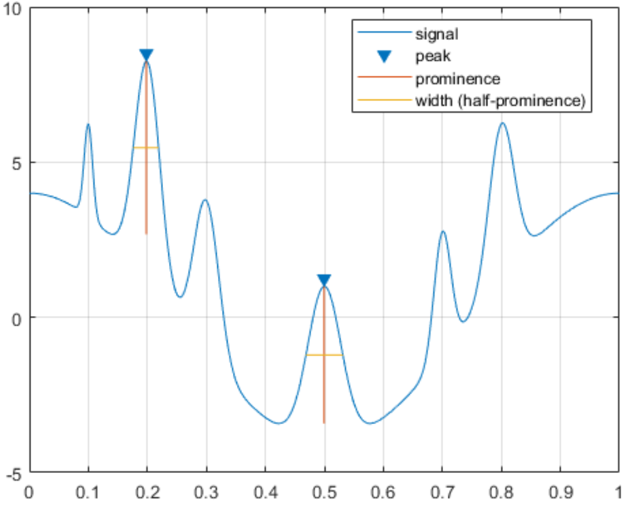

Illustration of peak analysis. Four important elements are automatic caculated by the function (MathWorks, 2022c).

#### 3.2.3.3 Feature Engineering

To create addition features from the raw datasets, we have carefully observed and analyzed the SWHEPP influent. We discovered that the SWHEPP influent is consisted of treated landfill effluent from NENT landfill leachate site and municipal wastewater, as shown in Fig. 3.16. We observed that with higher blending ratio, which is calculated from the daily volume of treated leachate effluent divided by the daily inflow volume of SHWEPP, the colour level is also higher, as shown in Fig 3.19. With the the Pearson coefficient of 0.68, the increased volume of treated leachate effluent in public sewege system is proportional to the increase of the colour levels in the SHWEPP influent, while the ammonia concentration is mostly from the municipal wastewater. During the mixing of both type of the wastewater as in Fig. 3.17, pollutants contribute to colour levels will be diluted by the municipal wastewater, same as the opposite for the dilution of the ammonia concentration. In Fig. 3.20, we can observe the time when the lowest colour level of the day occured is close to when the highest of ammonia concentration was observed. The changes of colour levels and ammonia concentration are interative, thus, in feature engineering, colour level data was selected for training ammonia forecasting model; ammonia data was selected for training colour forecasting model, as shown in Fig. 3.25.

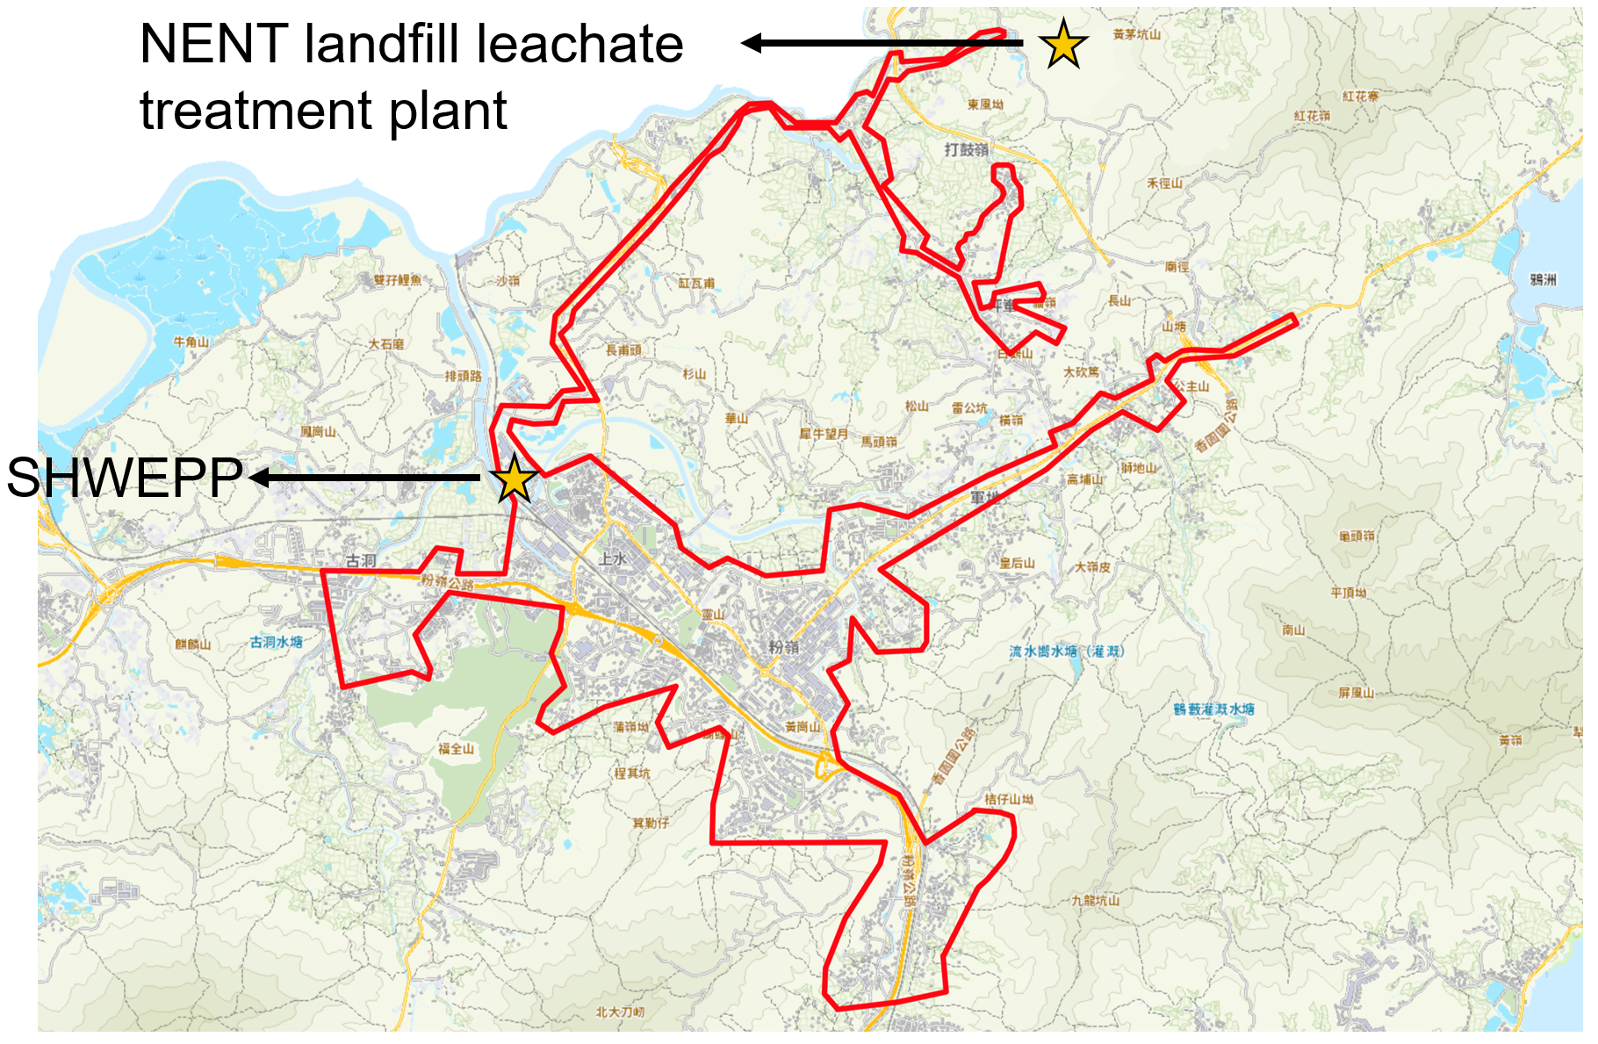

Sewer system coverage of SHWEPP. The covered areas (i.e., area circled in red boundary) include Fanling/Sheung-Shui new towns and NENT landfill leachate treament plant.

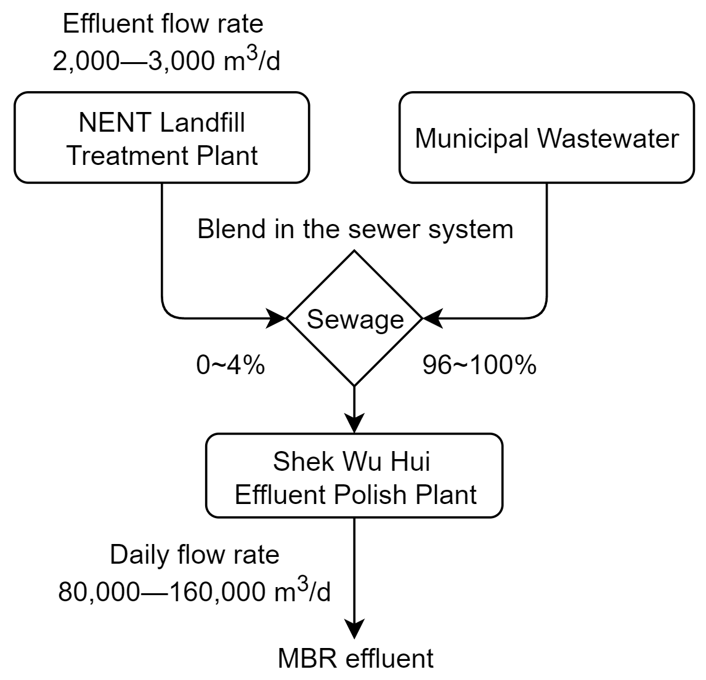

Flowchart showing the blending of treated leachate effluent with municipal wastewater.

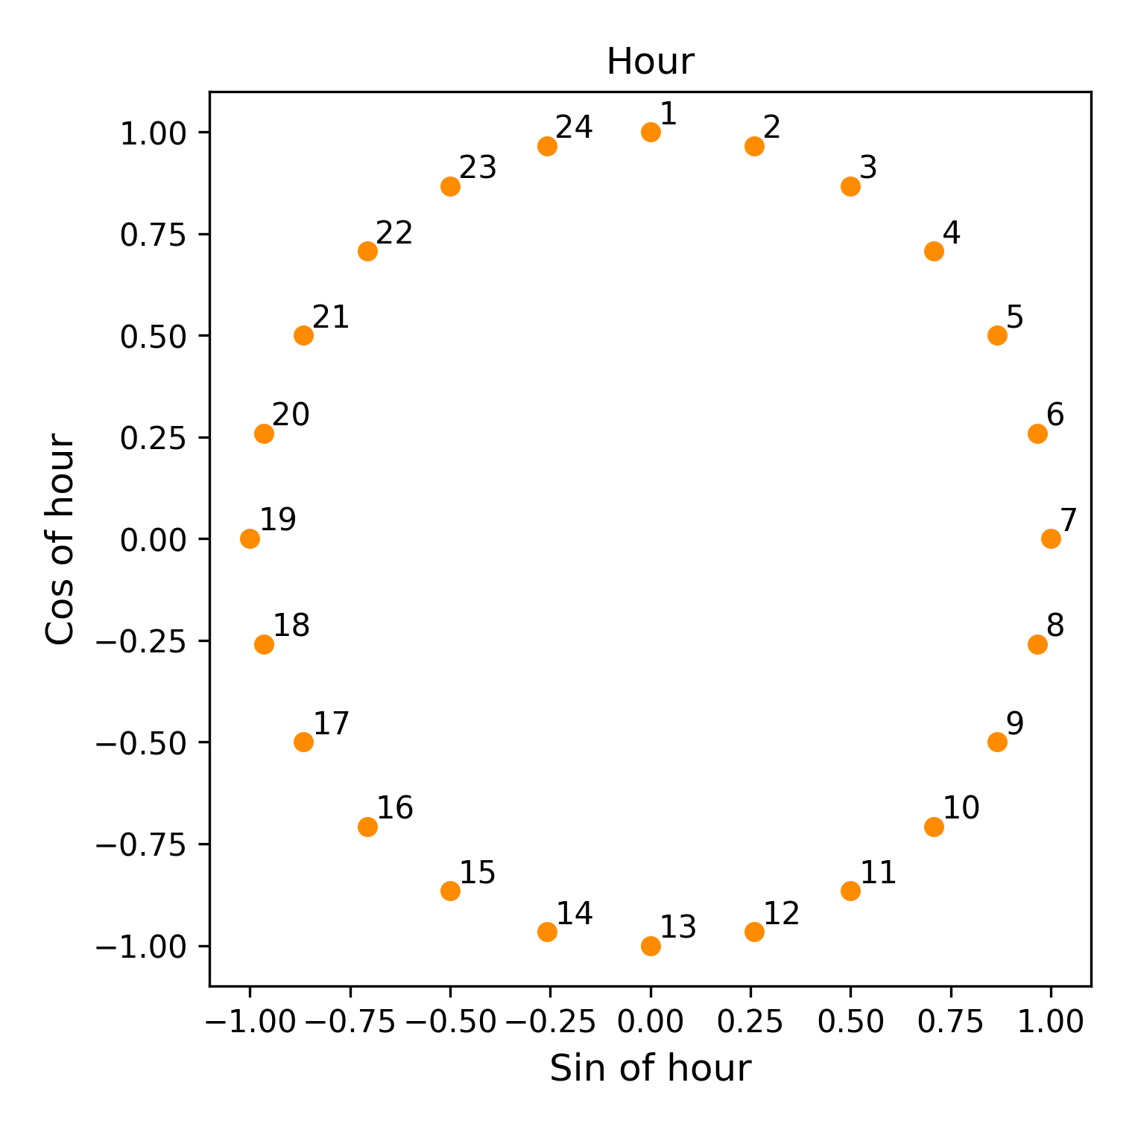

Positional encoding of hour components.

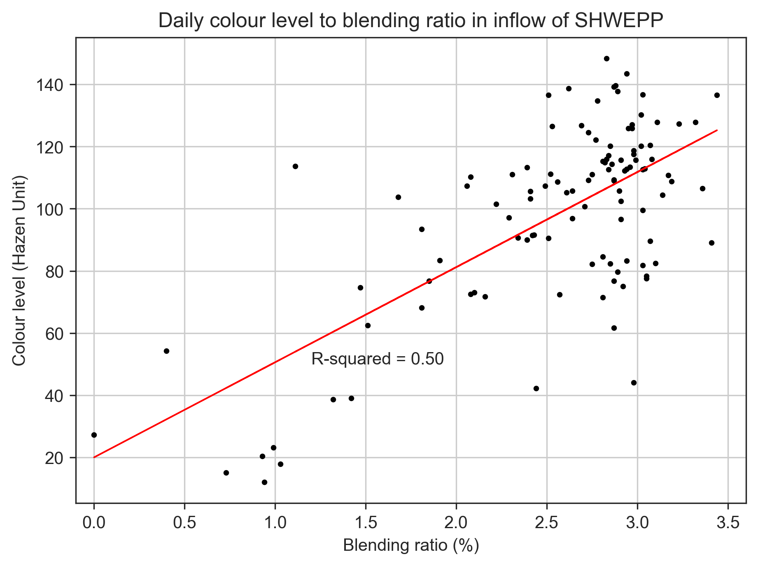

Coefficienct between blending ratio and colour levles.

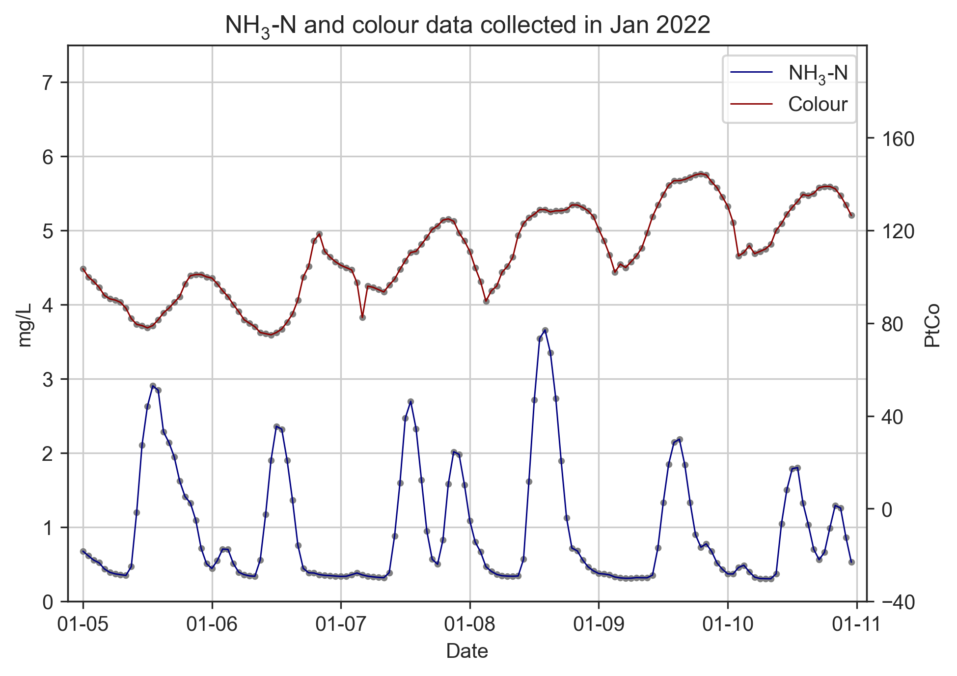

Trend comparison of ammonia concentration and colour levels.

The new features are inspired from the research work of Abu-Bakar et al. (2021). The author pointed out the four types of hourly household water consumption patterns as in Fig. 3.21, which correlates the specific time of the day to the volume of the water consumed in households. In other words, as fresh water is consumed, wastewater is generated at the same time, the wastewater then enters the public sewage system and result in the increase of ammonia concentration. As shown in Fig. 3.22, the peak analysis tool helped us to identify the peak hour of the ammonia concentration, which occured at around 13:00 to 14:00 o’clock at noon, and 20:00 to 21:00 o’clock at evening. Thus, it is convinced that time features will be able to help the machine learning models to better correlate and predict the change of ammonia concentration in the wastewater.

Time feature is realized through a technique called positional encoding (POS). The positioanl encoded feature was achieved as the following steps:

The timestamp are represented as three elements—hour, day and month.

Each element will bed decomposed into sine and cosine components.

Last step is applied to hours and days to make all elements represented cyclically.

Due to the size of the datasets used in this study for training ammonia and colour forecasting model is 31 days, only hour element was transformed into sine and cosine components as in Fig. 3.18.

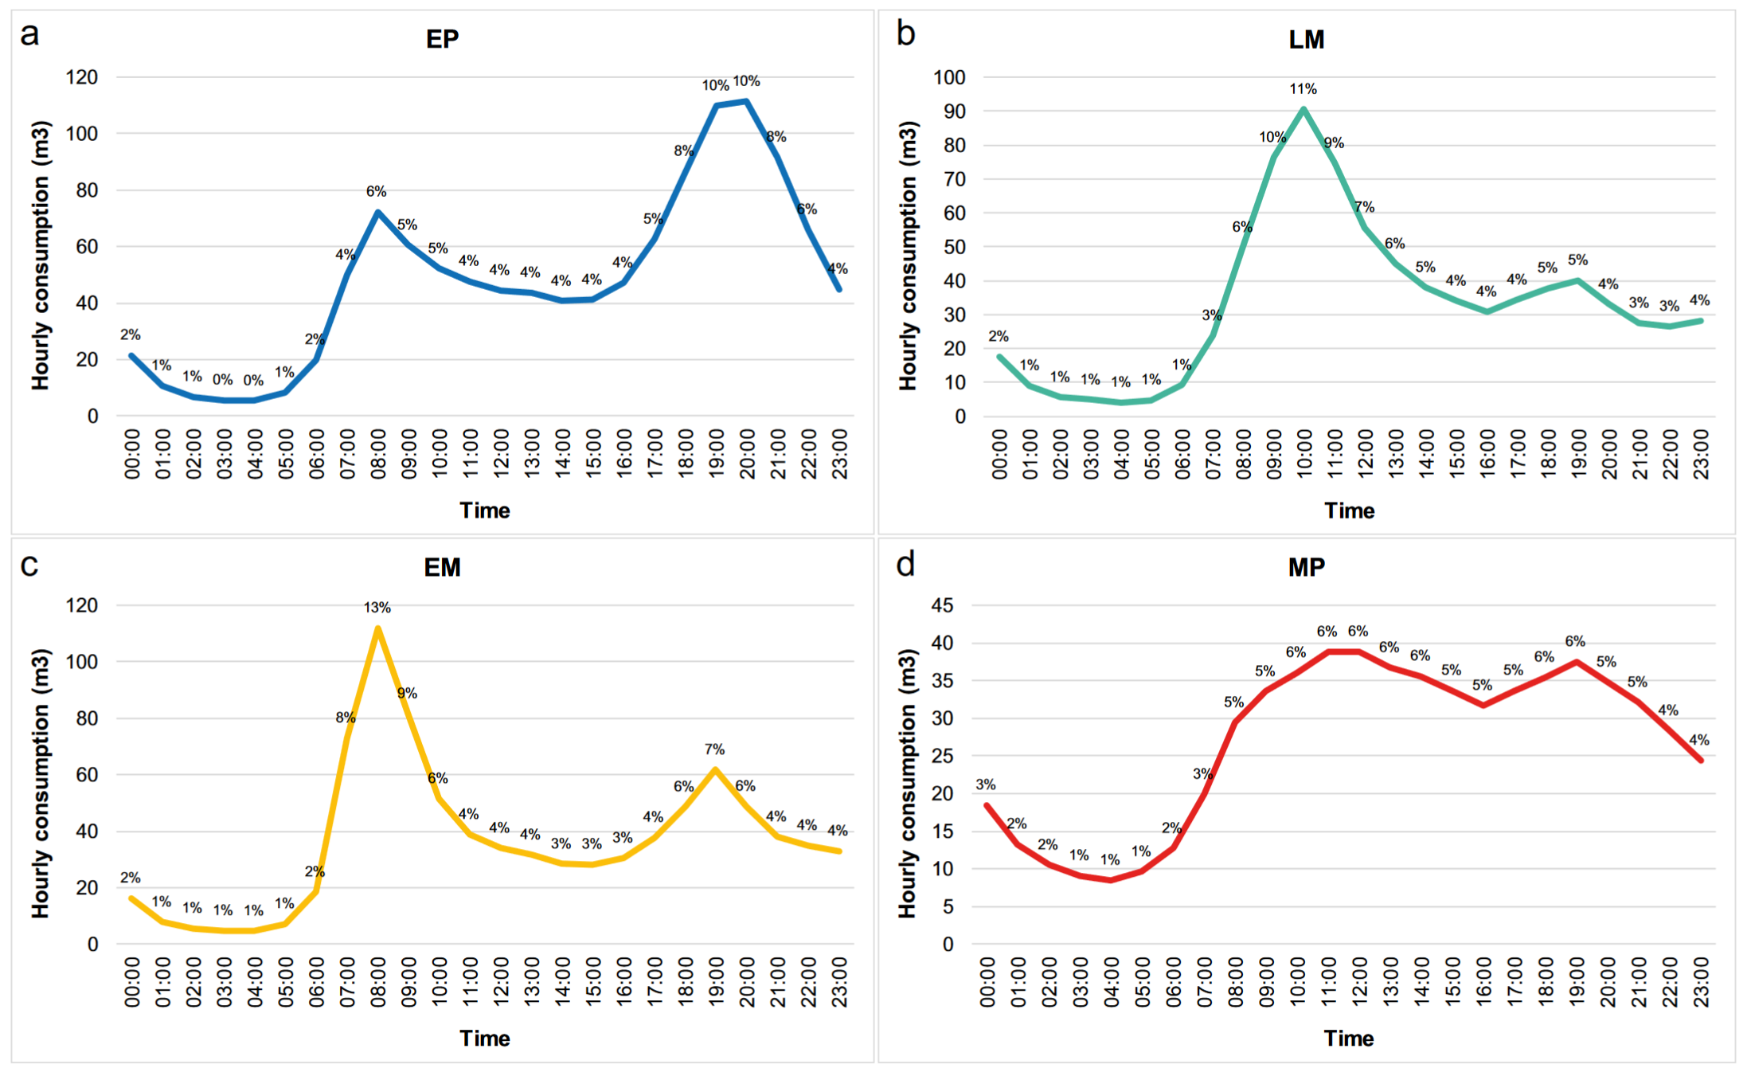

Hourly water consumption patterns in households (Abu-Bakar et al., 2021). (a) Cumulative pattern and percentage of hourly consumption for households in the “Evening Peak (EP)” cluster (b) Cumulative pattern and percentage of hourly consumption for households in the “Late Morning Peak Peak (LM)” cluster. (c) Cumulative pattern and percentage of hourly consumption for households in the “Early Morning Peak (EM)” cluster. (d) Cummulative pattern and percentage of hourly consumption for households in the “Multiple Peak (MP)” cluster. Consumption is in (m3).

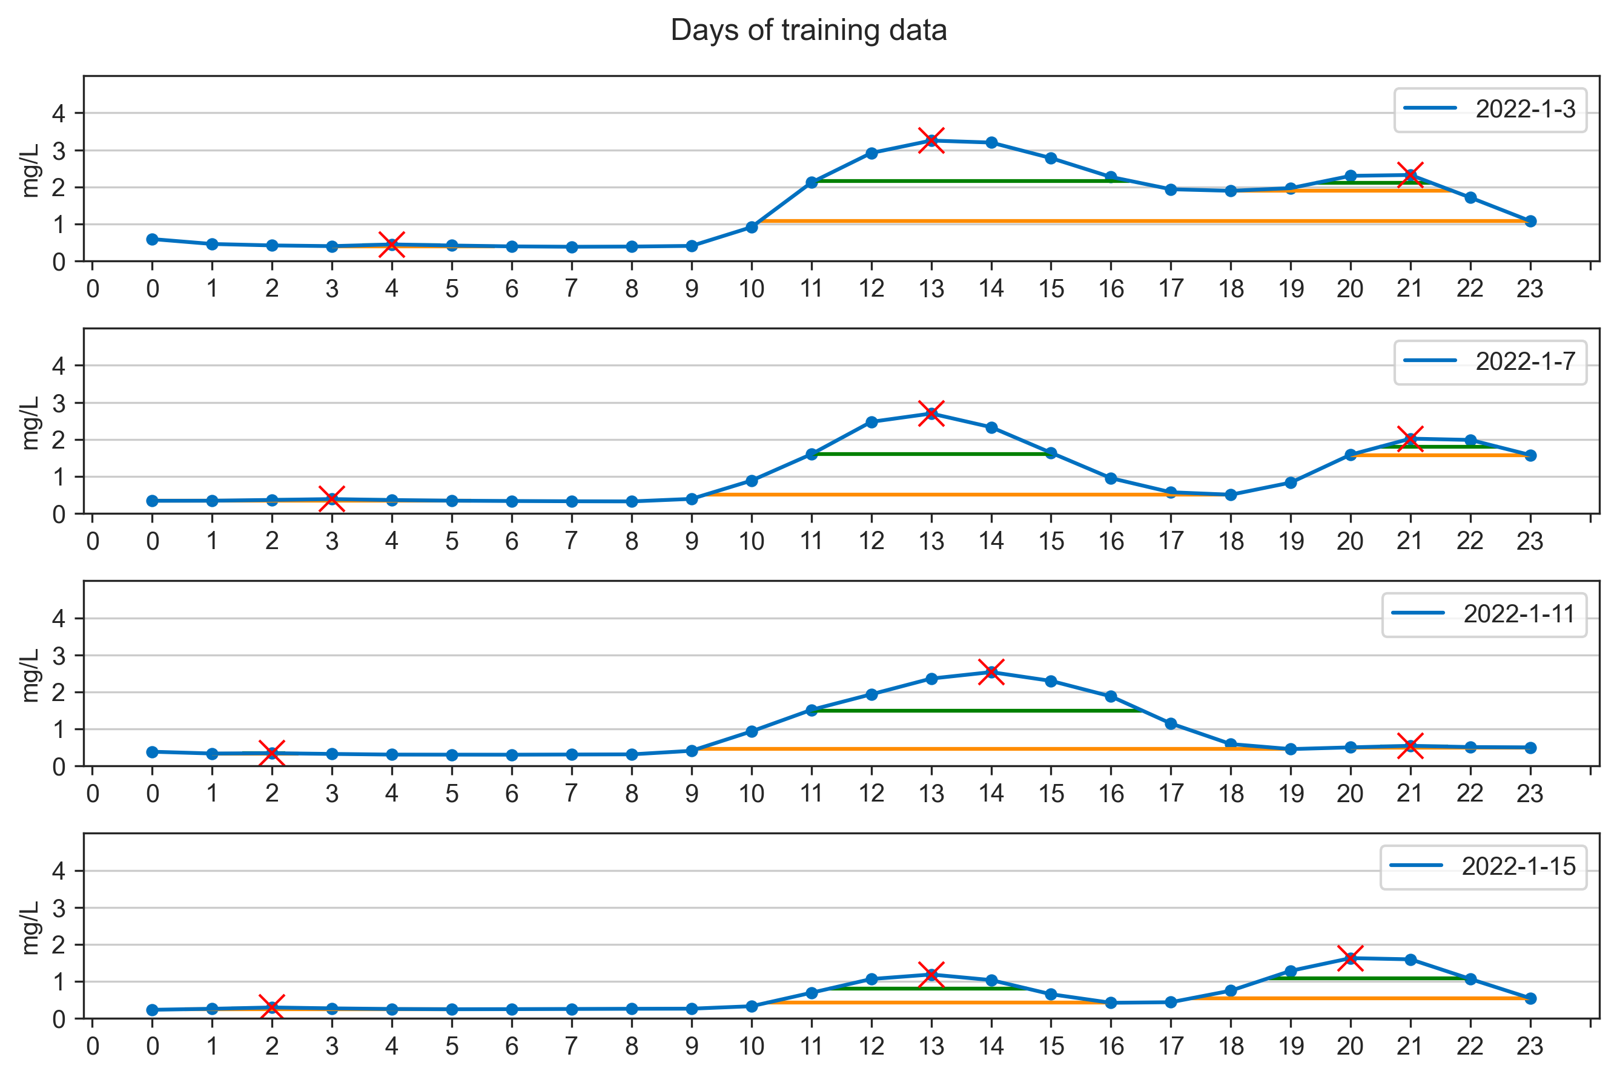

The daily patterns of ammonia concentration on 3, 7, 11, 15 Janurary 2022.

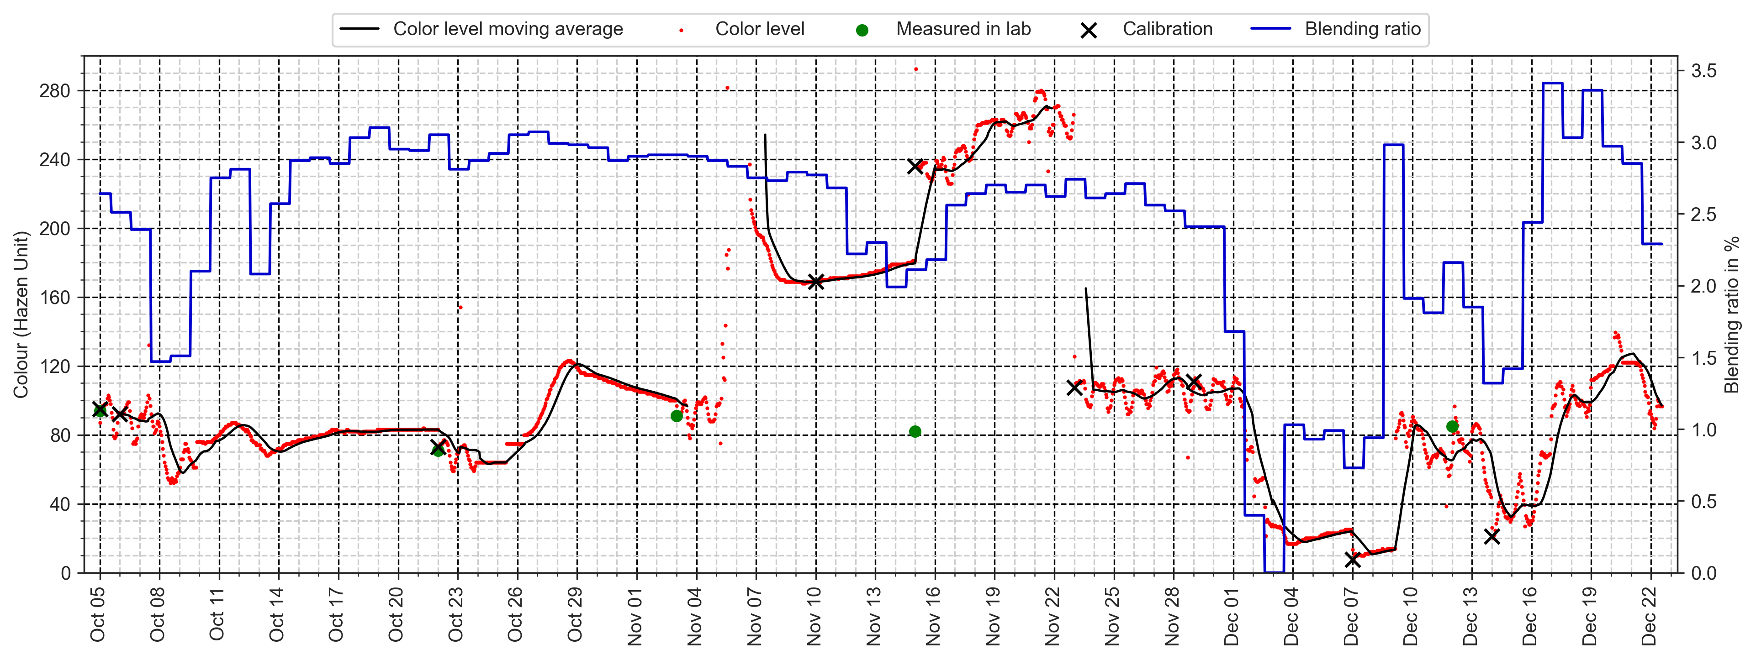

Data collected from 5 October 2021 to 22 December 2021.

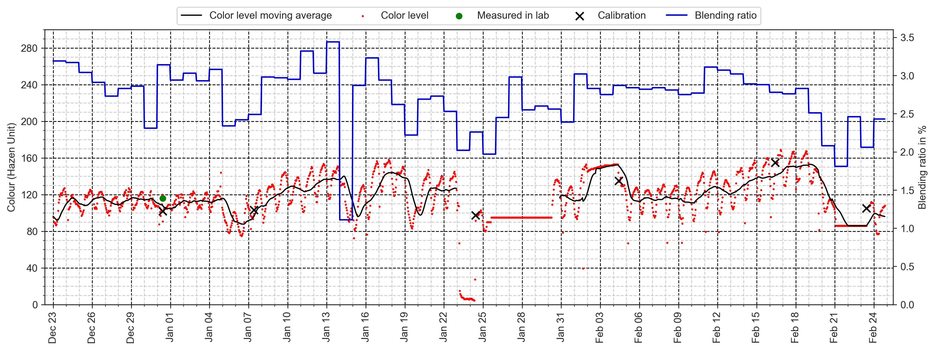

Data collected from 23 December 2021 to 24 February 2022.

### 3.2.4 Data transformation

Before the pre-processed data is fed into the models for training, we need to split the data into three clusters, which are training (60%), validation (20%), and testing dataset (20%). Among each training dataset, the data will be further split into input variables $X$ and output variable $Y$ (i.e., training X/training Y, testing X/testing Y). During the training process, machine learning algorithms will learn a target function $f$ to best map $X$ to $Y$.

A taining dataset is a set of examples (e.g., historical data) for models to learn the hidden trends and information in the data, shown in (a) in Fig. 3.10, and the training loss is calculated by taking the sum of loss for each example in the training dataset after each epoch. Since it is impossible to have the optimized hyperparameters in the first try of the training, a validation dataset as in (b) in Fig. 3.10 is used to assess the model performance until we obtain the optimzed settings. The validation loss plays an important role during the model training, the adjustments of the hyperparameters will directly reflect on the change of the validation loss, the lower the values, the better the model performance is. As the optimzed model is obtained, testing dataset is used to evaluate the performance of the forecasting model, as shown in (c) in Fig. 3.10. To the forecasting Models, testing dataset has never been seen by the models. If the model tuning process was performed on the testing dataset, the model performance would be a biased result since the hyperparameters are revised in favor to the evalution of the testing dataset.

In Fig. 3.10, the hyperparameters will remained the same once the optimzed values are found, thus generating a baseline model perfromance of a specific machine learning model. The baseline results will be further compared with the results from the model trained by the proposed model trianing steps, which include datasets that have been performed data smoothing and feature engineering techniques.

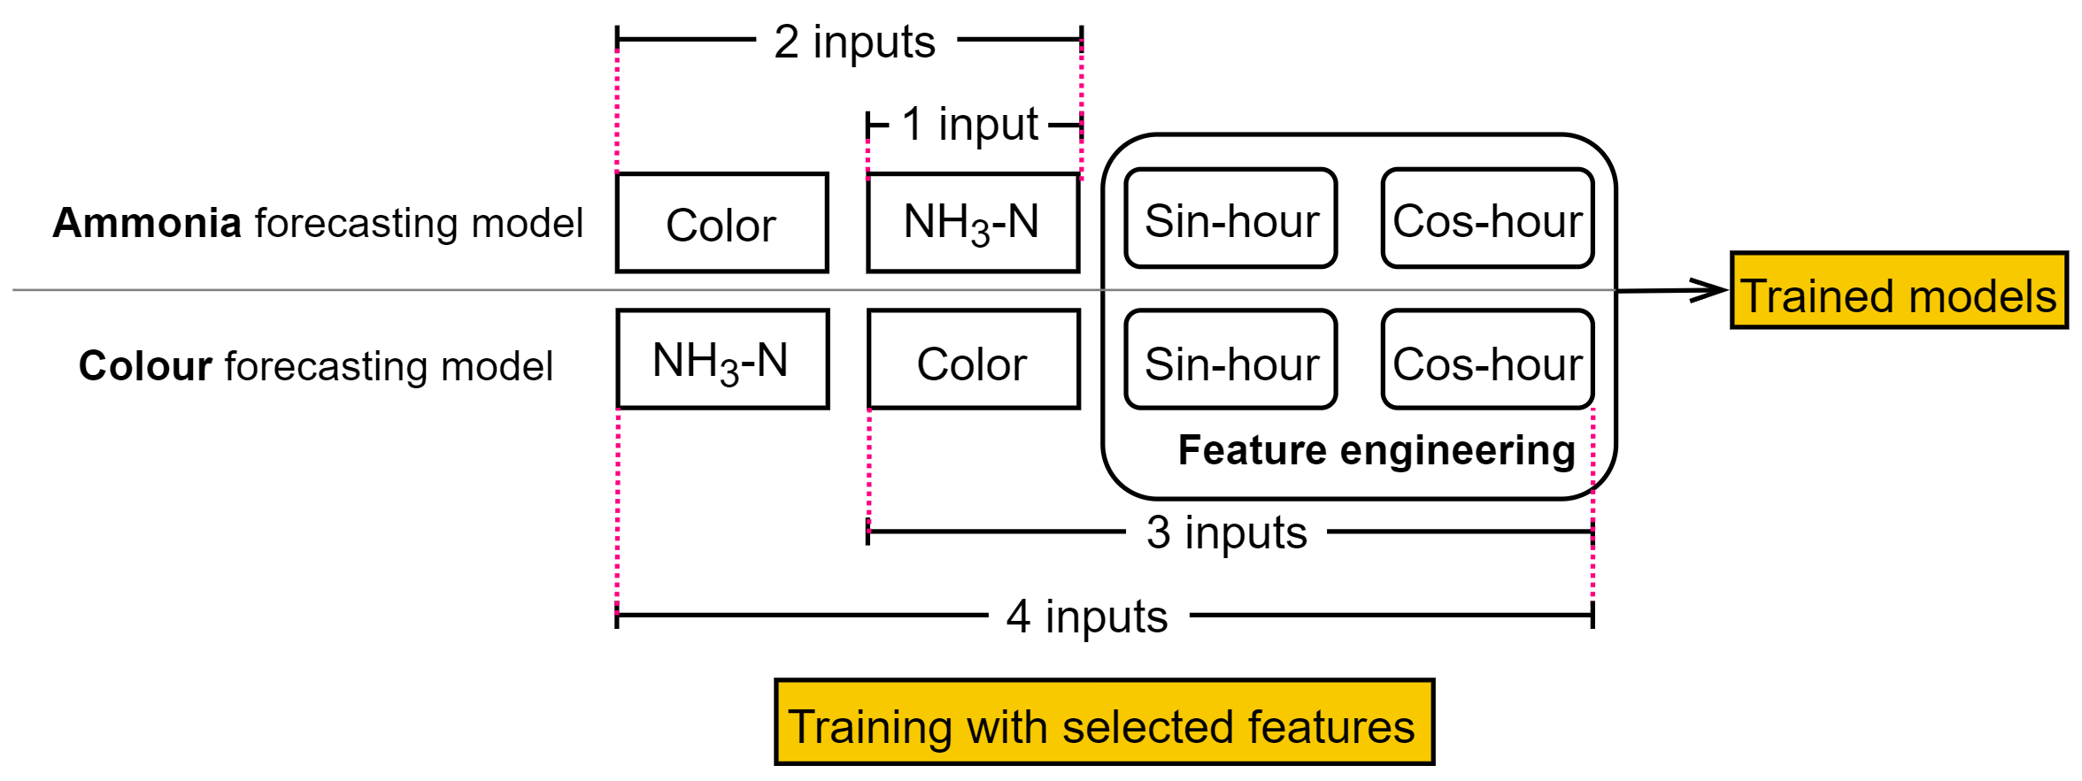

Illustration of feature selections for model training.

### 3.2.5 Feature selection

Fig. 3.25 illustrates which features are selected during the model training processes. In baseline model trianing steps, for both ammonia and colour forecasting model, only one feature is used for training for each model, which is ammonia and colour data, respectively. The model trained by a single feature, followed the baseline model training steps, will generate baseline models. The results from the final evaluation will be defined as the baseline model performance, which will be compared with the model evaluated results from proposed model training steps. Once the baseline model performance is obtained, more features will be input to the model training processes in the order of 2 inputs, 3 inputs, and 4 inputs.

## 3.3 Machine learning models

### 3.3.1 Random Forest

The machine learning model used in this study (i.e., not deep learning models) is random forest (RF). It is an ensemble method which the final output is obtained by averaging the results from multiple tree learners (Wang et al., 2021), as shown in Fig. 3.26. The training algorithm applies the general technique of bootstrap aggregating, also known as bagging, to tree learners. Given a training set $X=x_{1},...,x_{n}$ with targets $Y=y_{1},...,y_{n}$, bagging repeatedly (B times) selects a random sample with replacement (i.e., not putting the samples back to the population) of the training set and fits trees to these samples (Wikipedia, 2022b), RF generate an output through the following steps:

For $b=1,...,B:$

Sample (with replacement) n training examples from $X$, $Y$, call these $X_{b},Y_{b}$.

Train a regression tree $f_{b}$ on $X_{b},Y_{b}$.

Predict unseen samples $x^{'}$ by averaging the predicdtions from all the regression tree learners on $x^{'}$ as in Eq. [eq-rf]:

$$\hat{f}=\frac{1}{B}\sum_{b=1}^{B}{f_{b}}(x^{'})$$

### 3.3.2 Deep Neural Networks

Artificial Neural Network (ANN) is a very broad term that encompasses any form of Deep Learning model. A typical ANN consists with input, hidden and output layers, and each layer comprises multiple neurons (i.e., nodes). The connected neurons are to simulate the human brain by process and transmit input signals to the next nodes (Mohseni-Dargah et al., 2022) . What sets apart from a ANN model to a DNN model is that the former contains only one hidden layer while the latter has more than one, as shown in Fig. 3.27. The DNN models are nonlinear, which finds the correct mathematical manipulation to turn the input into the output (Bangaloreai, 2018).

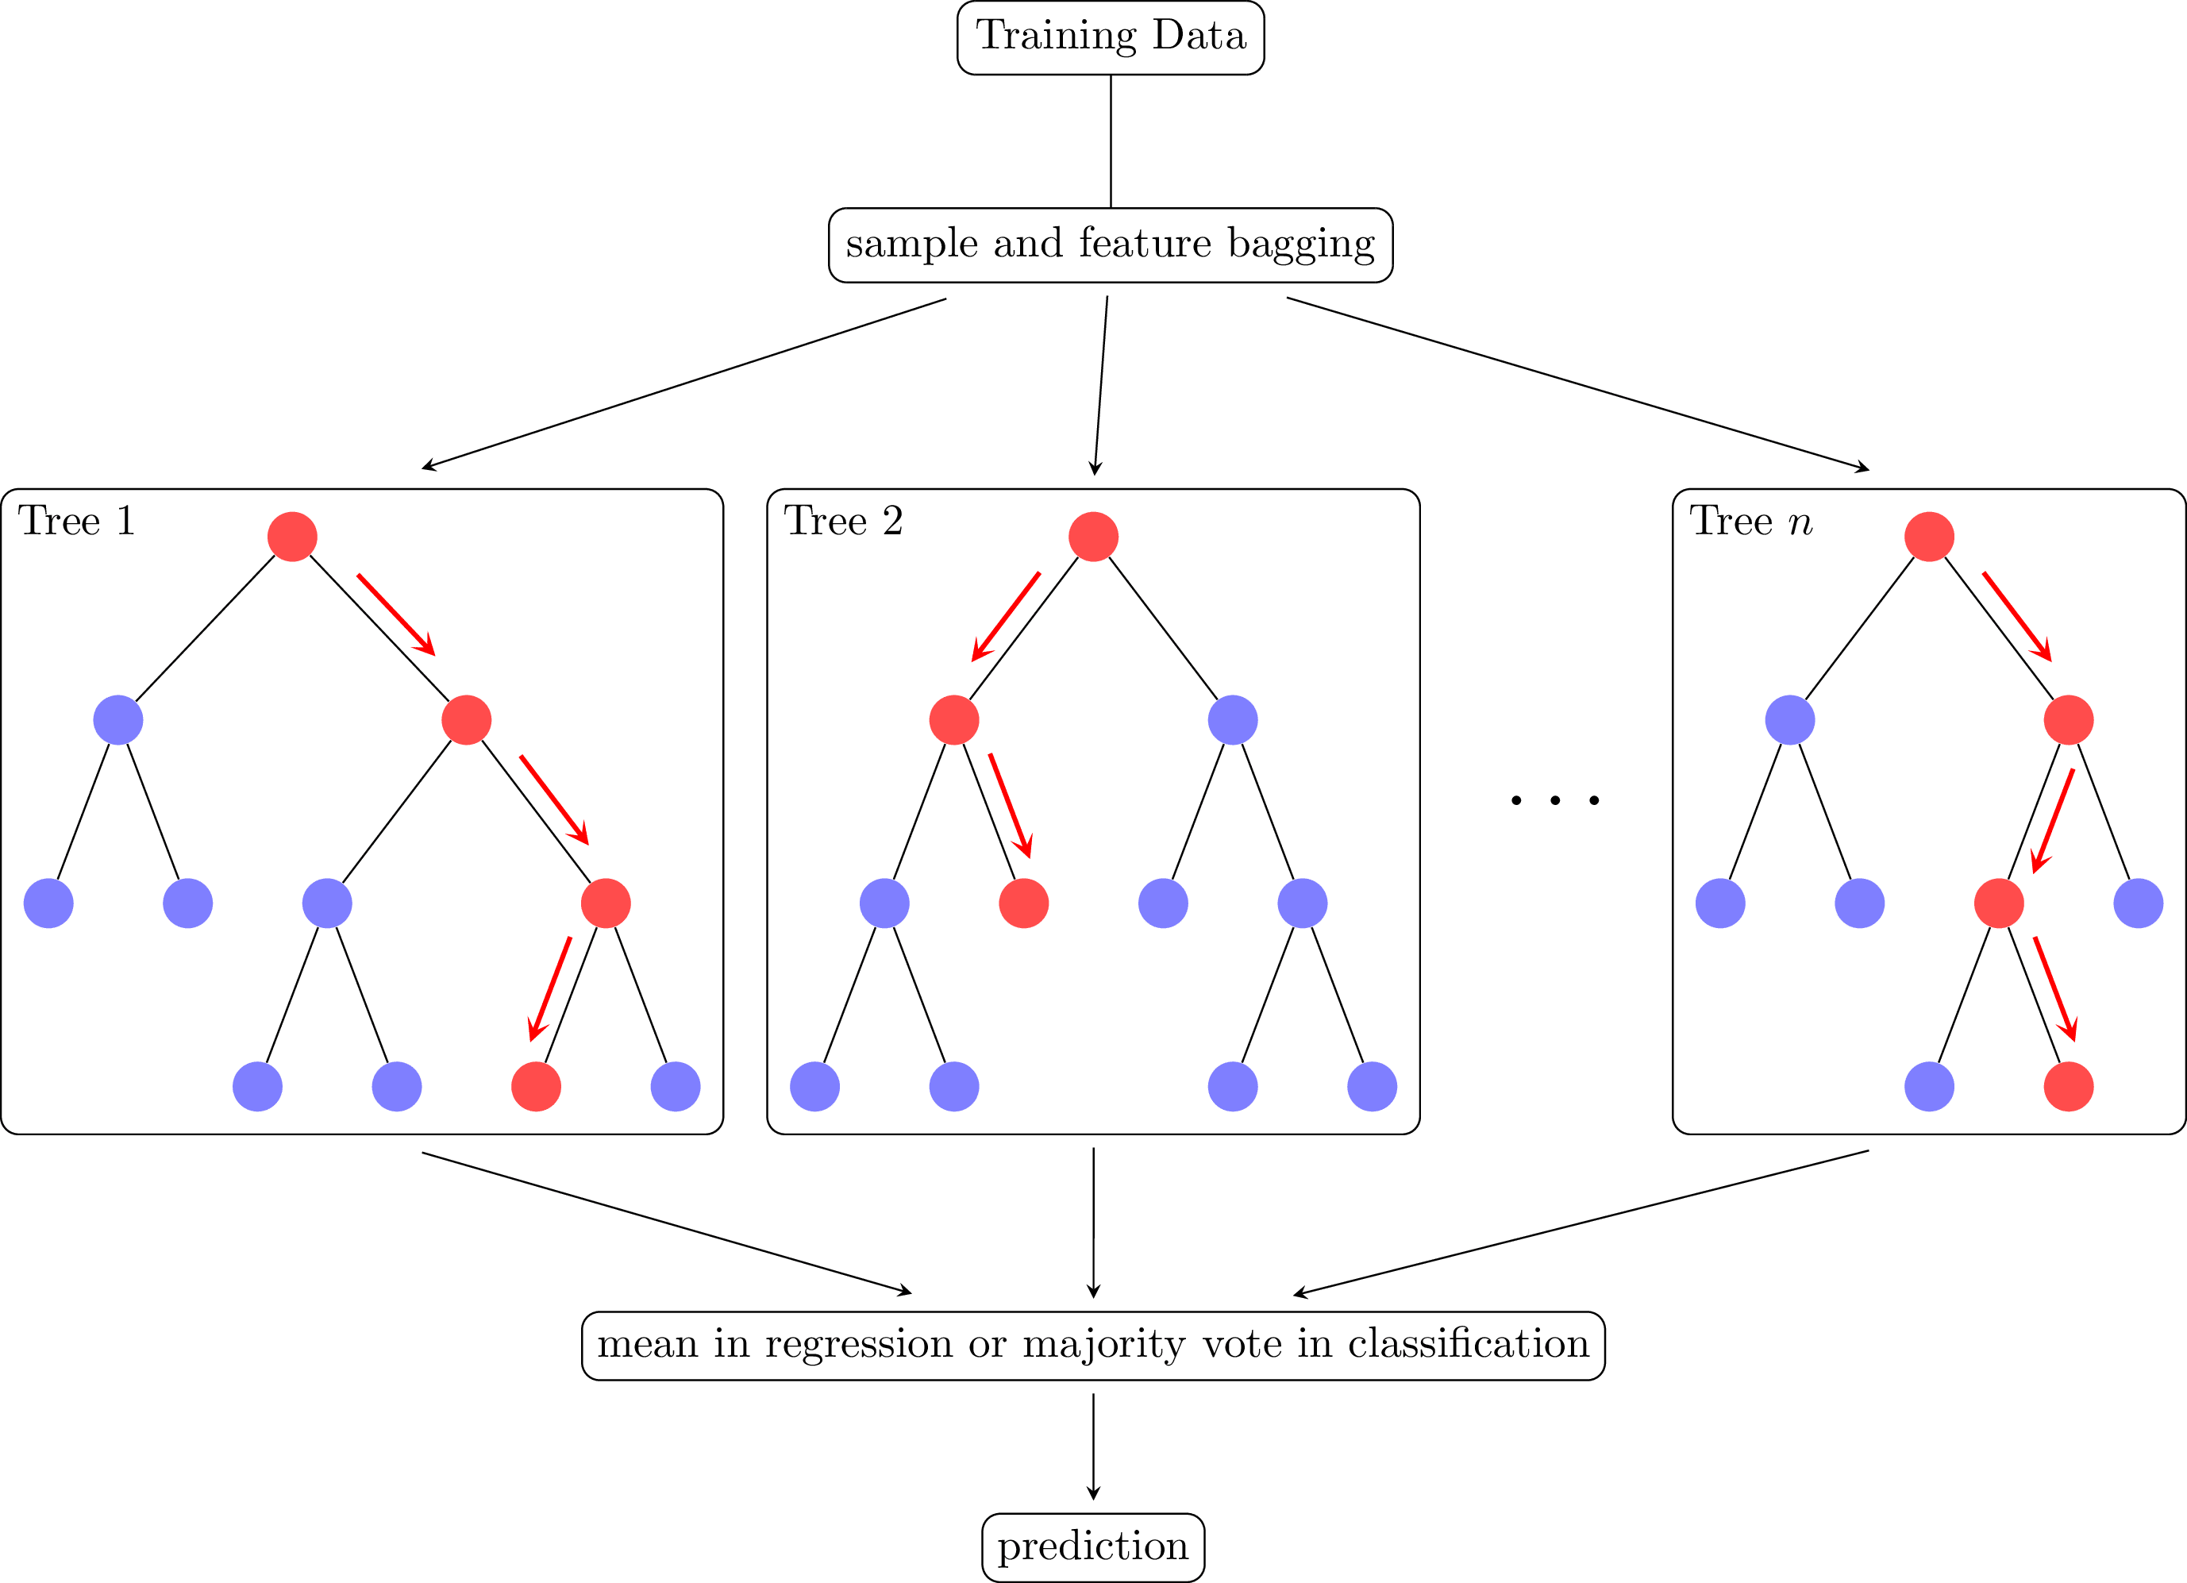

Random Forest (RF) (Riebesell, 2022).

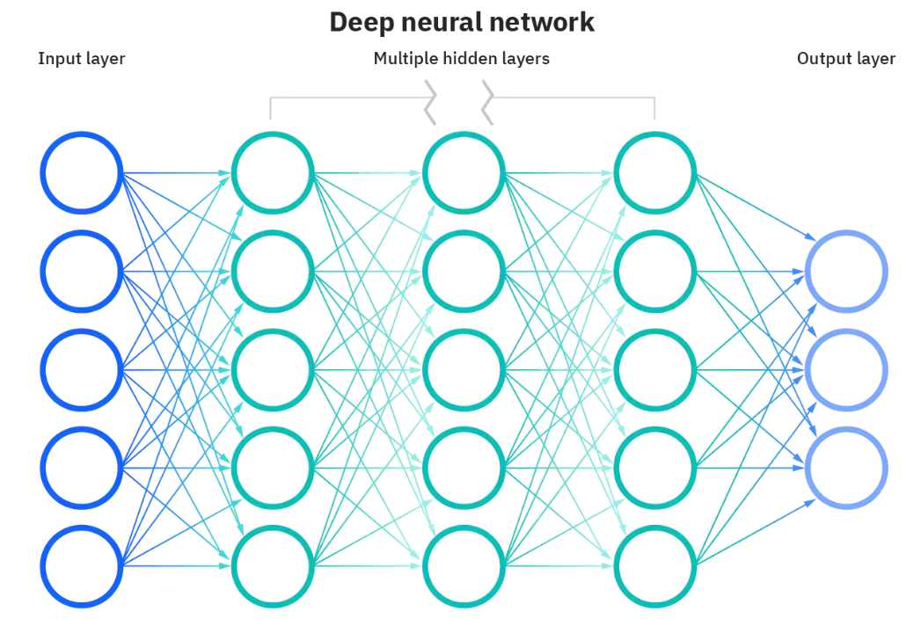

Deep Neural Network (DNN) (IBM, 2022).

### 3.3.3 Recurrent Neural Network

A recurrent neural network (RNN) is a type of Artificial Neural Network which designed to work with sequence data. For instance, sequence data are time series, DNA, language, speech and sequences of user actions data, etc. The ammonia concentration and colour level data are time series data, which is a series of data points listed in minute orders (Donges, 2021). A distinguished characteristic of RNN is that they share parameters across each layer of the network by allowing information to be passed from last step of the network to the next. Unlike RNN, feedforward networks like DNN have different weights across each node. The reuse of previous information for making decision on RNN makes it capable of "learning" from the previous inputs. The realization of the memorizing function is through a memory unit called hidden state (i.e., a vector contains weights) in RNN architecture, which enable RNN to presist data, thus capture short term dependencies. The RNN architecture is presented in Fig. 3.28. The general formulation of a RNN is expressed in Eq. [eq-rnn] (Mamandipoor et al., 2020):

$$h_{t}=σ(W^{h}h_{t-1}+W^{x}x_{t}+b)$$

where $x_{t}$ is the current input, $h_{t}$ is the current hidden state (output), $h_{t-1}$ is the previous output, $W^{x}$ is the weights of the hidden state, $W^{h}$ is the weight of the input, $b$ is the bias, $σ$ is the sigmoid activation function.

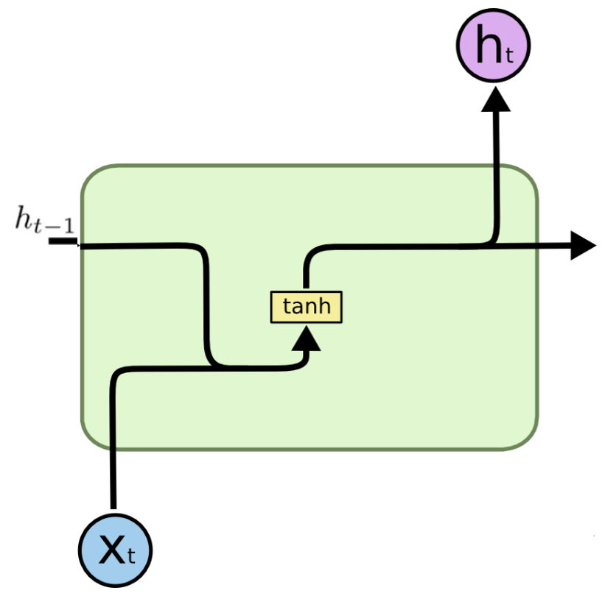

Recurrent Neural Network (RNN).

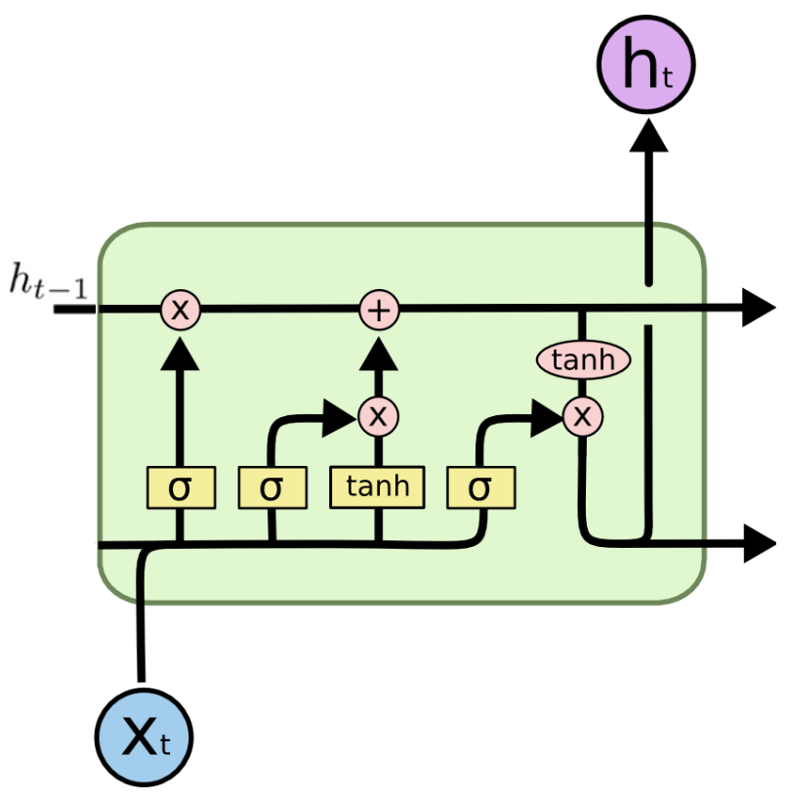

Long Short-term Memory (LSTM).

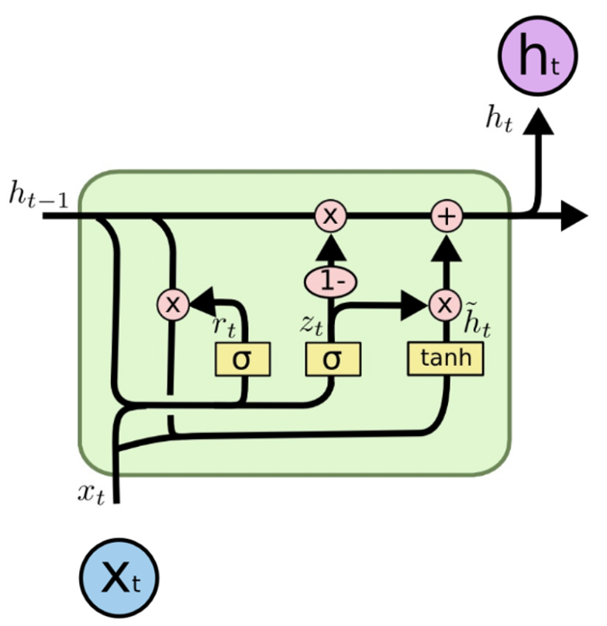

Gate Recurrent Unit (GRU).

### 3.3.4 Long Short-term Memory

Long Short-term Memory (LSTM) is a deep recurrent neural networks (RNN), an advanced and improved version of RNN. The advent of LSTM is to solve problems requiring learning long-term temporal dependencies which cannot be learned by RNN due to the simple model architecture. The fundmental of LSTM network is built on memory blocks called "cells", which are responsible for tranferring and receiving the states (i.e., vectors) recording the information from the previous cells. In a cell block, there are input gate, forget gate and the output gate. The function of these three gates is to control the movement of the information into and out of the cell via the sigmoid function. The inputs of the cell will first go through a forget gate ($f_{t}$) as Eq. [[lstm-(1)]](#lstm-(1)), where the function will mutiply each element in the input states by values ranging from 0 to 1 to realize the effect of "forget". Next, a input gate ($i_{t}$) as in Eq. [[lstm-(2)]](#lstm-(2)) will decide whether the new information should be updated or ignored by sigmoid function (i.e., 0 or 1), followed by a tangent function giving weight of importance (i.e., -1 to 1) to the values which passed by as in Eq. [[lstm-(3)]](#lstm-(3)). New memory then is appended to the previous memory $C_{t-1}$ resulting a new $C_{t}$. Lastly, output values ($h_{t}$) is obtained based on output cell state ($O_{t}$) as in Eq. [[lstm-(5)]](#lstm-(5)) and Eq. [[lstm-(6)]](#lstm-(6)) (Le et al., 2019). The equations for LSTM structure are shown in Eq. [eq-lstm]:

[eq-lstm]

$$\begin{matrix} & f_{t}=σ(W_{f}[h_{t-1},X_{t}]+b_{f}) \\ & i_{t}=σ(W_{i}[h_{t-1},X_{t}]+b_{i}) \\ & \tilde{C_{t}}=tanh(W_{n}[h_{t-1},X_{t}]+b_{n}) \\ & C_{t}=C_{t-1}f_{t}+\tilde{C_{t}}i_{t} \\ & O_{t}=σ(W_{o}[h_{t-1},X_{t}]+b_{o}) \\ & h_{t}=O_{t}tanh(C_{t})\end{matrix}$$

where $f_{t}$ corresponds to the forget gate, $i_{t}$ to the input gate, $\tilde{C_{t}}$ to the candidate cell state, $C_{t}$ to the current cell state, $O_{t}$ to the output cell state, $h_{t}$ to the output values, $σ$ to the sigmoid function, $X_{t}$ to the current input, tanh to the tangent function, $W$ and $b$ are the weight matrices and bias of the corresponding output gate, respectively.

### 3.3.5 Gate Recurrent Unit

Gated Recurrent Unit (GRU) model is a variant of LSTM model, by combining the forget gate and input gate into an update gate as in Fig. 3.30, GRU has less parameters compared to LSTM. The advantage of GRU over LSTM is less computing power required while maintaining a similar model performance compared to LSTM. The inputs of GRU model first enter the update gate ($z_{t}$) as in Eq. [[gru-(1)]](#gru-(1)), where the function will help the model to determine how much of the past information needs to be passed along to the future via sigmoid functions. Followed by the reset gate ($r_{t}$) as in Eq. [[gru-(2)]](#gru-(2)), which is used to decide how much of the past information to forget. Althogh Eq. [[gru-(1)]](#gru-(1)) and Eq. [[gru-(2)]](#gru-(2)) have the same inputs of $X_{t}$ and $h_{t-1}$, the usages of the gates are different. The outputs of reset gate will be used to determine the candidate hidden state ($]tildeh$) as in Eq. [[gru-(3)]](#gru-(3)), where the tangent fucntion will determine the importance of current input ($X_{t}$), reset gate output, and previous hidden state ($h_{t}$). At the last step, the output values ($h_{t}$) is calculated from the candidate hidden state ($\tilde{h_{t}}$), previous hidden state ($h_{t-1}$), and the outputs of update gate as in Eq. [[gru-(4)]](#gru-(4)). The equations of GRU structures are presented in Eq. [eq-gru] (Cheng et al., 2020):

[eq-gru]

$$\begin{matrix} & z_{t}=σ(X_{t}W_{xz}+h_{t-1}W_{hz}+b_{z}) \\ & r_{t}=σ(X_{t}W_{xr}+h_{t-1}W_{hr}+b_{r}) \\ & \tilde{h_{t}}=tanh(X_{t}W_{xh}+(r_{t}∘h_{t-1})W_{hh}+b_{h}) \\ & h_{t}=z_{t}∘h_{t-1}+(1-z_{t})∘\tilde{h_{t}}\end{matrix}$$

where $z_{t}$ corresponds to the update gate, $r_{t}$ to the reset gate, $\tilde{h_{t}}$ to the candidate hidden state, $h_{t}$ to the output values, $σ$ to the sigmoid function, tanh to the tangent function, $X_{t}$ to the current input, $W$ and the $b$ are the weight matrices and bias of the corresponding output gate, respectively.

# 4 Results and Discussion

## 4.1 Baseline performance of the forecasting models

We first review the ammonia and colour forecasting models trained by single-featured datasets. The performance of RF models in Fig. 4.1 and Fig. 4.2 showed poorer performance compared to the other four deep learning models, while the LSTM models showed the lowest values of test loss.

The significant higher test loss of RF models compared to other models can be visualized by plotting the forecasted values with the ground truths (i.e., observed values). In Fig. [fig:baseline-plot], one-step-ahead forecast horizon of ammonia concentration and colour level is plotted by RF as in Fig. 4.3 and Fig. 4.5 and LSTM models as in Fig. 4.4 and Fig. 4.6. It’s easier to observe that the RF models are less capable of predicting the water quality paratmers.

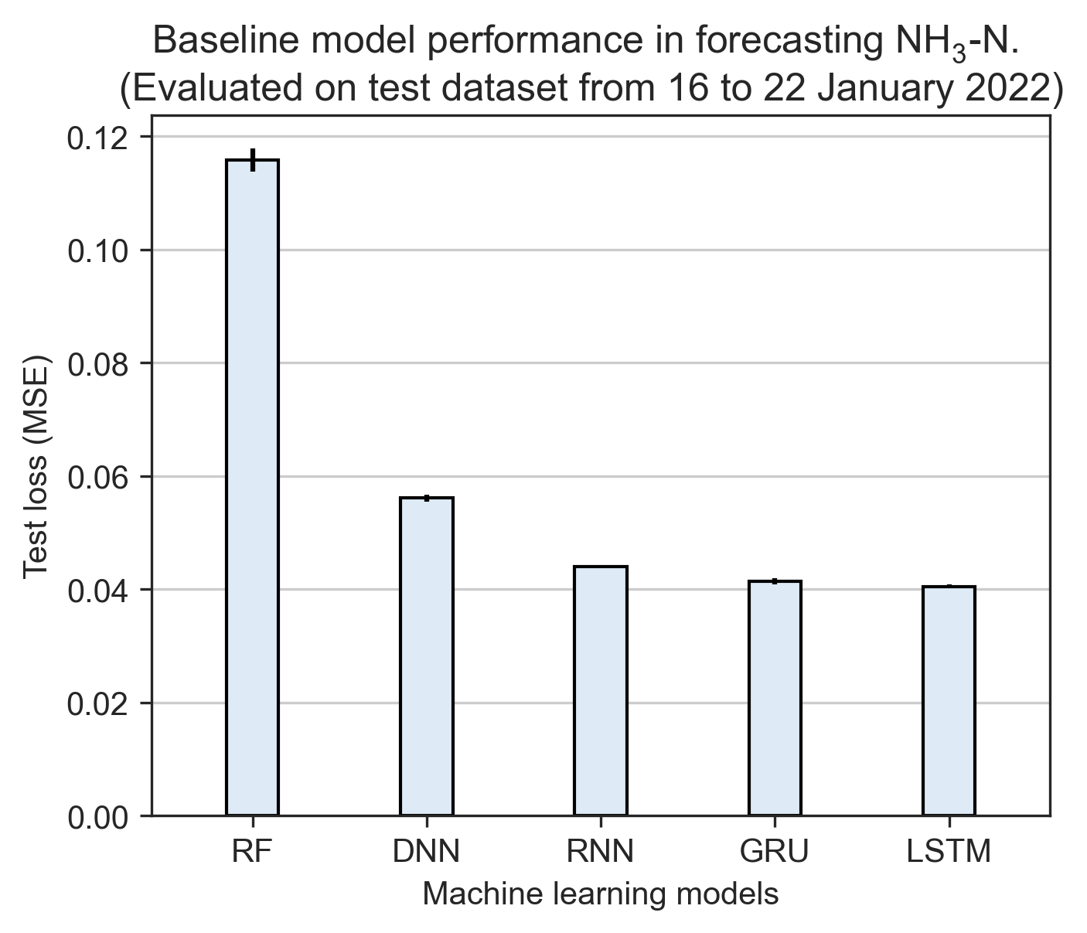

Test loss values from five ammonia forecasting models.

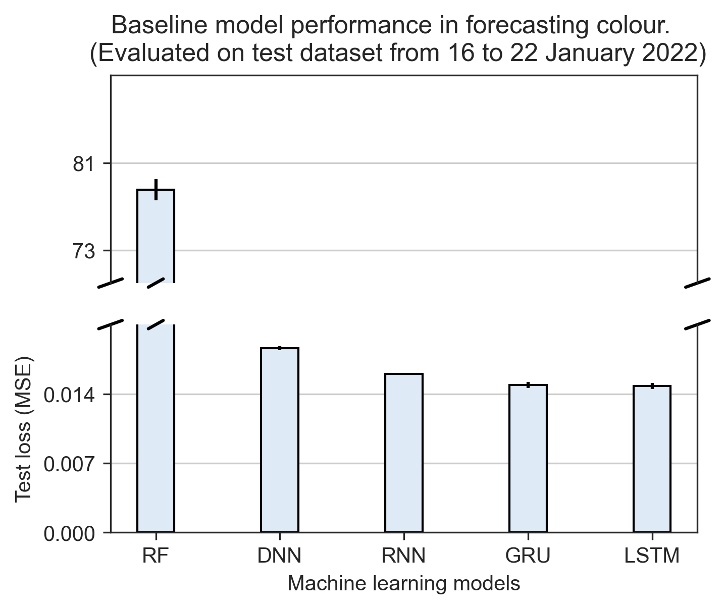

Test loss values from five colour forecasting models.

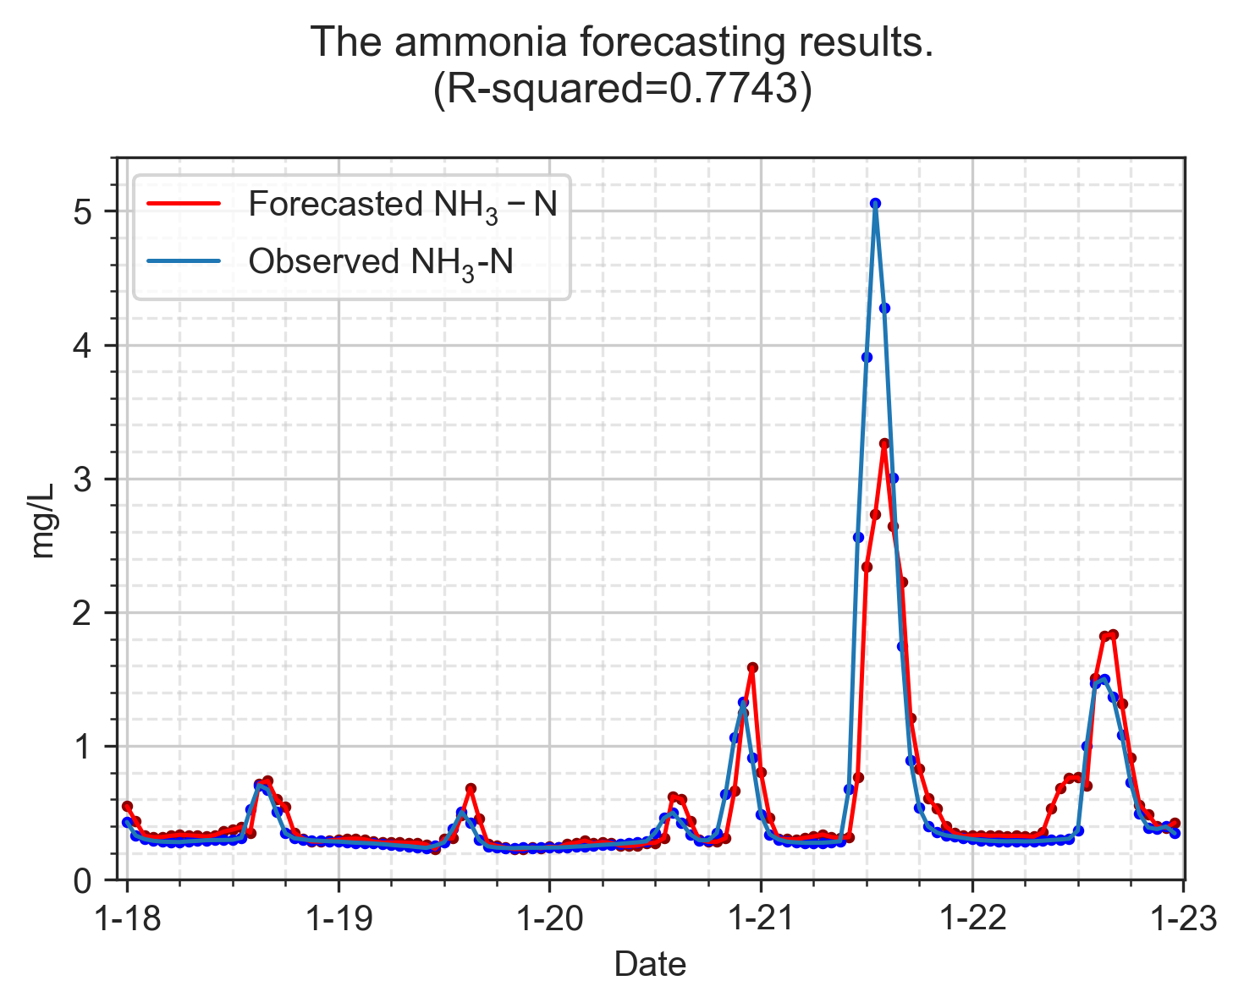

Baseline RF model forecasting ammonia concentration.

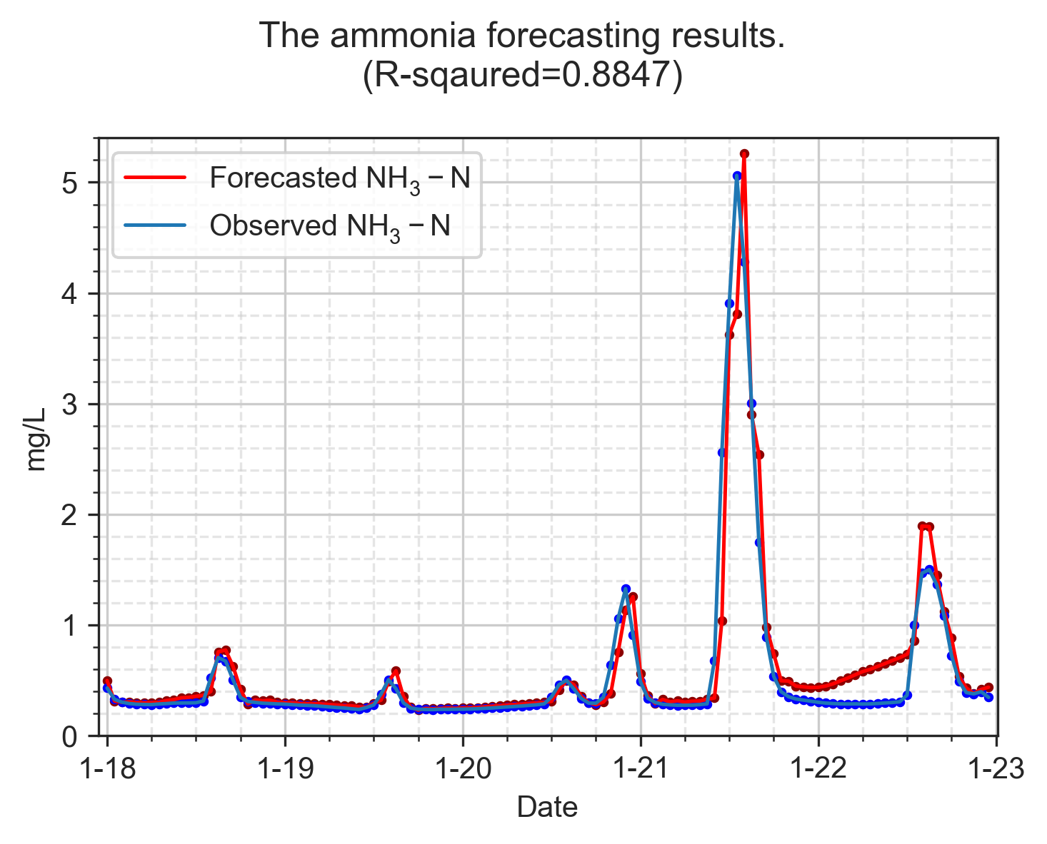

Baseline LSTM model forecasting ammonia concentration.

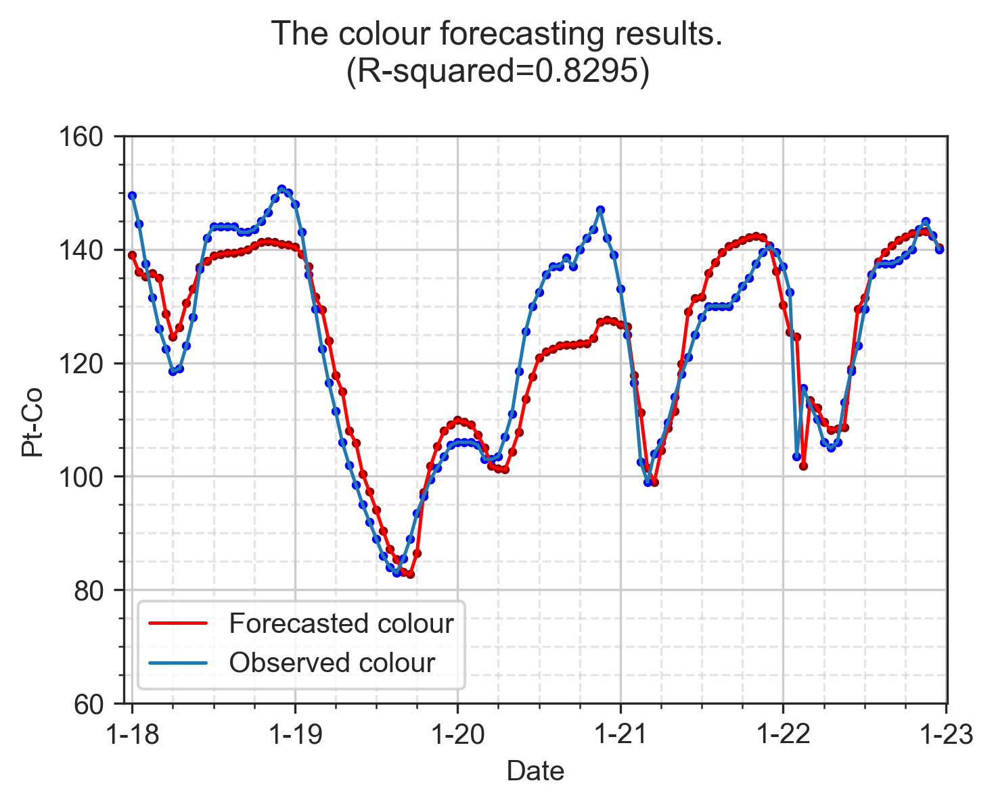

Baseline RF model forecasting colour levels.

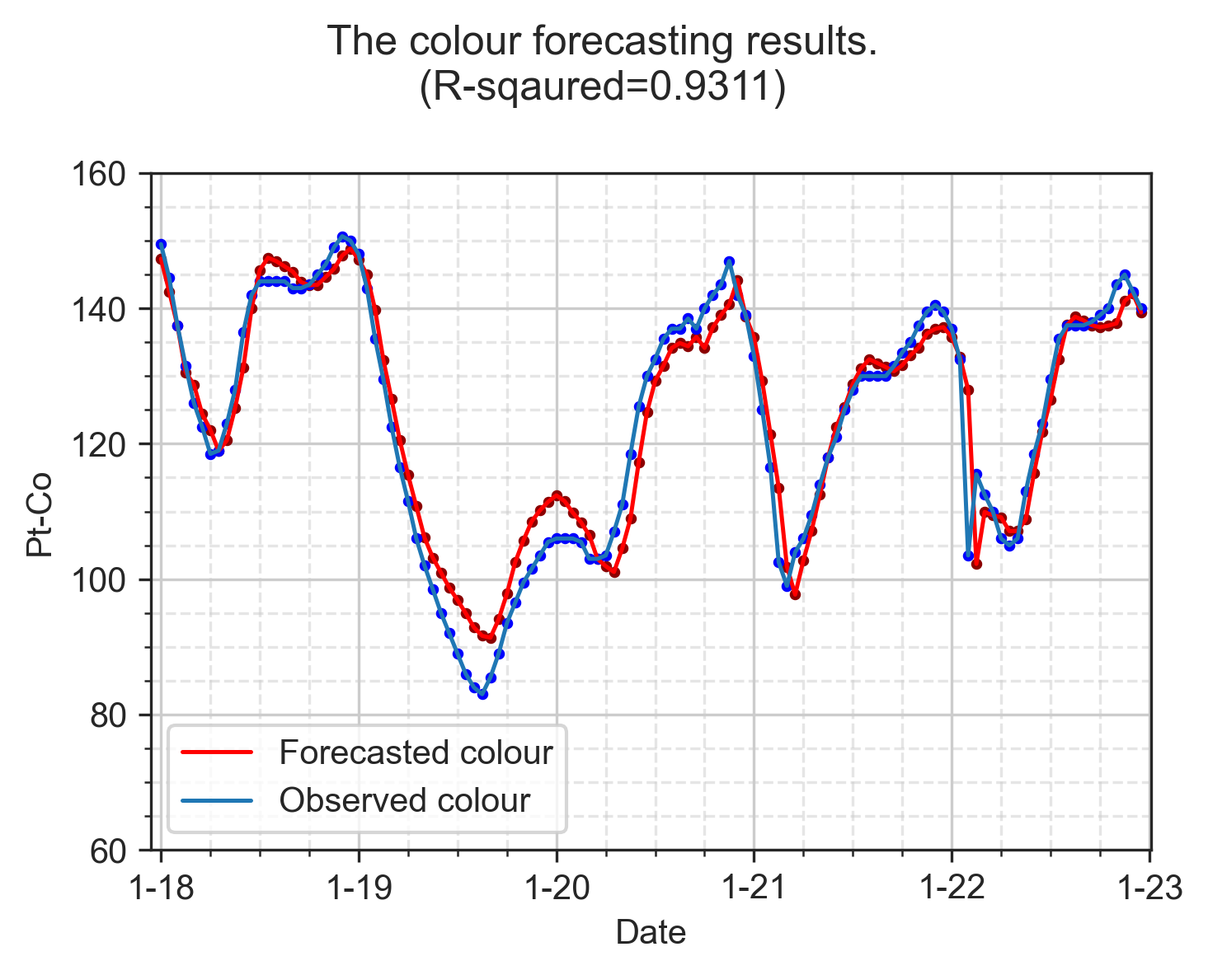

Baseline LSTM model forecasting colour levels.

## 4.2 Improved performance on forecasting models using data pre-processing techniques

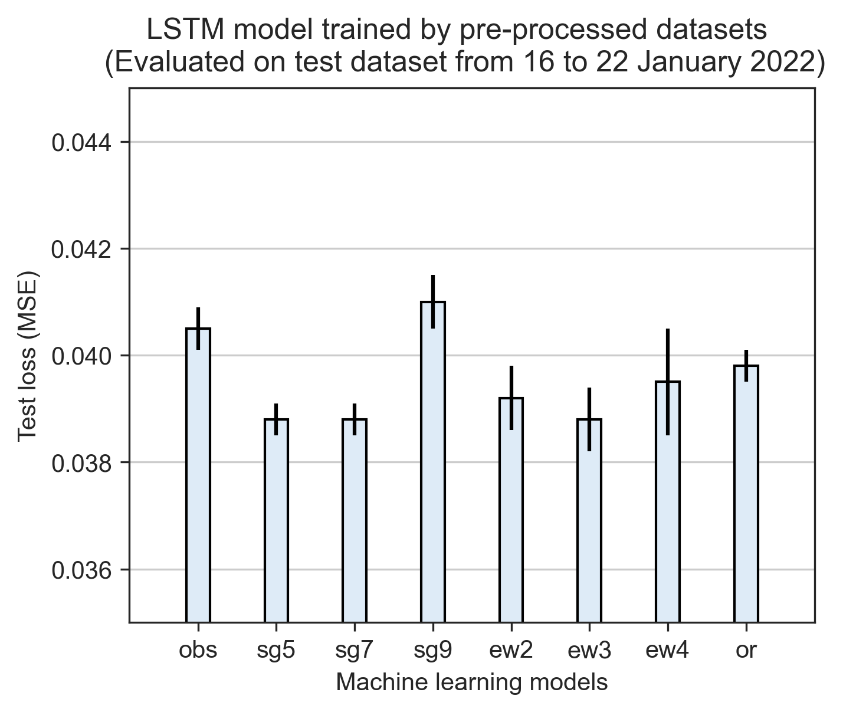

.

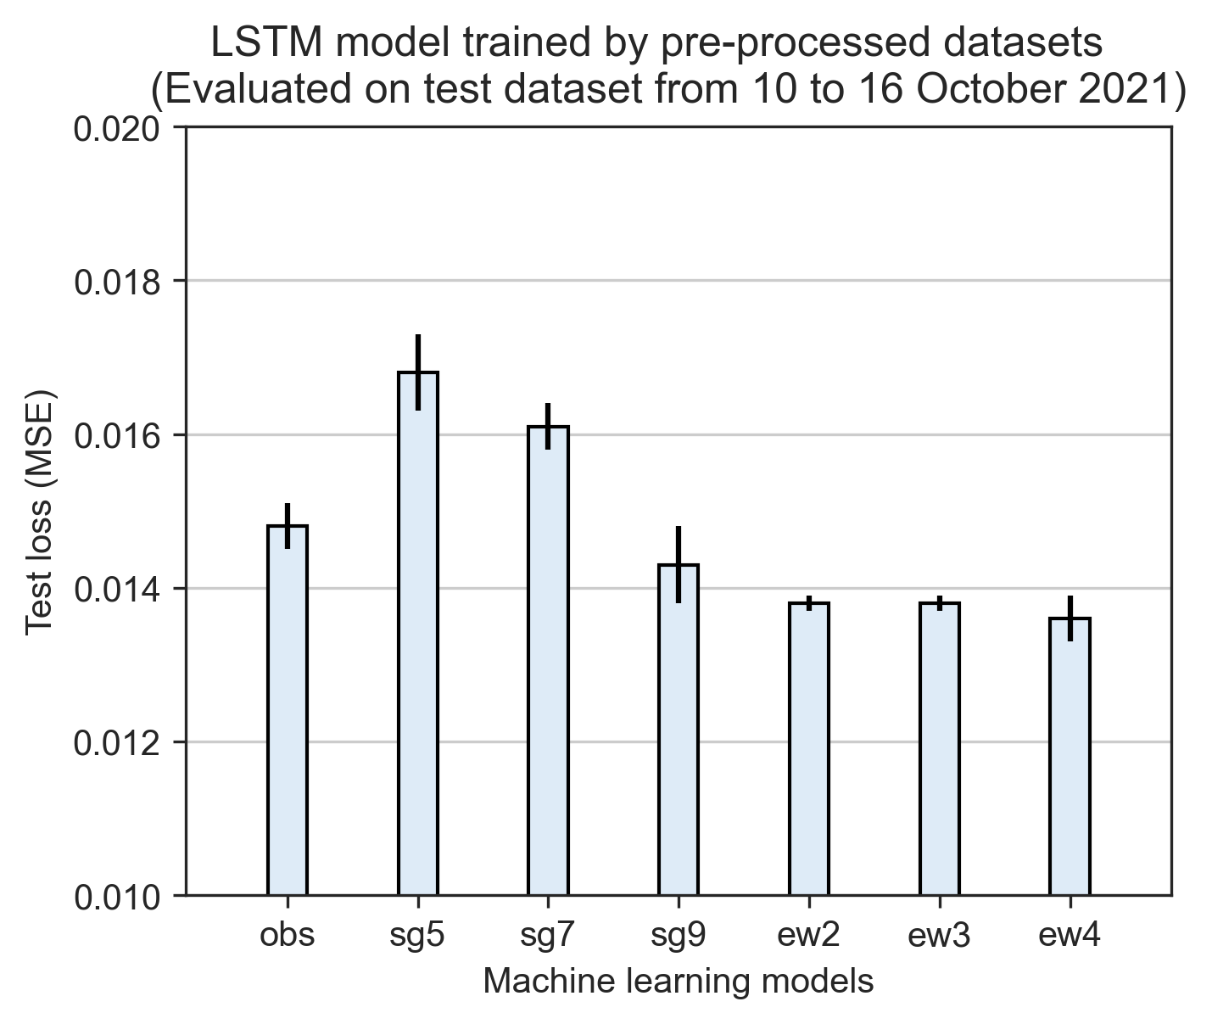

.

With the baseline model performance is known, we investigated the influence of pre-processed datasets on the ammonia forecasting models. In Fig. 4.7, we listed all the test loss of models trained with each proposed pre-processed methods. The models trained by SG filters at different window size are denoted as model-sg5, model-sg7, model-sg9; the naming rule applies the same to EWMA filters, and for the method of outlier removal for ammonia data is denoted as model-or.

We found that SG filters improved most in the quality of the raw dataset, as the top lowest test loss values are from GRU-sg7 and GRU-sg9 (i.e., at the window size of 7 and 9, respectively), followed by LSTM-ew3. However, the improvements of model performance resulted from the use of data smoothing methods are not consistant across different models. In other words, the best training datasets for GRU, LSTM, and DNN models are different.

The best performed colour forecasting models are the LSTM models trained by EWMA filters, which are 0.0136 from LSTM-ew4, 0.0138 from LSTM-ew2 and LSTM-ew3 as shown in Fig. 4.8. Interestingly, LSTM models trained by EWMA also showed the best performance in ammonia forecasting models. The top three ranks of Model-Dataset in the lowest validation loss ranks the 6th, 20th, and 1st from the lowest test loss values. However, we don’t have extra testing datasets for re-evaluating the colour forecasting models. Compromises have to be made during the analysis of colour forecasting models.

### 4.2.1 Ammonia forecasting models

lcclcc Model-Dataset & Test loss & Valid loss & Model-Dataset & Test loss & Valid loss  
GRU-sg7 & 0.0383 &1.2508&RNN-or & 0.0432&1.6345  
GRU-sg5 & 0.0385 &1.2644&RNN-ew3 & 0.0434&1.6041  
LSTM-ew3 & 0.0388 &1.0796&RNN-obs & 0.0440&1.6734  
LSTM-sg5 & 0.0388 &1.2346&RNN-sg9 & 0.0442&1.7046  
LSTM-sg7 & 0.0388 &1.1804&DNN-obs & 0.0561&3.2383  
GRU-ew2 & 0.0389 &1.1891&DNN-sg5 & 0.0562&3.2170  
GRU-ew4 & 0.0391 &1.2390&DNN-ew2 & 0.0563&3.1677  
GRU-ew3 & 0.0392 &1.2199&DNN-ew3 & 0.0569&3.2317  
LSTM-ew2 & 0.0392 &1.0969&DNN-sg7 & 0.0570&3.2014  
LSTM-ew4 & 0.0395 &1.1219&DNN-ew4 & 0.0571&3.2188  
GRU-sg9 & 0.0396 &1.3097&DNN-or & 0.0572&3.1972  
LSTM-or & 0.0398 &1.2612&DNN-sg9 & 0.0574&3.2484  
LSTM-obs & 0.0405 &1.3993&RF-obs & 0.1158&-  
GRU-or & 0.0405 &1.2366&RF-sg9 & 0.1196&-  
LSTM-sg9 & 0.0410 &1.3076&RF-ew2 & 0.1286&-  
GRU-obs & 0.0414 &1.3638&RF-or & 0.1294&-  
RNN-sg5 & 0.0415 &1.5088&RF-sg5 & 0.1298&-  
RNN-ew2 & 0.0421 &1.5425&RF-ew3 & 0.1313&-  
RNN-sg7 & 0.0423 &1.6267&RF-sg7 & 0.1409&-  
RNN-ew4 & 0.0432 &1.5992&RF-ew4 & 0.1441&-

Empirically, when different models are evaluated by the same testing dataset, the best Model-Dataset combination shold have both the lowest values of test and validation loss. For instance, GRU-sg7 model in forecasting ammonia has the lowest test loss of 0.0383, yet the validation loss of 1.2508 only ranks the tenth from the smallest validation loss vlaues. The models with top three lowest values of the validation loss are LSTM-ew3, LSTM-ew2 and LSTM-ew4. This finding points to the potential of the heterogeneity between the trianing and testing datasets. This hypothesis was the explanation with the highest likelihood when no overfitting was observed in the training datasets. Further tests were carried out using testing dataset from October to examine how the Model-Dataset ranks of test and validation loss values will change into. To the best of my understanding, the comparisons between testing and validation loss are not discussed on the currently available research papers in modelling of wastewater treatment industry.

As shown in Table. [tab:baseline-result-oct-nh3], the top three ranks of Model-Dataset in the lowest validation loss is the same to the top three ranks in the test loss values. This is in good agreement with how the heterogeneity of the datasets can impact on the model performance. The evluations of the ammonia forecasting models in October 2021 showed a complete different outcomes compared to the one in January 2022. Surpirsingly, the top three ranks of Model-Dataset in the lowest validation loss are the same of the lowest test loss, which are 0.0158 from LSTM-ew3, 0.0161 from LSTM-ew2, and 0.0163 from LSTM-ew4. Instead of GRU, LSTM becomes the best model for training ammonia forecasting model. The most remarkable results in Table. [tab:baseline-result-oct-nh3] is that EWMA filter seems to be the most ideal pre-processing methods for traning deep learning models as LSTM-ew3, GRU-ew3, RNN-ew4 and DNN-ew3 models showed the best model performance in test loss compared to the same models trained by other data pre-processing methods.

lcclcc Model-Dataset & Test loss & Valid loss & Model-Dataset & Test loss & Valid loss  
LSTM-ew3 & 0.0158 & 1.0796 & RNN-or & 0.0197 & 1.6345  
LSTM-ew2 & 0.0161 & 1.0969 & RNN-sg7 & 0.0201 & 1.6267  
LSTM-ew4 & 0.0163 & 1.1219 & RNN-sg9 & 0.0205 & 1.7046  
LSTM-sg5 & 0.0166 & 1.2346 & RNN-obs & 0.0206 & 1.6734  
GRU-ew3 & 0.0167 & 1.2199 & DNN-ew3 & 0.0316 & 3.2317  
GRU-ew4 & 0.0169 & 1.2390 & DNN-or & 0.0316 & 3.1972  
GRU-ew2 & 0.0170 & 1.1891 & DNN-sg7 & 0.0316 & 3.2014  
GRU-sg9 & 0.0174 & 1.3097 & DNN-ew2 & 0.0318 & 3.1677  
LSTM-obs & 0.0175 & 1.2366 & DNN-ew4 & 0.0319 & 3.2188  
LSTM-or & 0.0177 & 1.2612 & DNN-obs & 0.0319 & 3.2383  
GRU-sg5 & 0.0178 & 1.2644 & DNN-sg5 & 0.0319 & 3.2170  
GRU-sg7 & 0.0180 & 1.2508 & DNN-sg9 & 0.0319 & 3.2484  
LSTM-sg7 & 0.0180 & 1.1804 & RF-sg9 & 0.1307 & -  
GRU-or & 0.0187 & 1.3993 & RF-sg7 & 0.1311 & -  
LSTM-sg9 & 0.0188 & 1.3076 & RF-sg5 & 0.1343 & -  
GRU-obs & 0.0189 & 1.3638 & RF-ew2 & 0.1346 & -  
RNN-ew4 & 0.0190 & 1.5992 & RF-ew3 & 0.1368 & -  
RNN-ew2 & 0.0191 & 1.5425 & RF-obs & 0.1443 & -  
RNN-ew3 & 0.0193 & 1.6041 & RF-ew4 & 0.1451 & -  
RNN-sg5 & 0.0195 & 1.5088 & RF-or & 0.1477 & -

### 4.2.2 Colour forecasting models

lcclcc Model-Dataset & Test loss & Valid loss & Model-Dataset & Test loss & Valid loss  
LSTM-ew4 & 0.0136 &0.7515&RNN-obs & 0.0160 &1.0623  
LSTM-ew2 & 0.0138 &0.8011&LSTM-sg7 & 0.0161 &0.7439  
LSTM-ew3 & 0.0138 &0.7547&LSTM-sg5 & 0.0168 &0.8355  
GRU-ew3 & 0.0140 &0.8068&DNN-sg5 & 0.0180 &1.4702  
GRU-ew2 & 0.0142 &0.8330&DNN-sg7 & 0.0180 &1.4823  
GRU-ew4 & 0.0143 &0.7694&DNN-sg9 & 0.0180 &1.4574  
LSTM-sg9 & 0.0143 &0.7137&DNN-ew4 & 0.0181 &1.4632  
RNN-ew3 & 0.0144 &0.8492&DNN-ew3 & 0.0182 &1.4716  
RNN-ew4 & 0.0147 &0.8476&DNN-ew2 & 0.0183 &1.4946  
RNN-sg9 & 0.0147 &0.8363&DNN-obs & 0.0186 &1.5397  
LSTM-obs & 0.0148 &0.9744&RF-sg9 & 63.6847&  
GRU-obs & 0.0149 &0.9927&RF-sg7 & 73.8263&  
RNN-ew2 & 0.0150 &0.9083&RF-ew3 & 75.1974&-  
GRU-sg9 & 0.0151 &0.7575&RF-ew4 & 77.8829&-  
RNN-sg5 & 0.0158 &0.8846&RF-obs & 78.5296&-  
RNN-sg7 & 0.0158 &0.8755&RF-ew2 & 78.8753&-  
GRU-sg7 & 0.0159 &0.7791&RF-sg5 & 81.0696&-  
GRU-sg5 & 0.0160 &0.8080& - & - &-

By comparing the baseline performance and the influences of data pre-processing methods on machine learning models, our findings appear to be well substantiated the use of LSTM models for training ammonia and colour forecasting models due to it’s outstanding model performance evaluated by test loss values. Although EWMA filters showed surprising effects on improving the performance of most models, the influence of pre-processing methods are still not consistant across different models and training datasets. Thus, in the testings of the proposed model training processes will include all the pre-processing methods for model training, and LSTM will be used as the only machine learning model.

## 4.3 Exploit hidden patterns in MBR effluent water quality to enhance model performance

### 4.3.1 Ammonia forecasting models

In the section of feature engineering, we have introduced the selection and creation of the extra input features for training forecasting models. In Fig. 4.10, the performance of ammonia forecasting models trained by 2 to 4 input features are compared with the baseline performance to demonstrate how the feature engineered features influenced on the model outputs. Notice that due to colour data are not available from 10 to 16 October 2021, the models in Fig. 4.10 were evaluated on training dataset from 16 to 22 January 2022.

Leaving out the potential influences of heterogeneity between training and testing datasets on comparing the model performance, interesting resutls were still observed. For LSTM models trained by non pre-processed datasets, more input features deteriorate the model performance as LSTM-4-obs has the highest test loss and LSTM-1-obs has the lowest test loss. Based on our understanding to the extra features such as color level and positional encodings, the test loss of the forecasting models should be lower and inversely proportional to the increasing number of input features. The model performance from LSTM-sg7 and LSTM-sg9 fit well with what we hypothesized. The highest test loss values was observed in LSTM-1 models, followed by LSTM-2, LSTM-3 and LSTM-4.

LSTM-2 models show intriguing results. Except for LSTM-obs, all the LSTM-2 models showed lower test loss compared to LSTM-1. This finding lead us to believe that the flucturation of ammonia concentration is highly correlated with the colour level in SHWEPP influent.

Comparing to the baseline model performance using the LSTM-sg7 approach, the test loss values of LSTM-1-sg7, LSTM-2-sg7, LSTM-3-sg7 and LSTM-4-sg7 decreased by 4.2%, 6.4%, 7.9%, and 8.9%, respectively comapred to the baseline model test loss.

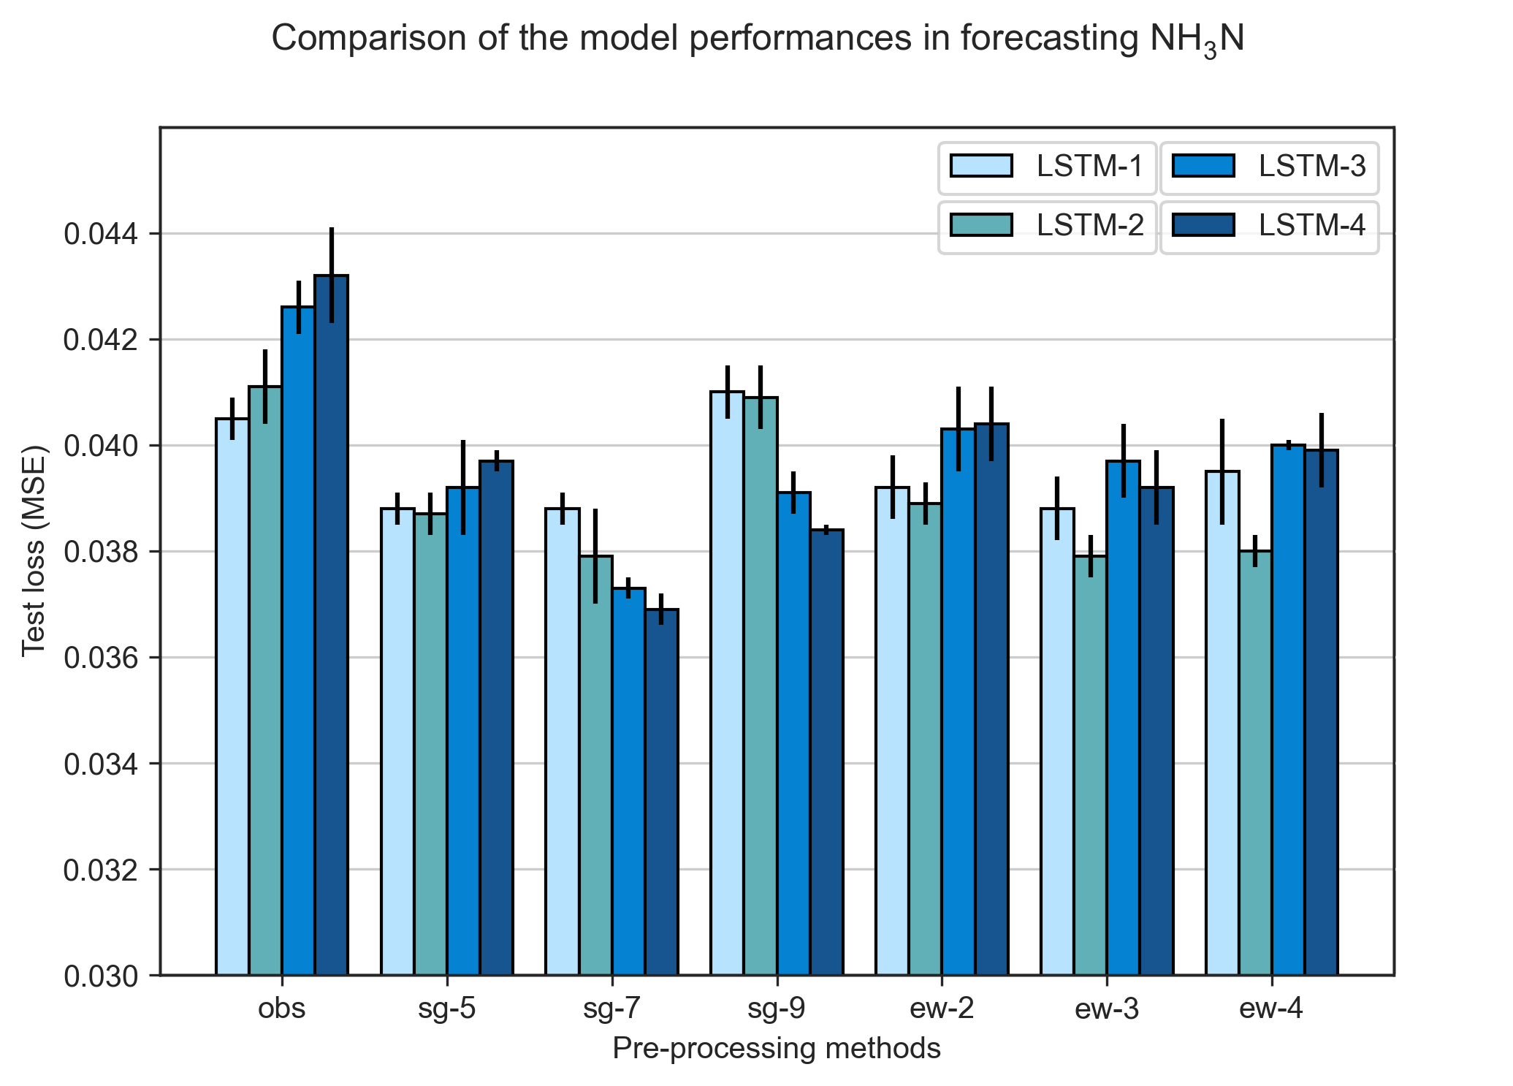

cap .

### 4.3.2 Colour forecasting models

Fig. 4.10 presents how the various pre-processing methods affect the performance of colour forecasting models evaluated on testing dataset from 16 to 22 January 2022. Unexpectedly, what we found in the results of colour forecasting models have many commons to the findings in Fig. 4.9, which are decribed as the followings:

In LSTM-obs, models trained with more inputs resulted in poorer model performance, except for LSTM-obs, LSTM-sg9 and LSTM-ew2.

In the results of LSTM-sg7, the test values decreased with the increased number of model inputs, which satified the hypothesis we claimed in previous section.

The test loss values of LSTM-2 in all the pre-processed datasets are lower than LSTM-1 except for LSTM-obs, LSTM-sg9 and LSTM-ew2.

Looking at the color forecasting model with the lowest test loss values of 0.0121, LSTM-3-sg9 successfully improved the model performance, by lowering test loss by 28.6% compared to the baseline model test loss.

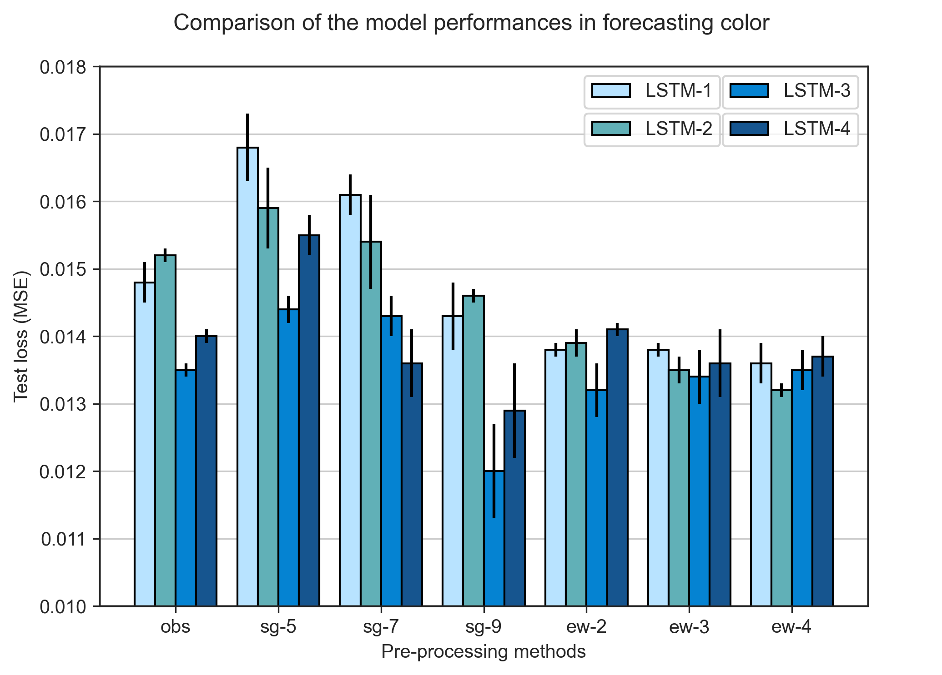

cap .

# 5 Conclusions and Recommendation

## 5.1 Conclusions

### 5.1.1 Machine learning models vs deep learning models

The selection of using which machine learning and deep learning models was not widely discussed to the best of our knowledge in the modelling of wastewater treatment industry. This study has investigated on the model performance of machine learning model of RF, and four other deep learning models of DNN, RNN, GRU and LSTM on forecasting ammonia concentrations and colour levels in reclaimed water system for assisting treatment operation and management. The evidence from this study suggests deep learning models are much capable in learning from the historical data and generate more accurate forecasting results. In both ammonia and colour forecasting models, the test loss values of RF are much higher than the values from the least performanced deep learning model of DNN. Among all the deep learning models, LSTM and GRU are the best models in training both baseline models of forecasting ammonia and colour. However, the further research works suggest LSTM models trained with pre-processing methods generate the lowest test loss compared to GRU, making the LSTM model the most promising recurrent neural network model for training forecasting models.

### 5.1.2 Data pre-processing methods

Our research also highlighted the importance of how the model performance can be improved from applying data pre-processing and feature engineering techniques. Generally speaking, all the proposed data smoothing and outlier removal methods reduced the test loss values compared to the baseline model performance (i.e., the window sizes of the filters need to be carefully selected), as showin in Fig. [fig:preprocessing-comparison]. It is believed that the convoluted datapoints generated from data smoothing filters enable the recurrent neural networks to predict the future values more easily.

### 5.1.3 Feature engineering

This study is the first step towards enhancing our understanding to the potential benefits of using created features for model training. The thorough examinations of the Geomap nearby the SHWEPP and the investigation of water composition in the public sewege system helped us to hypothesize that the change of ammonia concentrations and colour levels are dependent to each other. With the help of additional colour/ammonia data for ammonia/colour forecasting model, the test loss reduced by 6.4% (i.e., LSTM-2-sg7 compared to LSTM-1-obs) and 10.8% (i.e., LSTM-2-ew4 compared to LSTM-1-obs), respectively.

Moreover, the similarity between the household consumption patterns and the daily fluctuation of ammonia concentrations have unexpectedly helped us to formulate the time features via positional encoding. The influence of the sine and cosine hour features on the model perfromance showed tremendous improvements on both ammonia and colour forecasting models. In the former, test loss dropped by 8.9% (i.e., LSTM-1-obs compared with LSTM-4-sg7) while the latter reduced by 28.6% (i.e., LSTM-1-obs compared with LSTM-3-sg9). The remarkable use of positional encoding features is it is not limited to just ammonia and colour forecasting models. Any time series data characterized with daily fluctuation patterns can adopt the use of the features of sine and cosine hour as long as the patterns are based on actaul events. In addition, the positional encoding features are not limited to hour, we can encode features into from seconds to weeks, and even years, the application of it is infinite. However, the feature engineering method clearly has some limitations. In the results of ammonia forecasting models, LSTM-2-obs, LSTM-3-obs and LSTM-4-obs showed higher tess loss compared to LSTM-1-obs, indicating when the models were trained by any features other than ammonia, the model performance worsened. In addition to that, when extra features were train with EWMA filters, the test loss increased, and the worsening of model performance also occured on colour forecasting models trained by EWMA filters. Our results suggest that feature engineering needs to be carefully evaluated and experimented before the real use. Despite the limitations, the combined use of feature engineering in building ammonia and colour forecasting models in this study has fully proved it’s advantages.

## 5.2 Recommendations for future research

Due to the insufficient ammonia and colour data, we cannot differentiate whether the undesired model performance was caused by the heterogeneity of the training and testing datasets or caused by the pre-processing and feature engineering methods we applied on the datasets. It is recommended a larger dataset (e.g., dataset with the size of 2 months or longer) should be used in the future study when evaluating the proposed methods in this study. The insufficient amount of data could also lead to the unstable performance of different models trained by the same data smoothing methods. For instance, LSTM-4-sg7 and LSTM-3-sg7 have the lowest test loss among LSTM-4 and LSTM-3 models, however, LSTM-2-ew4 has the lower test loss than LSTM-4-sg7. We failed to explain what has caused such outcome.

All the forecasting models in this study only focus on predicting ammonia concentration and colour levles, and in the futher study, more water quality parameters should be included. In reclaimed water system, the concentration of water quality parameters such as turbidity and E. coli are also regulated by Water Supply Department. The violation of any water quality parameter will directly lead to the disqualification of being used as reclaimed water. Moreover, the hidden correlations reside between each water quality parameter will most likely be helpful in building any water quality forecasting models.

# Reference

Abu-Bakar, H., Williams, L., Hallett, S.H., 2021. Quantifying the impact of the COVID-19 lockdown on household water consumption patterns in England. npj Clean Water 4, 13. <https://doi.org/10.1038/s41545-021-00103-8>

Adewumi, J.R., Ilemobade, A.A., Van Zyl, J.E., 2010. Treated wastewater reuse in South Africa: Overview, potential and challenges. Resources, Conservation and Recycling 55, 221–231. <https://doi.org/10.1016/j.resconrec.2010.09.012>

Alferes, J., Lynggaard-Jensen, A., Munk-Nielsen, T., Tik, S., Vezzaro, L., Sharma, A.K., Mikkelsen, P.S., Vanrolleghem, P.A., 2013. Validating data quality during wet weather monitoring of wastewater treatment plant influents. Proceedings of the Water Environment Federation 2013, 4507–4520. <https://doi.org/10.2175/193864713813686060>

Al-Ghazawi, Z., Alawneh, R., 2021. Use of artificial neural network for predicting effluent quality parameters and enabling wastewater reuse for climate change resilience A case from Jordan. Journal of Water Process Engineering 44, 102423. <https://doi.org/10.1016/j.jwpe.2021.102423>

Andhare, S.L., Palkar, P.J., 2014. SCADA a tool to increase efficiency of water treatment plant. Asian Journal of Engineering and Technology Innovation 8.

Bachis, G., Maruéjouls, T., Tik, S., Amerlinck, Y., Melcer, H., Nopens, I., Lessard, P., Vanrolleghem, P.A., 2015. Modelling and characterization of primary settlers in view of whole plant and resource recovery modelling. Water Science and Technology 72, 2251–2261. <https://doi.org/10.2166/wst.2015.455>

Bados, J.S.F., Morejon, I.Y.P., 2020. Design of a PID Control System for a Wastewater Treatment Plant, in: 2020 3rd International Conference on Robotics, Control and Automation Engineering (RCAE). IEEE, Chongqing, China, pp. 31–35. <https://doi.org/10.1109/RCAE51546.2020.9294199>

Ballhysa, N., Kim, S., Byeon, S., 2020. Wastewater Treatment Plant Control Strategies. International journal of advanced smart convergence 9, 16–25. <https://doi.org/10.7236/IJASC.2020.9.4.16>

Bangaloreai, 2018. Deep neural network (DNN) is an artificial neural network (ANN).

Castro, S., 2018. Why should I choose matlab deep learning toolbox over other opensource frameworks like caffe, onnx, pytorch, torch etc?

Cecconi, F., Rosso, D., 2021. Soft Sensing for On-Line Fault Detection of Ammonium Sensors in Water Resource Recovery Facilities. Environmental Science: Water Research and Technology. <https://doi.org/10.1021/acs.est.0c06111>

CFI, 2022. Exponentially Weighted Moving Average (EWMA).

Chandola, V., n.d. Anomaly Detection : A Survey 72.

Chen, J.C., Chang, N.B., Shieh, W.K., 2003. Assessing wastewater reclamation potential by neural network model. Engineering Applications of Artificial Intelligence 16, 149–157. <https://doi.org/10.1016/S0952-1976(03)00056-3>

Cheng, T., Harrou, F., Kadri, F., Sun, Y., Leiknes, T., 2020. Forecasting of wastewater treatment plant key features using deep learning-based models: A case study. IEEE Access 8, 184475–184485. <https://doi.org/10.1109/ACCESS.2020.3030820>

Chojnacka, K., Witek-Krowiak, A., Moustakas, K., Skrzypczak, D., Mikula, K., Loizidou, M., 2020. A transition from conventional irrigation to fertigation with reclaimed wastewater: Prospects and challenges. Renewable and Sustainable Energy Reviews 130, 109959. <https://doi.org/10.1016/j.rser.2020.109959>

Colella, M., Ripa, M., Cocozza, A., Panfilo, C., Ulgiati, S., 2021. Challenges and opportunities for more efficient water use and circular wastewater management. The case of Campania Region, Italy. Journal of Environmental Management 297, 113171. <https://doi.org/10.1016/j.jenvman.2021.113171>

De Mulder, C., Flameling, T., Weijers, S., Amerlinck, Y., Nopens, I., 2018. An open software package for data reconciliation and gap filling in preparation of Water and Resource Recovery Facility Modeling. Environmental Modelling & Software 107, 186–198. <https://doi.org/10.1016/j.envsoft.2018.05.015>

DeepAI, 2022. Loss Function.

Demir, F., Woo, W.W., 2014. Feedback control over the chlorine disinfection process at a wastewater treatment plant using a Smith predictor, a method of characteristics and odometric transformation. Journal of Environmental Chemical Engineering 2, 1088–1097. <https://doi.org/10.1016/j.jece.2014.04.006>

Donges, N., 2021. A Guide to RNN: Understanding Recurrent Neural Networks and LSTM Networks.

Gamiz, J., Vilanova, R., Martinez-Garcia, H., Bolea, Y., Grau, A., 2020. Fuzzy Gain Scheduling and Feed-Forward Control for Drinking Water Treatment Plants (DWTP) Chlorination Process. IEEE Access 8, 110018–110032. <https://doi.org/10.1109/ACCESS.2020.3002156>

Gani, P., Mohamed Sunar, N., Matias-Peralta, H., Abdul Latiff, A.A., 2017. Effect of pH and alum dosage on the efficiency of microalgae harvesting via flocculation technique. International Journal of Green Energy 14, 395–399. <https://doi.org/10.1080/15435075.2016.1261707>

Godo-Pla, L., Rodríguez, J.J., Suquet, J., Emiliano, P., Valero, F., Poch, M., Monclús, H., 2021. Control of primary disinfection in a drinking water treatment plant based on a fuzzy inference system. Process Safety and Environmental Protection 145, 63–70. <https://doi.org/10.1016/j.psep.2020.07.037>

Guo, H., Jeong, K., Lim, J., Jo, J., Kim, Y.M., Park, J. pyo, Kim, J.H., Cho, K.H., 2015. Prediction of effluent concentration in a wastewater treatment plant using machine learning models. Journal of Environmental Sciences (China) 32, 90–101. <https://doi.org/10.1016/j.jes.2015.01.007>

Haimi, H., Corona, F., Mulas, M., Sundell, L., Heinonen, M., Vahala, R., 2015. Shall we use hardware sensor measurements or soft-sensor estimates? Case study in a full-scale WWTP. Environmental Modelling and Software 72, 215–229. <https://doi.org/10.1016/j.envsoft.2015.07.013>

Hong, S.-T., Lee, A.-K., Lee, H.-H., Park, N.-S., Lee, S.-H., 2012. Application of neuro-fuzzy PID controller for effective post-chlorination in water treatment plant. Desalination and Water Treatment 47, 211–220. <https://doi.org/10.1080/19443994.2012.696810>

IBM, 2022. Neural Networks.

Kehrein, P., van Loosdrecht, M., Osseweijer, P., Garfí, M., Dewulf, J., Posada, J., 2020. A critical review of resource recovery from municipal wastewater treatment plants market supply potentials, technologies and bottlenecks. Environmental Science: Water Research & Technology 6, 877–910. <https://doi.org/10.1039/C9EW00905A>

Kobylinski, E.A., Hunter, G.L., Shaw, A.R., 2006. On Line Control Strategies for Disinfection Systems: Success and Failure. Proceedings of the Water Environment Federation 2006, 6371–6394. <https://doi.org/10.2175/193864706783761716>

Le, Ho, Lee, Jung, 2019. Application of Long Short-Term Memory (LSTM) Neural Network for Flood Forecasting. Water 11, 1387. <https://doi.org/10.3390/w11071387>

Li, L., Rong, S., Wang, R., Yu, S., 2021. Recent advances in artificial intelligence and machine learning for nonlinear relationship analysis and process control in drinking water treatment: A review. Chemical Engineering Journal 405, 126673. <https://doi.org/10.1016/j.cej.2020.126673>

Li, P., Zhang, J., Krebs, P., 2022. Prediction of Flow Based on a CNN-LSTM Combined Deep Learning Approach. Water 14, 993. <https://doi.org/10.3390/w14060993>

Li, Z., Ding, C., Wang, S., Wen, W., Zhuo, Y., Liu, C., Qiu, Q., Xu, W., Lin, X., Qian, X., Wang, Y., 2018. E-RNN: Design Optimization for Efficient Recurrent Neural Networks in FPGAs.

Librantz, A.F., Santos, F.C.R. dos, Dias, C.G., 2018. Artificial neural networks to control chlorine dosing in a water treatment plant. Acta Scientiarum. Technology 40, 37275. <https://doi.org/10.4025/actascitechnol.v40i1.37275>

Lyu, S., Chen, W., Zhang, W., Fan, Y., Jiao, W., 2016. Wastewater reclamation and reuse in China: Opportunities and challenges. Journal of Environmental Sciences 39, 86–96. <https://doi.org/10.1016/j.jes.2015.11.012>

Mamandipoor, B., Majd, M., Sheikhalishahi, S., Modena, C., Osmani, V., 2020. Monitoring and detecting faults in wastewater treatment plants using deep learning. Environmental Monitoring and Assessment 192. <https://doi.org/10.1007/s10661-020-8064-1>

Mannina, G., Rebouças, T.F., Cosenza, A., Sànchez-Marrè, M., Gibert, K., 2019. Decision support systems (DSS) for wastewater treatment plants A review of the state of the art. Bioresource Technology 290, 121814. <https://doi.org/10.1016/j.biortech.2019.121814>

Maryam, B., Büyükgüngör, H., 2019. Wastewater reclamation and reuse trends in Turkey: Opportunities and challenges. Journal of Water Process Engineering 30, 100501. <https://doi.org/10.1016/j.jwpe.2017.10.001>

MathWorks, 2022b. Call Python Function Using MATLAB Function and MATLAB System Block.

MathWorks, 2022c. Documentation-Findpeaks.

MathWorks, 2022a. MATLAB for Machine Learning.

Mohseni-Dargah, M., Falahati, Z., Dabirmanesh, B., Nasrollahi, P., Khajeh, K., 2022. Chapter 12 - Machine learning in surface plasmon resonance for environmental monitoring, in: Asadnia, M., Razmjou, A., Beheshti, A. (Eds.), Artificial Intelligence and Data Science in Environmental Sensing, Cognitive Data Science in Sustainable Computing. Academic Press, pp. 269–298. <https://doi.org/10.1016/B978-0-323-90508-4.00012-5>

National Center for Biotechnology Information, 2022. "PubChem Compound Summary for CID 222, Ammonia" PubChem.

Newhart, K.B., Holloway, R.W., Hering, A.S., Cath, T.Y., 2019. Data-driven performance analyses of wastewater treatment plants: A review. Water Research 157, 498–513. <https://doi.org/10.1016/j.watres.2019.03.030>

Norton-Brandão, D., Scherrenberg, S.M., van Lier, J.B., 2013. Reclamation of used urban waters for irrigation purposes A review of treatment technologies. Journal of Environmental Management 122, 85–98. <https://doi.org/10.1016/j.jenvman.2013.03.012>

Pattnaik, B.S., Pattanayak, A.S., Udgata, S.K., Panda, A.K., 2021. Machine learning based soft sensor model for BOD estimation using intelligence at edge. Complex & Intelligent Systems 7, 961–976. <https://doi.org/10.1007/s40747-020-00259-9>

Riebesell, J., 2022. Random Forest.

Rosen, C., Rieger, L., Jeppsson, U., Vanrolleghem, P.A., 2008. Adding realism to simulated sensors and actuators. Water Science and Technology 57, 337–344. <https://doi.org/10.2166/wst.2008.130>

Santín, I., Pedret, C., Vilanova, R., 2015. Fuzzy Control and Model Predictive Control Configurations for Effluent Violations Removal in Wastewater Treatment Plants. Industrial & Engineering Chemistry Research 54, 2763–2775. <https://doi.org/10.1021/ie504079q>

Savitzky, Abraham., Golay, M.J.E., 1964. Smoothing and Differentiation of Data by Simplified Least Squares Procedures. Analytical Chemistry 36, 1627–1639. <https://doi.org/10.1021/ac60214a047>

Stevenson, M., Bravo, C., 2019. Advanced turbidity prediction for operational water supply planning. Decision Support Systems 119, 72–84. <https://doi.org/10.1016/j.dss.2019.02.009>

Taal, C., 2017. Smoothing your data with polynomial fitting: A signal processing perspective.

Talib, A.H. bin, 2011. Modeling and Control of Wastewater Treatment Process (PhD thesis). Universiti Teknologi Petronas.

TheWorldBank, 2021. Circular Economy: An Opportunity to Transform Urban Water Services.

UNICEF, 2021. URBAN WATER SCARCITY GUIDANCE NOTE: PREVENTING DAY ZERO.

Viet, N.D., Jang, D., Yoon, Y., Jang, A., 2021. Enhancement of membrane system performance using artificial intelligence technologies for sustainable water and wastewater treatment: A critical review. Critical Reviews in Environmental Science and Technology 1–31. <https://doi.org/10.1080/10643389.2021.1940031>

Wang, D., Shen, J., Zhu, S., Jiang, G., 2020. Model predictive control for chlorine dosing of drinking water treatment based on support vector machine model. DESALINATION AND WATER TREATMENT 173, 133–141. <https://doi.org/10.5004/dwt.2020.24144>

Wang, D., Thunéll, S., Lindberg, U., Jiang, L., Trygg, J., Tysklind, M., Souihi, N., 2021. A machine learning framework to improve effluent quality control in wastewater treatment plants. Science of The Total Environment 784, 147138. <https://doi.org/10.1016/j.scitotenv.2021.147138>

Wang, D., Xiang, H., 2019. Composite Control of Post-Chlorine Dosage During Drinking Water Treatment. IEEE Access 7, 27893–27898. <https://doi.org/10.1109/ACCESS.2019.2901059>

Wang, H., Asefa, T., Thornburgh, J., 2022. Integrating water quality and streamflow into prediction of chemical dosage in a drinking water treatment plant using machine learning algorithms. Water Supply 22, 2803–2815. <https://doi.org/10.2166/ws.2021.435>

Wang, X., Kvaal, K., Ratnaweera, H., 2019. Explicit and interpretable nonlinear soft sensor models for influent surveillance at a full-scale wastewater treatment plant. Journal of Process Control 77, 1–6. <https://doi.org/10.1016/j.jprocont.2019.03.005>

What is Python? Executive Summary, n.d.

Wikipedia, 2022b. Random forest.

Wikipedia, 2022a. SavitzkyGolay filter.

Wilén, B.-M., Liébana, R., Persson, F., Modin, O., Hermansson, M., 2018. The mechanisms of granulation of activated sludge in wastewater treatment, its optimization, and impact on effluent quality. Applied Microbiology and Biotechnology 102, 5005–5020. <https://doi.org/10.1007/s00253-018-8990-9>

World Health Organization, 2017. Water quality and health - review of turbidity: Information for regulators and water suppliers. World Health Organization, Geneva.

Xu, J., Xu, Z., Kuang, J., Lin, C., Xiao, L., Huang, X., Zhang, Y., 2021. An Alternative to Laboratory Testing: Random Forest-Based Water Quality Prediction Framework for Inland and Nearshore Water Bodies. Water 13, 3262. <https://doi.org/10.3390/w13223262>

Xu, Z., Shen, J., Qu, Y., Chen, H., Zhou, X., Hong, H., Sun, H., Lin, H., Deng, W., Wu, F., 2022. Using simple and easy water quality parameters to predict trihalomethane occurrence in tap water. Chemosphere 286, 131586. <https://doi.org/10.1016/j.chemosphere.2021.131586>

Zaghloul, M.S., Iorhemen, O.T., Hamza, R.A., Tay, J.H., Achari, G., 2021. Development of an ensemble of machine learning algorithms to model aerobic granular sludge reactors. Water Research 189, 116657–116657. <https://doi.org/10.1016/j.watres.2020.116657>

Zhu, H., Qiu, X., 2017. The Application of PLC in Sewage Treatment. Journal of Water Resource and Protection 09, 841–850. <https://doi.org/10.4236/jwarp.2017.97056>

Zhu, H., Wang, Q., Zhang, F., Yang, C., Li, Y., 2021. A prediction method of electrocoagulation reactor removal rate based on Long Term and Short Term Memory - Autoregressive Integrated Moving Average Model. Process Safety and Environmental Protection 152, 462–470. <https://doi.org/10.1016/j.psep.2021.06.020>